

*Draft*

**VACCINE LOGISTICS**

**MANAGEMENT INFORMATION SYSTEM**

User Manual (National and Provincial Users)

September 2014



**Table of Contents**

[Revision History 9](#_Toc402253057)

[List of Acronyms 10](#_Toc402253058)

[Overview 14](#_Toc402253059)

[Background 15](#_Toc402253060)

[Overview of Web-based LMIS 16](#_Toc402253061)

[**Vaccine Logistics Management Information System (vLMIS)** 18](#_Toc402253062)

[**vLMIS Features** 20](#_Toc402253063)

[**Assumptions** 21](#_Toc402253064)

[**System Requirements** 21](#_Toc402253065)

[**Browser Support** 21](#_Toc402253066)

[Users & User Roles 22](#_Toc402253067)

[**Anonymous/Guest User** 22](#_Toc402253068)

[**Authenticated Users** 23](#_Toc402253069)

[**EPI User – National** 23](#_Toc402253070)

[**EPI User – Provincial** 24](#_Toc402253071)

[**EPI User – District** 25](#_Toc402253072)

[**EPI User - Tehsil** 27](#_Toc402253073)

[**EPI User - UC** 28](#_Toc402253074)

[**Policy User (National, Provincial and District)** 29](#_Toc402253075)

[**Campaign User (National)** 29](#_Toc402253076)

[**Campaign User (Provincial)** 30](#_Toc402253077)

[**Campaign User (District)** 30](#_Toc402253078)

[**CCEM Manager (National, Provincial, District)** 31](#_Toc402253079)

[**Geographical Areas** 32](#_Toc402253080)

[Step-by-Step 33](#_Toc402253081)

[vLMIS Homepage 34](#_Toc402253082)

[**Homepage Menu** 35](#_Toc402253083)

[**Contact Us Tab** 35](#_Toc402253084)

[**Frequently Asked Questions Tab** 35](#_Toc402253085)

[**Changing Your Password** 38](#_Toc402253086)

[**Forgot Password** 39](#_Toc402253087)

[**Logging Out** 40](#_Toc402253088)

[Dashboards 42](#_Toc402253089)

[Overview 42](#_Toc402253090)

[**vLMIS User** 43](#_Toc402253091)

[**National Level Dashboard** 45](#_Toc402253092)

[**Routine Immunization** 46](#_Toc402253093)

[**Inventory Management** 50](#_Toc402253094)

[**Cold Chain Equipment Management** 54](#_Toc402253095)

[**Campaign Management** 59](#_Toc402253096)

[**Provincial Level Dashboard** 65](#_Toc402253097)

[**Routine Immunization** 67](#_Toc402253098)

[**Inventory Management** 73](#_Toc402253099)

[**Cold Chain Equipment Management** 81](#_Toc402253100)

[**Campaign Management** 86](#_Toc402253101)

[**District Level Dashboard** 93](#_Toc402253102)

[**Routine Immunization** 95](#_Toc402253103)

[**Inventory Management** 103](#_Toc402253104)

[**Cold Chain Equipment Management** 111](#_Toc402253105)

[**Campaign Management** 112](#_Toc402253106)

[Reports 117](#_Toc402253107)

[Overview 117](#_Toc402253108)

[**Summary Reports** 119](#_Toc402253109)

[**National Report** 120](#_Toc402253110)

[**Provincial Report** 123](#_Toc402253111)

[**District Report** 126](#_Toc402253112)

[**Tehsil Report** 129](#_Toc402253113)

[**UC Report** 133](#_Toc402253114)

[**Stock Availability Report** 136](#_Toc402253115)

[**Yearly Reports** 140](#_Toc402253116)

[**Provincial Yearly Report** 141](#_Toc402253117)

[**District Report** 143](#_Toc402253118)

[**Wastage Report** 145](#_Toc402253119)

[**Shipment Report** 147](#_Toc402253120)

[**Monthly Provincial Reports** 149](#_Toc402253121)

[**AMC** 150](#_Toc402253122)

[**Month of Stock** 151](#_Toc402253123)

[**Consumption** 152](#_Toc402253124)

[**Stock on Hand** 153](#_Toc402253125)

[**Data Performance** 154](#_Toc402253126)

[**Reported Provinces** 155](#_Toc402253127)

[**Non Reported Districts** 157](#_Toc402253128)

[**Reported Districts** 160](#_Toc402253129)

[**Others** 163](#_Toc402253130)

[**Federal Provincial Warehouse** 164](#_Toc402253131)

[CCEM Reports 165](#_Toc402253132)

[**Storage** 166](#_Toc402253133)

[**Inventory** 172](#_Toc402253134)

[**Refrigerators Freezers** 174](#_Toc402253135)

[**Cold Rooms** 183](#_Toc402253136)

[**Cold Boxes** 186](#_Toc402253137)

[**Generators and Stabilizers** 189](#_Toc402253138)

[Campaign Reports 192](#_Toc402253139)

[**Campaigns Summary (Coverage)** 193](#_Toc402253140)

[**Campaigns Detail (Coverage)** 194](#_Toc402253141)

[**Catch-Up** 195](#_Toc402253142)

[**Lot Quality Assurance Sampling (LQAS) Report** 196](#_Toc402253143)

[Maps 197](#_Toc402253144)

[Overview 197](#_Toc402253145)

[**Why Web Mapping is important?** 197](#_Toc402253146)

[**Web mapping in Pakistan** 198](#_Toc402253147)

[**Survey of Pakistan** 199](#_Toc402253148)

[**Maps** 200](#_Toc402253149)

[Graphs 210](#_Toc402253150)

[IM Graphs 210](#_Toc402253151)

[**Comparison Graphs** 211](#_Toc402253152)

[**Simple Graphs** 227](#_Toc402253153)

[CCEM Graphs 232](#_Toc402253154)

[**Storage** 233](#_Toc402253155)

[**Refrigerator Freezers** 237](#_Toc402253156)

[**Cold Boxes** 241](#_Toc402253157)

[**Generators Stabilizers** 244](#_Toc402253158)

[EPI Users 246](#_Toc402253159)

[EPI Users – National / Provincial 246](#_Toc402253160)

[Dashboards 249](#_Toc402253161)

[Inventory Management 250](#_Toc402253162)

[**Stock Receive (Supplier)** 252](#_Toc402253163)

[**Stock Receive (Warehouse)** 256](#_Toc402253164)

[**Stock Receive Search** 258](#_Toc402253165)

[**Batch Management** 261](#_Toc402253166)

[**Stock Issue** 263](#_Toc402253167)

[**Stock Issue Search** 267](#_Toc402253168)

[**Search Adjustments** 269](#_Toc402253169)

[**Add Adjustment** 271](#_Toc402253170)

[Stock Placement 273](#_Toc402253171)

[**Manage Location** 274](#_Toc402253172)

[**Location Status** 277](#_Toc402253173)

[**Stock Pick** 280](#_Toc402253174)

[Gate Pass 281](#_Toc402253175)

[**New Gate Pass** 282](#_Toc402253176)

[**Gate Pass List** 283](#_Toc402253177)

[CCEM 284](#_Toc402253178)

[**Asset Status Update** 286](#_Toc402253179)

[vLMIS Explorer 288](#_Toc402253180)

[Reports 292](#_Toc402253181)

[CCEM Reports 292](#_Toc402253182)

[Maps 292](#_Toc402253183)

[IM Graphs 292](#_Toc402253184)

[CCEM Graphs 292](#_Toc402253185)

# Revision History

|  |  |  |  |
| --- | --- | --- | --- |
| **Name** | **Date** | **Reason For Changes** | **Version** |
| Pakistan Field Office | 30 August 2014 | First Draft | 1.0 |
| Pakistan Field Office | 15 September 2014 | Additions to Inventory Module | 1.1 |

# List of Acronyms

|  |  |
| --- | --- |
| AJK | Azad Jammu & Kashmir |
| AMC | Average Monthly Consumption |
| BCG | Bacillus Calmette–Guérin Vaccine |
| BHU | Basic Health Unit |
| bOPV | Bivalent oral polio vaccine |
| CCEM | Cold Chain Equipment Manager |
| DHCSO | District Health Communication Support Officer |
| DHQ | District Head Quarter Hospital |
| DMS | Deputy Medical Superintendent |
| DSV | District Superintendent Vaccination |
| EDO | Executive District Officer |
| EPI | Expanded Program on Immunization |
| FATA | Federally Administered Tribal Areas |
| GAVI | Global Alliance for Vaccines and Immunization |
| GOP | Government of Pakistan |
| HF | Health Facility |
| ICT | Information Communications Technologies |
| IM | Inventory Management |
| IT | Information Technology |
| JSI | John Snow, Inc. |
| KP | Khyber Pakhtunkhwa |
| LMIS | Logistics Management Information System |
| LQAS | Lot Quality Assurance Sampling |
| MIS | Management Information System |
| MIPC | Ministry of Inter Provincial Coordination |
| MNHRC | Ministry of National Health Services, Regulation and Coordination |
| NID | National Immunization Days |
| OPV | Oral Polio Vaccine |
| PEI | Polio Eradication Initiative |
| PPHI | Peoples Primary Healthcare Initiative |
| SDP | Service Delivery Point |
| SIADs | Short Interval Additional Dose Strategy |
| SIAs | Supplementary Immunization Activities |
| SOP | Standard Operating Procedure |
| Syr. | Syringe |
| THO | Taluka Health Officer |
| THQ | Tehsil Head Quarter Hospital |
| tOPV | Trivalent oral polio vaccine |
| TSI | Tehsil Sanitary Inspector |
| UC | Union Council |
| UNICEF | United Nations Children's Fund |
| UPEC | Union Council Polio Eradication Committee |
| USAID | United States Agency for International Development |
| WHO | World Health Organization |

|  |  |
| --- | --- |
| Overview | **1** |
| With Vaccine Logistics Management Information System | |

The *Vaccine Logistics Management Information System User Guide* provides step-by-step instructions that help you get started with Vaccine Logistics Management Information System (vLMIS) functions and features and provides guidelines on managing relevant Vaccines Logistics data using the Vaccine Logistics Management Information System accounts.

This guide is organized according to the logical flow of Vaccine Logistics Management Information System features and describes tasks in the same order you can use while working with the product.

|  |  |
| --- | --- |
| *C:\Users\isbah.zulfiqar\Desktop\1382615592_file_edit.png* | Before You Begin...  It is recommended to have a working internet connection for web-access to the application in order to review the product side-by-side when reading this manual. |

# Background

In July 2011, Pakistan’s first web-based Logistics Management Information System (web-LMIS) for contraceptive products was launched, which is currently in use in all 143 districts. Following the success of the Logistics Management Information System for Contraceptives, the design of a   
web-based Tuberculosis Drug Management Information System (TBDMIS) was rolled-out in   
March, 2013 and now, Vaccine Logistics Management Information System has also been incorporated into the current Logistics Management Information System in 54 priority districts in Pakistan, thus making the web-based Pakistan Logistics Management Information System as one automated logistics management information system for all health commodities, i.e., Contraceptives, Tuberculosis and Vaccines.

The Vaccine Logistics Management Information System (vLMIS) is designed to replace the current manual Vaccine Logistics Record keeping system and therefore considers the current system’s strengths and challenges.

Among the strengths in the current vaccine logistics data is that key data items are collected, such as consumption, stock balance, and storage capacity. Some logistics-related key performance indicators have been defined and are tracked. Data is collected routinely and there is a defined process flow for reporting up the system. There are established forms and spreadsheets used to collect data, and a vaccine stock management software solution used at the National EPI Store. There is a culture of compiling and analyzing data for logistics decision making. The data on existing cold chain equipment (age, type, capacity, operability) in the national cold chain inventory as well as facility profile data has also been collected to help identify gaps in the cold chain storage capacity and functionality that need to be addressed.

However, there are significant challenges in the collection, use and management of vaccine logistics data. Routine reporting of logistics data is impeded by poor accuracy and timeliness of the reports and inadequate supervision and feedback on reporting. Wastage (due to open vial) data are under-reported and poorly tracked. Resupply is calculated based on demographic based targets (using population figures that are outdated) rather than consumption data, and stock balance is not always factored into resupply decisions. Because data is not available in real-time electronic form to all stakeholders, there is very limited visibility in the pipeline below the national level.

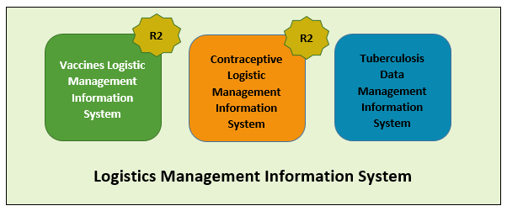

# Overview of Web-based LMIS

Pakistan Web-based LMIS provides transparency to all stakeholders based on user rights, is easy to use, and integrates both routine and special immunization campaign vaccine logistics data. Standardized reporting forms and Data triangulation is implemented to validate data and improve visibility in wastage rates.

Resupply quantities for routine EPI are calculated based on average monthly consumption and stock balances, and wastage rates are calculated automatically. The use of stock balance, consumption and issued data, losses and adjustments are also collected.

New routine reporting forms are aquatically printed using vLMIS inventory management module in order to collect data from service delivery points, along with vaccine logistics standard operating procedures (SOPs) for each level of the supply chain.

The Vaccine Logistics Management Information System contains the following features:

1. A module for Vaccine reporting in the centralized web-accessible data repository of LMIS to report data from data providers. Data Providers can perform monthly data entry. This also includes being able to generate reports for themselves.
2. The data provided by different geographical levels tracks vaccines in different data entry forms. The Stock Issue and Receive Data, (National, Provincial, Divisional, District, Tehsil) users will enter vaccines logistics data with batch and expiry information, while Monthly Consumption data (Tehsil and Union Council level) users will report data without batch. Wastage will be calculated automatically with the help of consumed and unused vial information.
3. The cold-chain inventory and use is tracked in vLMIS. This module is capable of entering new cold chain assets as well as its current operational status. Each month, along with other logistics data, users will update the operational status of their cold chain assets.
4. The Administrator will manage vLMIS and create all of the necessary data in order to assist users to continue to provide and review logistics data.
5. Data Reviewers can access vLMIS using the ‘guest’ user account and get reports about the country’s provinces and districts to help them in logistical decision-making regarding supply chain management in their assigned districts.

## **Vaccine Logistics Management Information System (vLMIS)**

The web-based Vaccine Logistics Management Information System has been designed to help plan and manage the immunization resources and ensure that vaccines are always available to meet demand at the right time, to the right place, at the right cost, in the right condition of the right product in the right amount – No matter where they live.

|  |
| --- |
| http://www.mchip.net/sites/default/files/India%20mom%20and%20boy%20saveJPG_0.JPG**Millions of people are alive today because of immunization programs** from diseases such as diarrhea, pneumonia, polio, measles, tetanus, and other life-threatening illnesses. The current immunization programs save more than **2.5 million lives each year**; however, **24 million children still do not get** the complete routine immunizations scheduled for their first year of life, because of weak health systems and difficulties with delivering vaccines to remote locations on time. |

The web-based Vaccine Logistics Management Information System (vLMIS) is an extension of the Logistics Management Information System (LMIS) and is designed to replace the current paper-based logistics information system that is being used for managing the vaccine distribution and logistics.

The Vaccine Logistics Management Information System introduces systematic vaccine product management and create sustainable dependencies among different vaccine procurement procedures and geographical level operations.

The web-based Vaccine Logistics Management Information System (vLMIS) is easy to use and contextualized to fit local stakeholder’s structure and the devolution of health and population programs to provincial governments. The system brings in district and EPI-level reporting by aggregating facility-level data through paper-based reports. With a unified system for reporting and requisitioning, the vLMIS system is able to integrate information from all levels and sectors. The web-based vLMIS can be accessed at <http://lmis.gov.pk>.

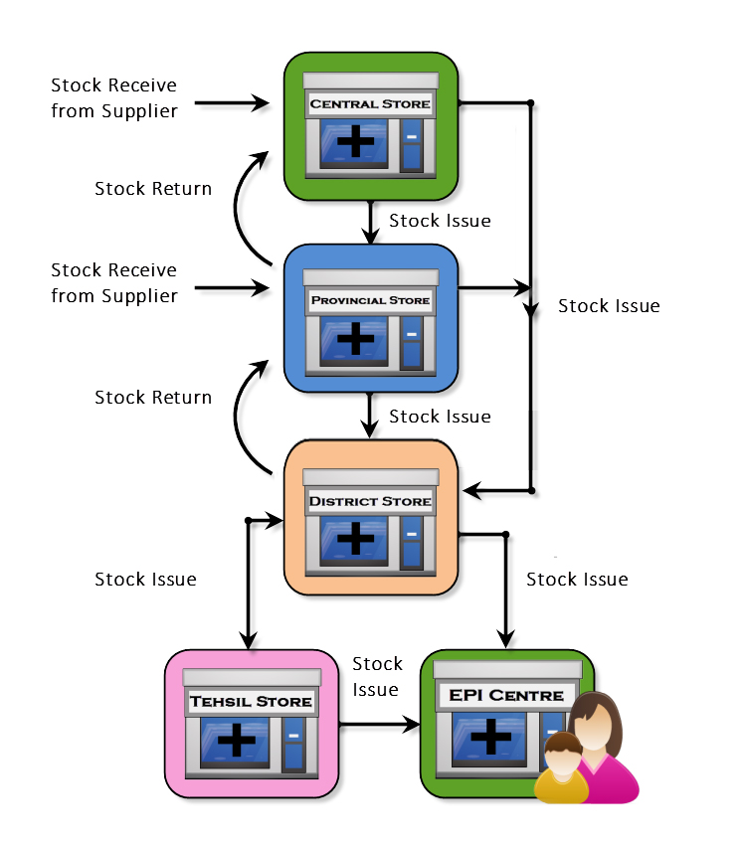

**The Vaccine Supply Chain**

## **vLMIS Features**

Vaccine Logistics Management Information System provides the following functions and features:

|  |  |
| --- | --- |
| Role-Based Access for Users  Users are authenticated based on their geographical levels and the roles that are associated with them. | Inventory Management  Stock Issued, Received, and adjustments are recorded on transaction basis in vLMIS by the EPI Store Users. |
| Automated Stock Transactions  Stock transactions are updated in the system and calculated automatically for transfers and adjustments using vLMIS for better management of inventory. | Cold-Chain Assets  The details of Cold-chain assets, their location, status and capacity is tracked in vLMIS for maintaining the cold-chain of immunization vaccines. |
| Batch Management  vLMIS offers batch management in order to maintain the First expiry first out process for vaccine during stock issue. | Consumption Reporting  Service delivery point data will be collected and recorded daily and compiled and reported online monthly using vLMIS. |
| Data Reports  Performance reports enable you to view the monthly reporting performance country-wide. | Graph and Maps  Graphs and maps enable you to view and compare different Indicators and view performance and comparison reports over time. |

## **Assumptions**

This user guide assumes that you already have Vaccine Logistics Management Information System accounts as per your geographical level and role. This user guide also assumes that you are familiar with basic web-application account login procedures.

## **System Requirements**

The Vaccines Logistics Management Information System is accessible from any Desktop PC, Mac, or Linux computer with Internet access and a supported Web-browser.

## **Browser Support**

The following browsers and later versions fully support vLMIS standard view:

* Mozilla Firefox (Windows, Mac, Linux)
* Google Chrome (Windows, Mac, Linux)
* Netscape (Windows, Mac, Linux)
* Safari (Mac)
* Internet Explorer 9 and above (Windows)

|  |  |
| --- | --- |
| Users & User Roles | **2** |
| of Vaccines Logistics Management Information System | |

This section explains the users and their roles in Vaccine Logistics Management Information System. The Vaccine Logistics Management Information System Users are basically store operators that manage and record the inventory and stock transactions. Each geographical level entails different user roles associated with their warehouse/store operations.

## **Anonymous/Guest User**

The Anonymous or Guest user can be any web user with the following capabilities:

|  |  |
| --- | --- |
| **Feature** | **Responsibilities** |
| **Reports** | View national and provincial level geographical and periodic logistics information in tabular formats. |
| **CCEM Reports** | View geographical and periodic CCEM information in tabular formats. |
| **Campaign Reports** | View geographical and periodic campaign information in tabular formats. |

## **Authenticated Users**

The Authenticated users can log in to vLMIS and perform assigned functions. Each user is assigned responsibilities based on the role and geographical level.

### **EPI User – National**

|  |  |
| --- | --- |
| **Feature** | **Responsibilities** |
| **Inventory Management** | Receive stock from provincial warehouses.  Receive stock from supplier and create placement vouchers.  Search for received stock.  Issue stock to other warehouses  (Province, District and Field stores) and  create pick order forms.  Search for issued stock.  Manage Batches.  Add placement locations for stock.  Transfer stock to other locations. |
| **Stock Adjustments** | Manage adjustments.  Search for adjustments |
| **Manage Gate Pass** | Issue a new gate pass.  View the list of issued gate passes. |
| **CCEM** | Manage Cold Chain Assets.  Asset Working Status update |
| **Reports** | View geographical and periodic logistics information in tabular formats. |
| **CCEM Reports** | View geographical and periodic CCEM information in tabular formats. |
| **IM Graphs** | View geographical and periodic inventory management information in graphical formats. |
| **CCEM Graphs** | View geographical and periodic cold-chain equipment management information in graphical formats. |
| **Maps** | View geographical and periodic logistics information in map formats. |
| **Campaign Reports** | View geographical and periodic campaign information in tabular formats. |
| **Others** | Change account password. |

### **EPI User – Provincial**

|  |  |
| --- | --- |
| **Feature** | **Responsibilities** |
| **Inventory Management** | Receive stock from National warehouse.  Receive stock from supplier and create placement vouchers.  Search for received stock.  Issue stock to other warehouses  (National, Province, Division, District stores) and  create pick order forms.  Search for issued stock.  Manage Batches.  Add placement locations for stock.  Transfer stock to other locations. |
| **Stock Adjustments** | Add adjustments.  Search for adjustments |
| **Manage Gate Pass** | Issue a new gate pass.  View the list of issued gate passes. |
| **CCEM** | Manage Cold Chain Assets.  Asset Working Status update |
| **Reports** | View geographical and periodic logistics information in tabular formats. |
| **Maps** | View geographical and periodic logistics information in map formats. |
| **CCEM Reports** | View geographical and periodic CCEM information in tabular formats. |
| **IM Graphs** | View geographical and periodic inventory management information in graphical formats. |
| **CCEM Graphs** | View geographical and periodic cold-chain equipment management information in graphical formats. |
| **Campaign Reports** | View geographical and periodic campaign information in tabular formats. |
| **Others** | Change account password. |

### **EPI User – District**

|  |  |
| --- | --- |
| **Feature** | **Responsibilities** |
| **Inventory Management** | Receive stock from National / Provincial warehouse.  Search for received stock.  Issue stock to other warehouses  (National, Province, Division, District stores) and  create pick order forms.  Search for issued stock.  Manage Batches.  Add placement locations for stock.  Transfer stock to other locations. |
| **Stock Adjustments** | Add adjustments.  Search for adjustments |
| **Manage Gate Pass** | Issue a new gate pass.  View the list of issued gate passes. |
| **CCEM** | Manage Cold Chain Assets.  Asset Working Status update |
| **Reports** | View geographical and periodic logistics information in tabular formats. |
| **Maps** | View geographical and periodic logistics information in map formats. |
| **CCEM Reports** | View geographical and periodic CCEM information in tabular formats. |
| **IM Graphs** | View geographical and periodic inventory management information in graphical formats. |
| **CCEM Graphs** | View geographical and periodic cold-chain equipment management information in graphical formats. |
| **Campaign Reports** | View geographical and periodic campaign information in tabular formats. |
| **vLMIS Explorer** | View previously submitted Monthly Report data for the selected warehouse and the specified month and year. |
| **Others** | Change account password. |

### **EPI User - Tehsil**

|  |  |
| --- | --- |
| **Feature** | **Responsibilities** |
| **Inventory Management** | Receive stock from Provincial / District warehouse.  Search for received stock.  Issue stock to other warehouses  (National, Province, Division, District stores) and  create pick order forms.  Search for issued stock.  Manage Batches.  Add placement locations for stock.  Transfer stock to other locations. |
| **Stock Adjustments** | Add adjustments.  Search for adjustments |
| **Manage Gate Pass** | Issue a new gate pass.  View the list of issued gate passes. |
| **CCEM** | Manage Cold Chain Assets.  Asset Working Status update |
| **Reports** | View geographical and periodic logistics information in tabular formats. |
| **Maps** | View geographical and periodic logistics information in map formats. |
| **CCEM Reports** | View geographical and periodic CCEM information in tabular formats. |
| **IM Graphs** | View geographical and periodic inventory management information in graphical formats. |
| **CCEM Graphs** | View geographical and periodic cold-chain equipment management information in graphical formats. |
| **Monthly Stock Consumption** | Enter/View monthly reported data of products for the assigned Warehouse/Store. |
| **Others** | Change account password. |

### **EPI User - UC**

|  |  |
| --- | --- |
| **Feature** | **Responsibilities** |
| **Monthly Stock Consumption** | Enter/View monthly reported data of products for the assigned Warehouse/Store. |
| **CCEM** | Cold Chain Status Update. |
| **Reports** | View geographical and periodic logistics information in tabular formats. |
| **CCEM Reports** | View geographical and periodic CCEM information in tabular formats. |
| **CCEM Graphs** | View geographical and periodic cold-chain equipment management information in graphical formats. |
| **Campaign Reports** | View geographical and periodic campaign information in tabular formats. |
| **Others** | Change account password. |

### **Policy User (National, Provincial and District)**

|  |  |
| --- | --- |
| **Feature** | **Responsibilities** |
| **Reports** | View geographical and periodic logistics information in tabular formats. |
| **CCEM Reports** | View geographical and periodic CCEM information in tabular formats. |
| **CCEM Graphs** | View geographical and periodic cold-chain equipment management information in graphical formats. |
| **IM Graphs** | View geographical and periodic inventory management information in graphical formats. |
| **Campaign Reports** | View geographical and periodic campaign information in tabular formats. |
| **Others** | Change account password. |

### **Campaign User (National)**

|  |  |
| --- | --- |
| **Feature** | **Responsibilities** |
| **Campaigns** | Add Campaign  Search Campaigns  Data Entry History  Campaigns Target  LQAS Data Entry |
| **Campaign Reports** | View geographical and periodic campaign information in tabular formats. |
| **Others** | Change account password. |

### **Campaign User (Provincial)**

|  |  |
| --- | --- |
| **Feature** | **Responsibilities** |
| **Campaigns** | Add Campaign  Search Campaigns  Data Entry History  Campaigns Target  LQAS Data Entry |
| **Campaign Reports** | View geographical and periodic campaign information in tabular formats. |
| **Others** | Change account password. |

### **Campaign User (District)**

|  |  |
| --- | --- |
| **Feature** | **Responsibilities** |
| **Campaigns** | New Data Entry  Data Entry History  Reported UCs  Campaign Readiness  Campaign Readiness UCs |
| **Campaign Reports** | View geographical and periodic campaign information in tabular formats. |
| **Others** | Change account password. |

### **CCEM Manager (National, Provincial, District)**

|  |  |
| --- | --- |
| **Feature** | **Responsibilities** |
| **CCEM** | Search Refrigerator  Add Refrigerator  Search Vaccine Carriers  Add Vaccine Carriers  Search Ice Pack  Add Ice Pack  Search Cold Room  Add Cold Room  Search Voltage Regulator  Add Voltage Regulator  Search Generator  Add Generator  Search Transport  Add Transport  Transfer Asset  Asset Status Update |
| **CCEM Reports** | View geographical and periodic CCEM information in tabular formats. |
| **CCEM Graphs** | View geographical and periodic cold-chain equipment management information in graphical formats. |
| **Others** | Change account password. |

## **Geographical Areas**

The geographical distribution of areas is displayed below. Data is reported on 4th and 5th levels, while stock transactions are recorded on layer 1 – 3. Data in all layers is segregated in vLMIS. It is possible to enter aggregated data in layer 4 (Tehsil) and 5 (UC) level due to the lack of internet infrastructure in the sub districts and other remote areas.

|  |  |
| --- | --- |
| **Layer** | **Geographical Area** |
| Layer 1 | National |
| Layer 2 | Provincial / Regional |
| Layer 3 | District |
| Layer 4 | Tehsil |
| Layer 5 | UC |

|  |  |
| --- | --- |
| Step-by-Step | **3** |
| Process to using Vaccines Logistics Management Information System | |

This section explains the step-by-step instructions on getting started with vLMIS. In this section, you will learn about:

1. The Vaccine Logistics Management Information System User Interface.
2. Logging Into Vaccine Logistics Management Information System.
3. Changing your account password.
4. What to do if you forget your password.
5. Logging Out of Vaccine Logistics Management Information System.

# vLMIS Homepage

The Logistics Management Information System has a single landing page for its three modules for Contraceptives, TB, and Vaccines Management Information System. Enter the URL <http://lmis.gov.pk> to access the application homepage.

**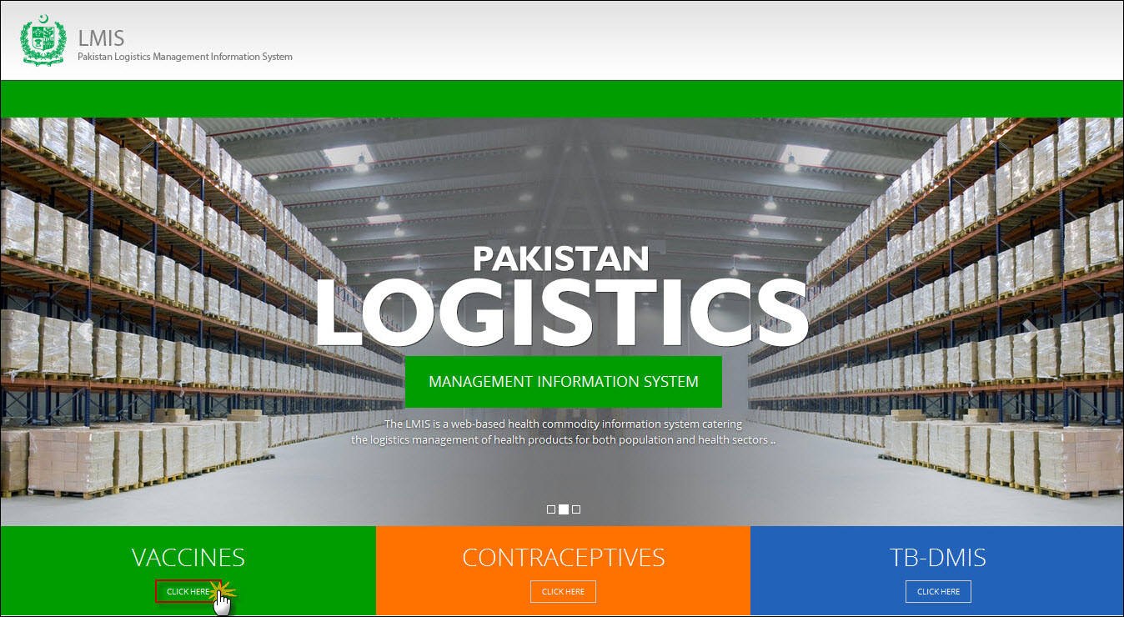**

Users can also access vaccine LMIS application directly by using <http://v.lmis.gov.pk> URL. Once the user enters the URL <http://v.lmis.gov.pk>, a user interface (homepage) will appear. The homepage displays a basic introduction to the ‘vaccine LMIS’.

|  |  |
| --- | --- |
| *C:\Users\isbah.zulfiqar\Desktop\1382615592_file_edit.png* | Before You Begin...  It is recommended to use vLMIS with Google or Mozilla Fire Fox. Older generations of browsers are also supported; however, their use can lead to issues with on-screen formatting and display. |

Once you click Vaccines, homepage for vLMIS will display.

## **Homepage Menu**

The available menu items can be found on the top of homepage screen. The components are displayed adjacently, as shown in the image below:

****

### **Contact Us Tab**

The Contact Us tab contains addresses, telephone numbers and email addresses (where available) for key personnel as a system communication list. Therefore, the user of LMIS will be able to see contact details of other stakeholders and can contact them as needed.

### **Frequently Asked Questions Tab**

The menu also contains a FAQ’s tab in order to provide guidance towards the most frequently asked and critical questions.

**Logging into Vaccine Logistics Management Information System**

vLMIS is a web-based inventory and cold chain management application that makes it simple for beginners and experienced users to report inventory and cold chain data, view performance and graphical reports as well as maps.

|  |  |
| --- | --- |
| *C:\Users\isbah.zulfiqar\Desktop\1382615592_file_edit.png* | **Before You Begin...**  Make sure you have your correct log in credentials. When you register with vLMIS, the accounts and its related details along with the login domain details will be provided to you by the vLMIS Administrator. |

To Log in to vLMIS:

1. Go to <http://v.lmis.gov.pk>
2. Click the button **Click Here** on the Vaccines tab.

vLMIS login page will be displayed.  
**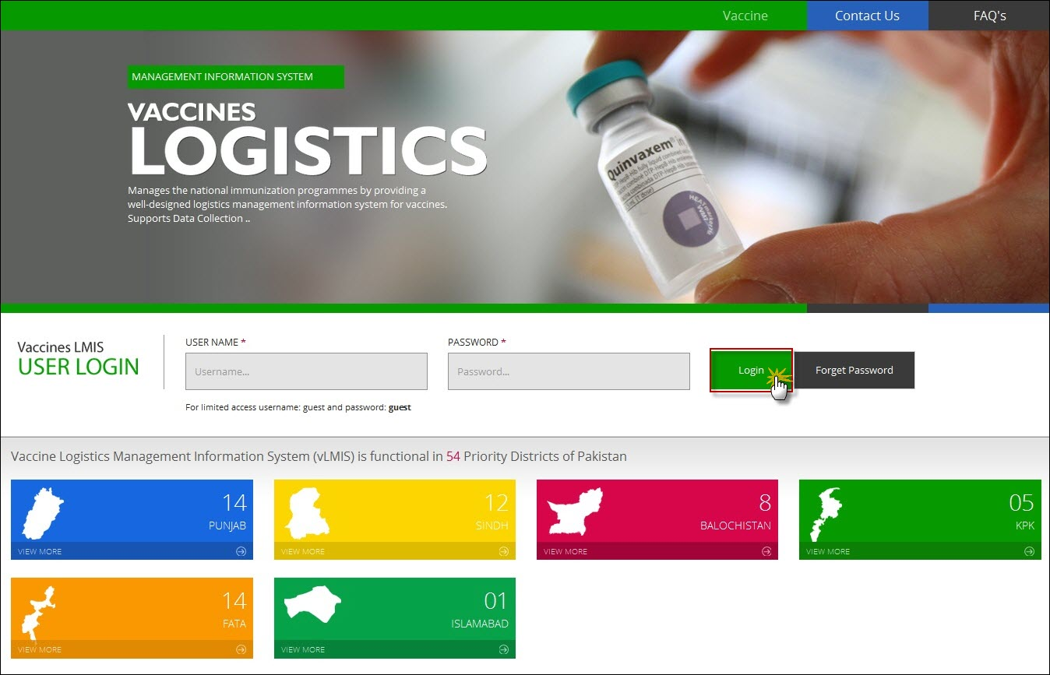**

1. Specify the **Username** and **Password** provided to you by the Administrator.

|  |  |
| --- | --- |
| *C:\Users\isbah.zulfiqar\Desktop\1382615592_file_edit.png* | To login as a guest or anonymous user, you can simply provide the following credentials:  **Username**: guest **Password**: guest |

|  |  |
| --- | --- |
|  | You can change the password provided to you by the administrator. See “*Changing Your Password*” for details.  Never give out your password to anyone for security purposes. |

1. Click **Login**.  
   The Vaccine Logistics Management Information System Dashboard Screen displays.

### **Changing Your Password**

To change your vLMIS password:

1. Login to vLMIS application.

The welcome screen displays.

1. On the right-side of the application, the user login name appears.
2. Under the login name, click Change Password as shown in the image below:

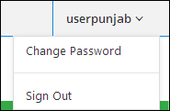

1. Specify the following:

* **Old Password**: specify your old password.
* **New Password**: specify the new password.
* **Confirm New Password**: retype your password.

|  |  |
| --- | --- |
| *C:\Users\isbah.zulfiqar\Desktop\1382615592_file_edit.png* | Password Requirements  Your password must have a combination of a capital alphabet and one Numeric. |

|  |  |
| --- | --- |
|  | Never give out your password to anyone for security purposes. |

1. Click **Change Password**.  
   Your password will be changed successfully.

### **Forgot Password**

In case you have forgotten your password:

1. Open the vLMIS login page by entering the URL: <http://v.lmis.gov.pk>.
2. In the Login section, click **Forgot Password** as shown in the image below:  
     
   **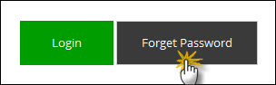**

You will be redirected to the Forgot Password Page.

1. In the Email entry box, enter your email address as validated in your account information by the Administrator.   
   An email will be sent on your email address for resetting your password.
2. Click the Reset Password link in the email to go to reset password page.
3. Specify the following:
   * **New Password**: specify the new password.
   * **Confirm New Password**: retype your password.

|  |  |
| --- | --- |
| *C:\Users\isbah.zulfiqar\Desktop\1382615592_file_edit.png* | Password Requirements  Your password must have a combination of a capital alphabet and one Numeric. |

|  |  |
| --- | --- |
|  | Never give out your password to anyone for security purposes. |

1. Click **Change Password**.  
   Your password will be changed successfully.

### **Logging Out**

When signed in, click **Sign out** on the right-side of the application, as shown in the image below:  
  


|  |  |
| --- | --- |
| Dashboards | **4** |
| in Vaccine Logistics Management Information System | |

This section explains the step-by-step instructions on the dashboard features that can be used by the Vaccine Logistics Management Information system’s users.

The Vaccine Logistics Management Information System enables you to login as an authenticated user to view different dashboards. These dashboards are available to different level users such as:

* National Level Dashboards
* Provincial Level Dashboards
* District Level Dashboards

# Overview

Dashboard is a visual display of the most important information needed to achieve one or more objectives; consolidated and arranged on a single screen so the information can be monitored at a glance.

## **vLMIS User**

When a user logs in, s/he will view the dashboard tabs as shown below:

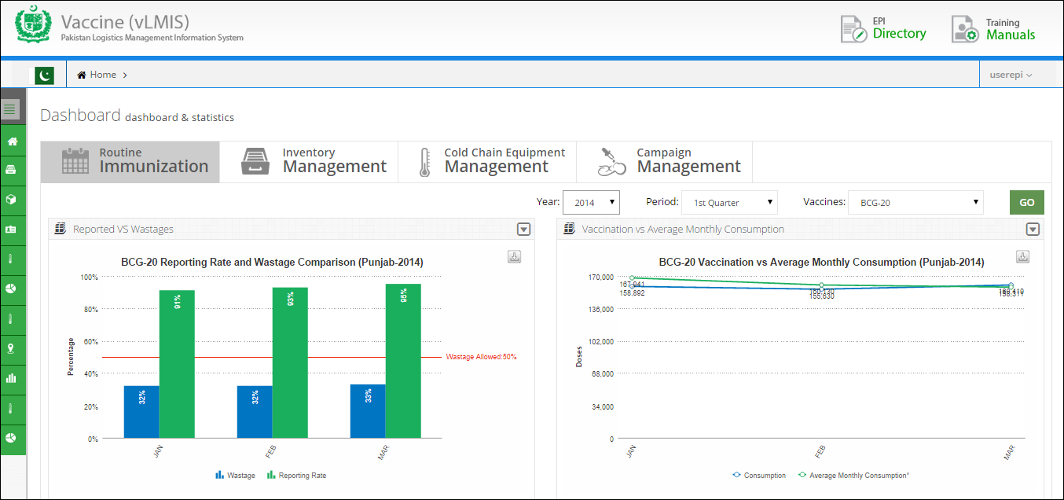

On the left-side of the screen, user can see the main menu with Dashboard tab.

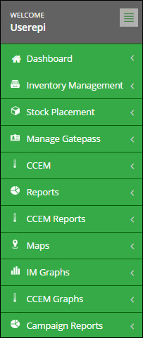

Users can select the level by clicking the Dashboard tab.

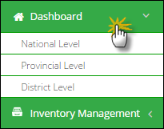

Select the National Level to view the Dashboard.

## **National Level Dashboard**

When national level user logs in, user will view the dashboard tabs as shown below:



The following dashboard tabs are available by default.

* Routine Immunization
* Inventory Management
* Cold Chain Equipment Management
* Campaign Management

### **Routine Immunization**

Routine immunization management dashboard allows users to quickly view reports in a graphical manner by clicking on this tab.

* **Reporting Rate**

This graph is showing that the reporting rate in each province and also shows the province wise comparison.

* **Wastage Rate**

To show the provincial level Vaccine wastage comparison to take measures where the wastage is at higher side.

* **Average Monthly Consumption (AMC)**

Users can view AMC as average of aggregated consumption of the last three non-zero consumption months of vaccines and related products.

Users can select the following filters:



* **Year:** select the year from the drop-down list.
* **Period:** select the period for which you want to view report.
* **Vaccines:** select the product from the drop-down list.

Click **Go** to view routine immunization reports.

**Reporting Rate and Wastage Comparison**

Routine immunization management dashboard shows reporting rate and wastage comparison for each province / region. Users can view the comparison graph for reporting rate and wastage rate. The graph depicts the overall reporting and wastage rates for each province.

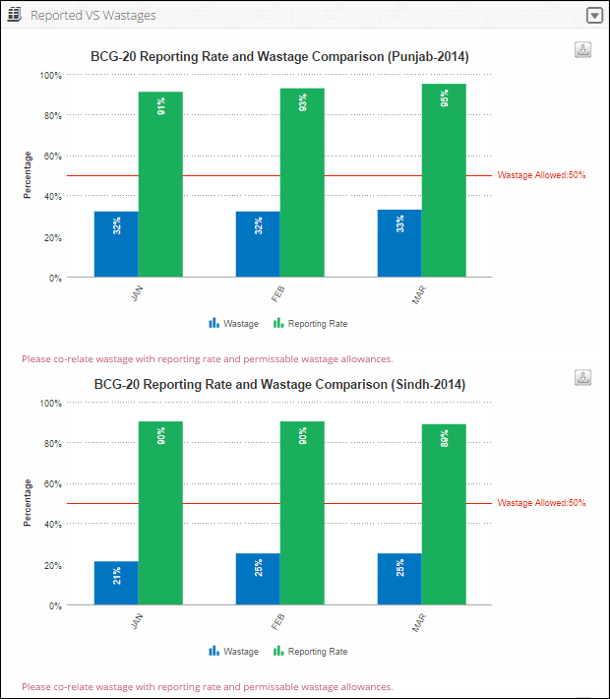

Users can also export charts in JPEG, PNG, PDF and SVG format.

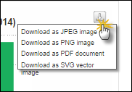

**Vaccination vs Average Monthly Consumption**

Routine immunization management dashboard also shows vaccination vs average monthly consumption (AMC) for each province / region. Users can view the comparison line graph for consumption and AMC. The graph depicts the overall consumption for each province.

**Average Monthly Consumption (AMC):** Average Monthly Consumption is calculated as average of aggregated consumption of the last three non-zero consumption months of vaccines and related products.

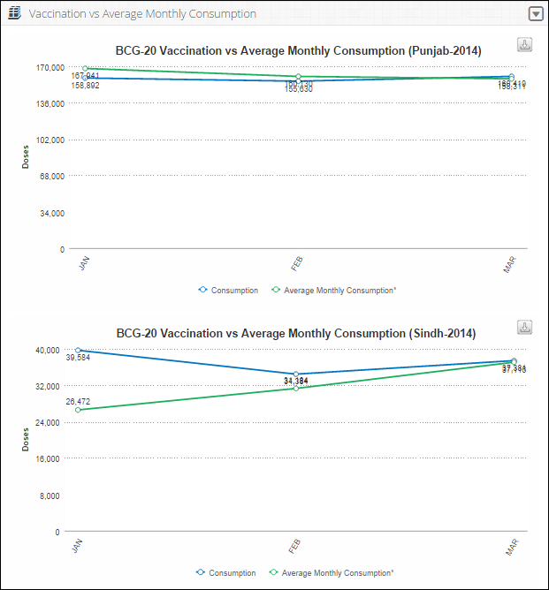

Users can also export charts in JPEG, PNG, PDF and SVG format.



### **Inventory Management**

Inventory management allows users to quickly review reports by clicking on this tab.

* **Stock Status**

To show product wise stock status at National level e.g. Opening Balance, Receive, Issue and Closing Balance.

* **Month of Stock**

The user can have a bird’s eye view of Month of Stock (MOS) map.

* **Stock Expiry Status**

It shows the stock expiry status pie chart for the selected vaccine.

Users can select the following filters:



* **Year:** select the year from the drop-down list.
* **Period:** select the period for which you want to view report.
* **Vaccines:** select the product from the drop-down list.

Click **Go** to view routine immunization reports.

**Vaccination vs Month of Stock**

Inventory management dashboard shows vaccination and month of stock comparison for each province / region. Users can view the comparison line graph of consumption vs month of stock for each province.

**Month of Stock (MOS):** Month of Stocks is the estimate of number of months the stock will last. This obtains by dividing Stock of Hand by average monthly consumption.

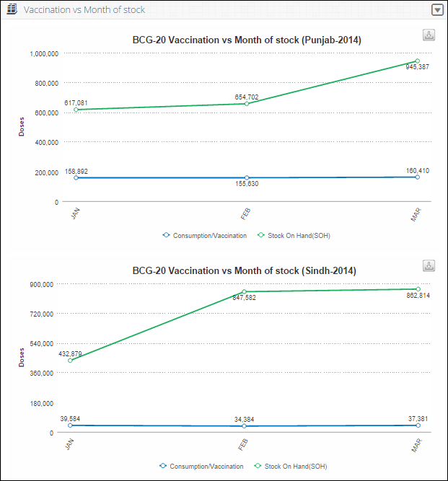

Users can also export charts in JPEG, PNG, PDF and SVG format.



**Month of Stock Map**

Inventory management dashboard also shows month of stock map at the national level. Users can select the **Month** from the drop-down menu to view the MOS map for each month in the selected quarter.

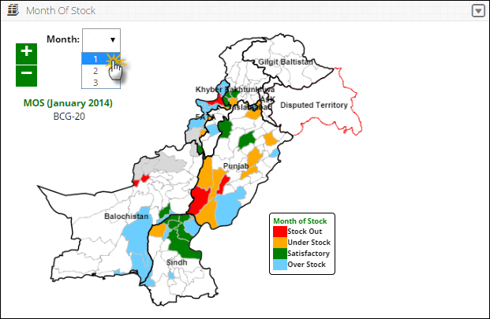

**Stock Expiry Status**

Inventory management dashboard also shows stock expiry status pie chart at the national level. Users can view the percentage expiry status of the selected vaccine in months.

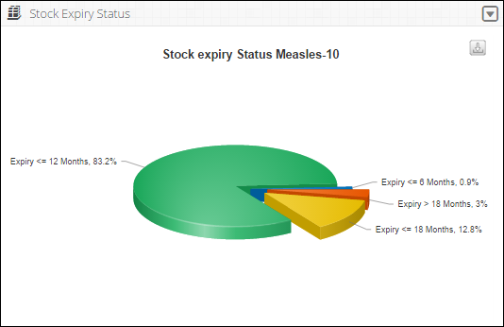

Users can also export charts in JPEG, PNG, PDF and SVG format.

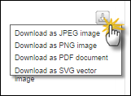

### **Cold Chain Equipment Management**

Cold Chain Equipment Management dashboard allows users to view the cold chain capacity map by clicking on this tab.

* **Cold Chain Capacity**

This map shows the map of Pakistan highlighting the cold chain capacity of each district.

* **Vaccine storage capacity at +2c to +8c**

To show the storage capacity of vaccines at certain temperature range within selected health facilities.

* **Vaccine storage capacity at +20c**

To show the storage capacity of vaccines at 20 degrees centigrade within selected health facilities.

* **Icepack freezing capacity against routine requirements**

To show the icepack freezing capacity within selected health facilities.

**Cold Chain Capacity**

Cold Chain Capacity will be displayed on the federal level through map.

The user can choose product from the drop-down menu.

* ILR/Refrigerators
* Cold Rooms

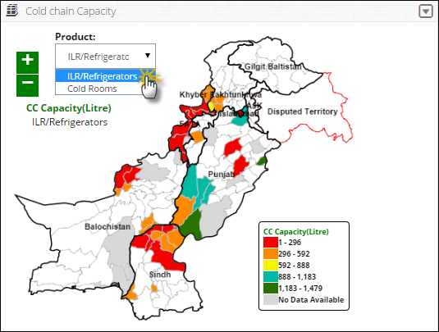

**Vaccine Storage Capacity at +2c to +8c**

Vaccine Storage Capacity at +2c to +8c will be displayed on the federal level in the form of a bar graph. The user can view the health facilities list on the vertical axis while the capacity range is shown on the horizontal axis.

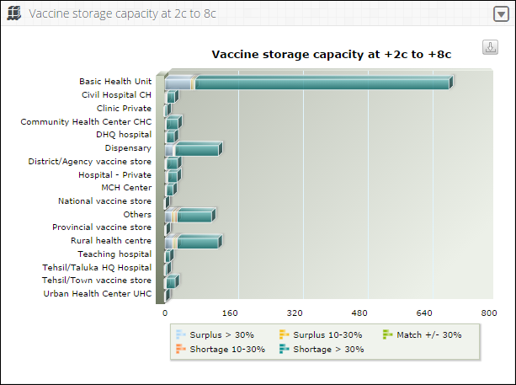

**Vaccine Storage Capacity at +20c**

Vaccine Storage Capacity at +20c will be displayed on the federal level in the form of a bar graph. The user can view the health facilities list on the vertical axis while the capacity range is shown on the horizontal axis.

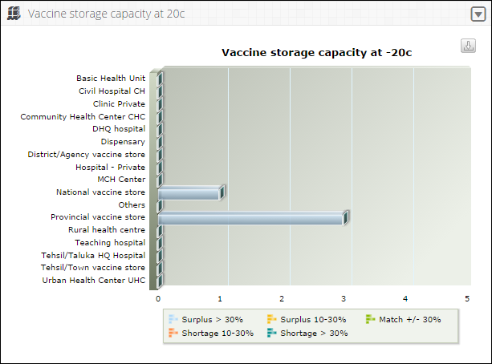

**Icepack freezing capacity against routine requirements**

Cold chain equipment management dashboard will also display icepack freezing capacity graph against routine requirements on the federal level in the form of a bar graph. The users can view the health facilities list on the vertical axis while the capacity range is shown on the horizontal axis.

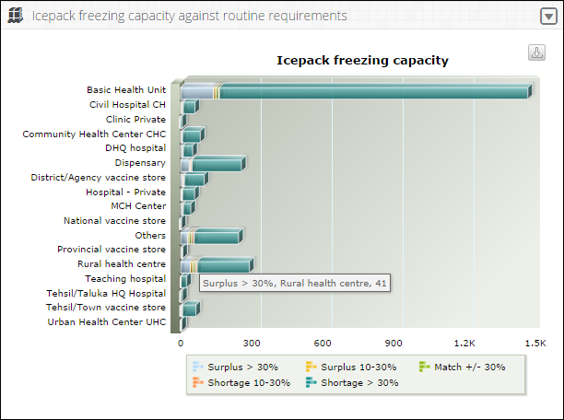

### **Campaign Management**

Campaign Management dashboard allows users to view the campaign reports and graphs by clicking on this tab. It will show:

* **Campaign Data Entry Status**

Shows the data entry stats for a selected campaign in the pie chart.

* **Day wise Target vs Coverage**

Shows the day wise comparison of target versus coverage stats.

* **Missed Children Types**

This is the comparison graph of defined different missed as well as unreachable list.

* **Campaign vaccines (vials)**

To show the list of each campaign’s vaccines (vials) which are used in any or all districts in the specified time span.

Users can select the following filter:

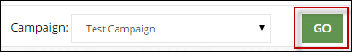

* **Campaign:** select the desired campaign from the drop-down list.

Click **Go** to view campaign management dashboard graphs.

**Data Entry Status**

Campaign management dashboard shows the data entry status for each district in a pie chart. Users can view the reported (Data Entered) and non-reported (Remaining) districts in the chart.

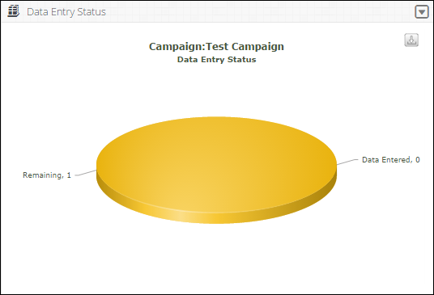

Users can also export charts in JPEG, PNG, PDF and SVG format.



**Day Wise Target vs Coverage**

Campaign management dashboard also shows day wise target vs coverage for the selected campaign at the national level.

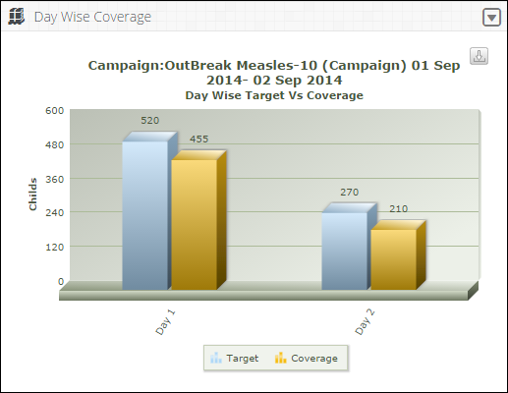

Click on **Target** or **Coverage** to view the target or coverage bar chart respectively.

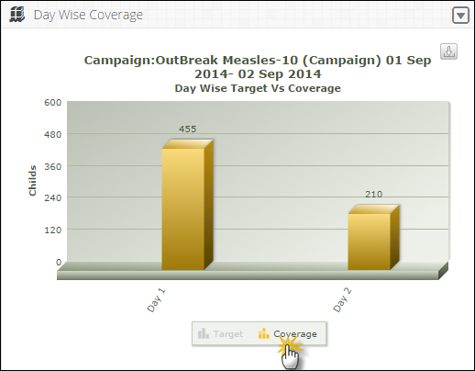

Users can also export charts in JPEG, PNG, PDF and SVG format.



**Missed Children Graph**

Campaign management dashboard also shows different type of the missed or unreachable children in a graphical manner.

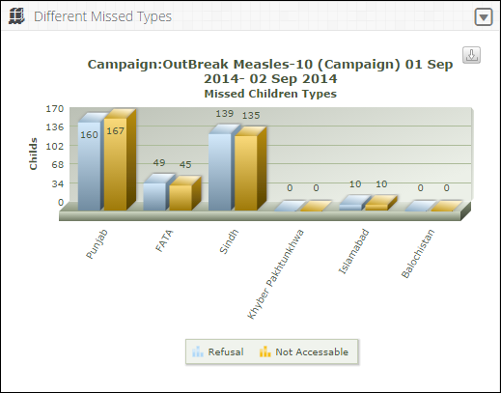

Click on **Refusal** or **Not Accessible** to view the refusal or not accessible children on the bar graph respectively.

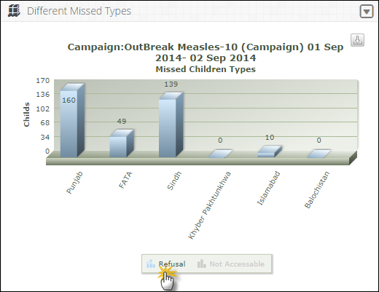

Users can also export charts in JPEG, PNG, PDF and SVG format.



**Campaign Vaccines**

Campaign management dashboard also shows the list of each campaign’s vaccines which are used in any or all districts in the specified time span.

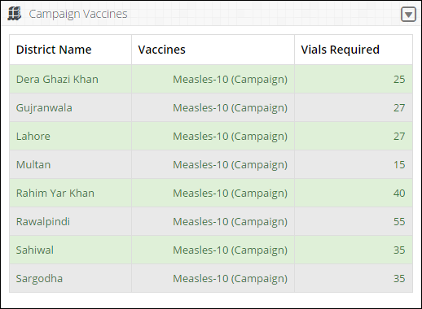

Users can also export charts in JPEG, PNG, PDF and SVG format.



Select the Provincial Level to view the desired Dashboard.

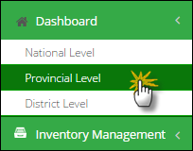

## **Provincial Level Dashboard**

When the user selects the provincial level, a dashboard screen will be displayed with four tabs.

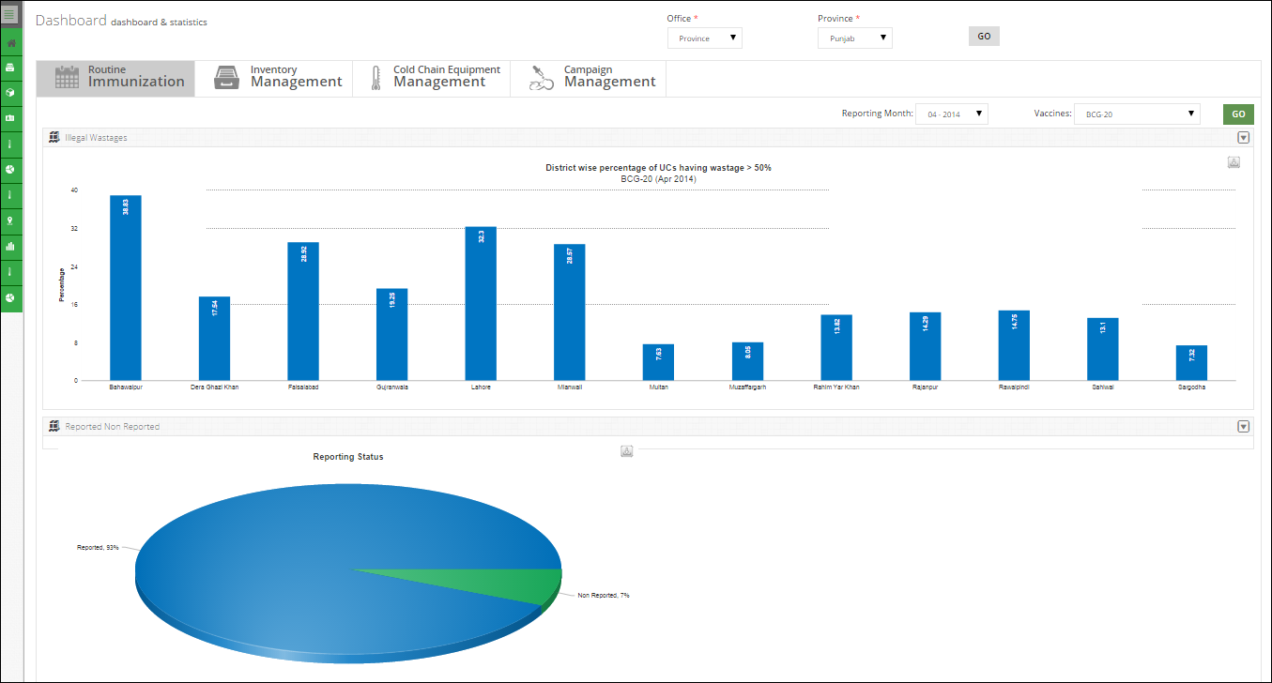

User can select the Office and Province at the top of the dashboard screen. Province is selected by default at the provincial level dashboard. Select the Province and click **GO.**

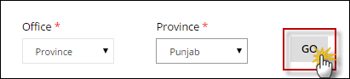

The following dashboard tabs are available by default.

* Routine Immunization
* Inventory Management
* Cold Chain Equipment Management
* Campaign Management

### **Routine Immunization**

Routine immunization management dashboard allows users to quickly view reports in a graphical manner by clicking on this tab.

* **Unacceptable Wastage**

This graph is the district wise percentage of vaccine wastages for the selected vaccine.

* **Reporting Status**

To show the reporting and non-reporting rates pie chart for each district in the selected province.

* **Month of Stock (MOS)**

User can view Month of stock status for the selected province (district wise).

* **Consumption**

Users can view consumption status in term of doses for the select province (district wise).

Users can select the following filters:

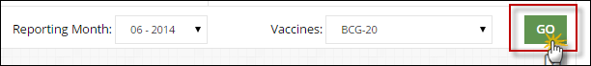

* **Reporting Month:** select the reporting month and year from the drop-down list.
* **Vaccines:** select the product from the drop-down list.

Click **Go** to view routine immunization graphs.

**Unacceptable Wastages**

Routine immunization management dashboard shows the district wise unacceptable wastages of the selected vaccine for the province / region. Users can view the bar graph for the wastage rates in each district.

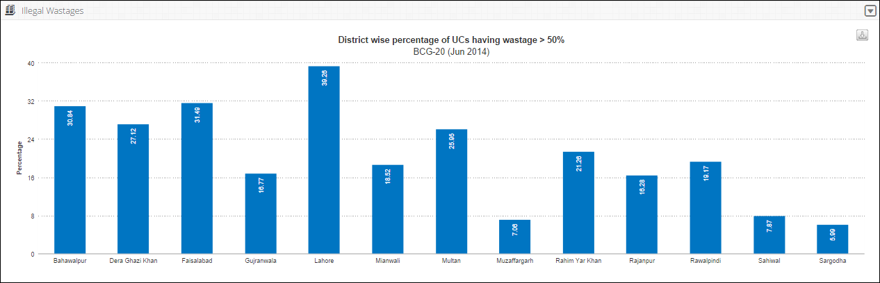

Users can also export graphs in JPEG, PNG, PDF and SVG format.

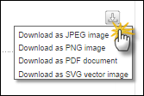

**Reporting Status**

Routine immunization management dashboard also shows reporting status for each district in the selected province in the form of a pie chart.

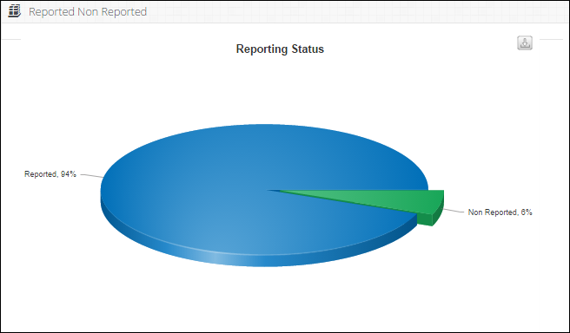

Click the reported or non-reported portion of the pie chart to view the district wise reporting rate.

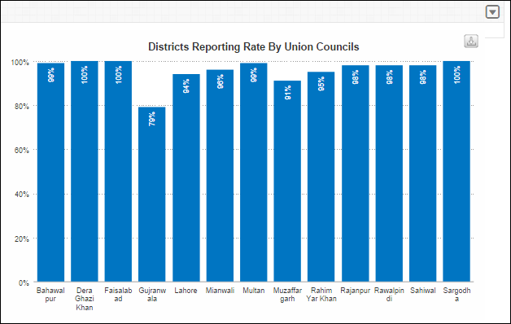

Users can also export charts in JPEG, PNG, PDF and SVG format.



**Month of Stock**

Routine immunization management dashboard also shows the month of stock status for each district in the selected province in the form of a bar graph.

Select the **View By** from the drop-down menu.

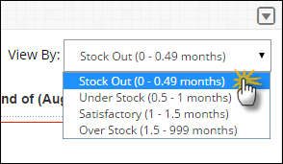

A bar graph for the stock out level for the selected vaccine in the districts of the selected province.

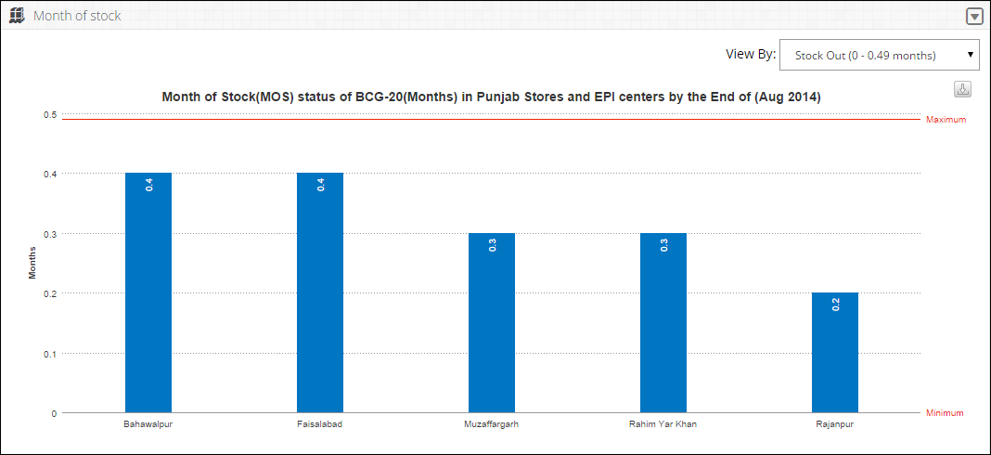

Users can also export charts in JPEG, PNG, PDF and SVG format.



**Consumption Graph**

Routine immunization management dashboard also shows the consumption status of the selected vaccine for each district in the selected province in the form of a bar graph.

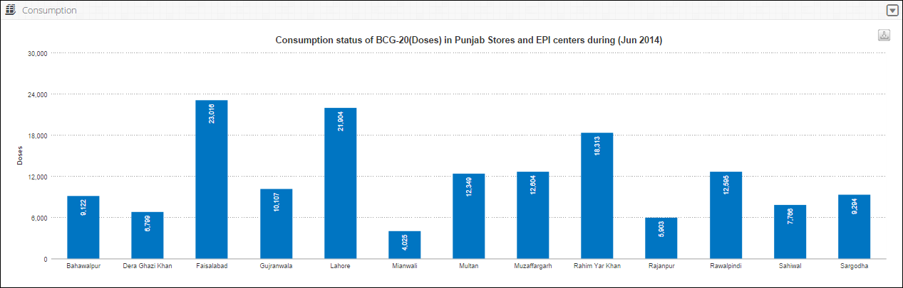

Users can also export charts in JPEG, PNG, PDF and SVG format.



### **Inventory Management**

Inventory management allows users to quickly review reports by clicking on this tab.

* **Stock Status by Item**

Shows the stock status by item for each district in the selected province.

* **Vaccine vial monitor (VVM) Stage Status**

To show vaccine vial monitor (VVM) stage status at the Provincial level.

* **Stock Status**

To show product wise stock status at Provincial level e.g. Opening Balance, Receive, Issue and Closing Balance.

* **Month of Stock**

The user can have a bird’s eye view of Month of Stock (MOS) map.

* **Stock Expiry Status**

It shows the stock expiry status pie chart for the selected vaccine.

Users can select the following filters:



* **Reporting Month:** select the reporting month and year from the drop-down list.
* **Vaccines:** select the product from the drop-down list.

Click **Go** to view inventory management dashboard.

**Stock Status by Item**

Inventory management dashboard shows the stock status by item for all the districts in the selected province / region. Users can view the pie graph for the stock status (in vials) in each district.

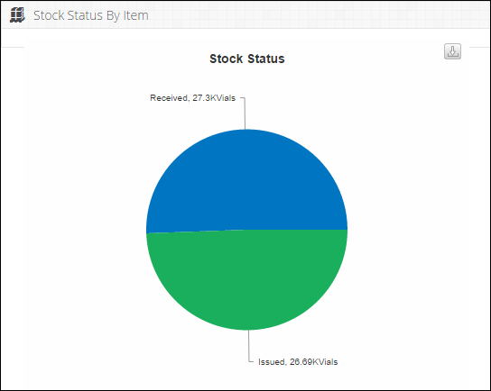

Click the received stock portion of the pie chart to view **Receive From** and **Issue To** list of warehouses.

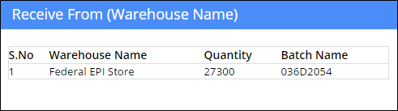

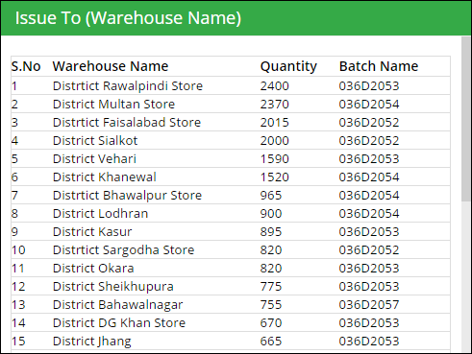

Users can also export charts in JPEG, PNG, PDF and SVG format.



**Vaccine vial monitor (VVM) Stage Status**

Inventory Management dashboard also allows users to view vaccine vial monitor (VVM) stage status pie chart at the Provincial level. The pie chart will be shown for the selected vaccine and the reporting month for one province / region.

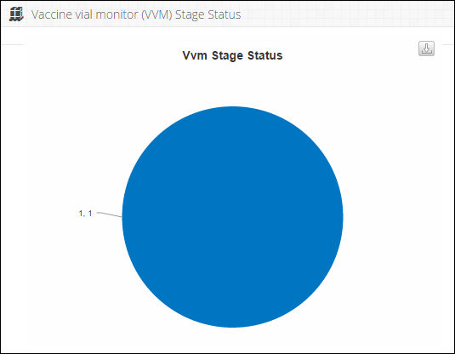

Click on the pie chart to view **VVM Stage Status** list according to the batch.

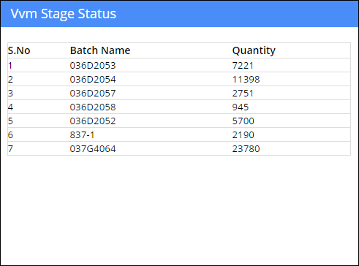

Users can also export charts in JPEG, PNG, PDF and SVG format.



**Stock Status**

Inventory management dashboard shows the stock status (in doses) for all the vaccine products in the selected province / region. Users can view the report for the vaccines such as:

* OB (Opening Balance)
* Receive
* Issue
* CB (Closing Balance)

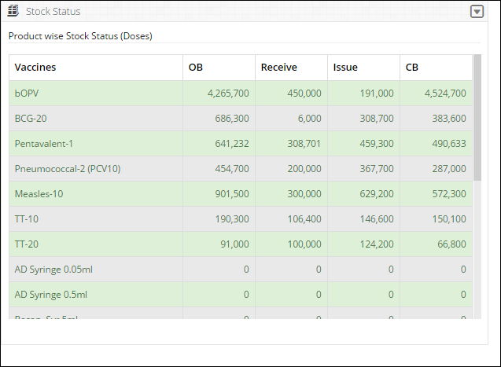

**Month of Stock Map**

Inventory management dashboard also shows month of stock map at the provincial level. Users can view the MOS map for the selected month and vaccine.

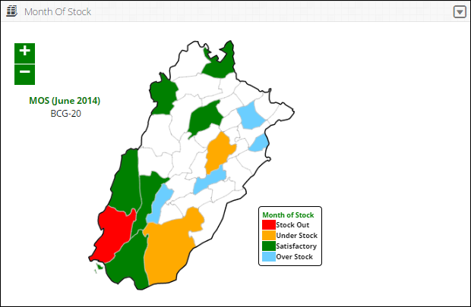

**Stock Expiry Status**

Inventory management dashboard also shows stock expiry status pie chart at the provincial level. Users can view the percentage expiry status of the selected vaccine in months.

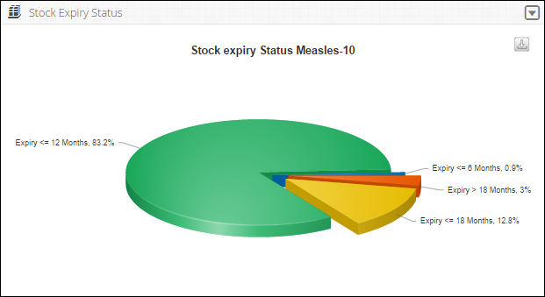

Users can also export the pie chart in JPEG, PNG, PDF and SVG format.



### **Cold Chain Equipment Management**

Cold Chain Equipment Management dashboard allows users to view the cold chain capacity map at the provincial level by clicking on this tab.

* **Cold Chain Capacity**

This map shows the map of Pakistan highlighting the cold chain capacity of each district in the selected province.

* **Vaccine storage capacity at +2c to +8c**

To show the storage capacity of vaccines at certain temperature range within selected health facilities.

* **Vaccine storage capacity at +20c**

To show the storage capacity of vaccines at 20 degrees centigrade within selected health facilities.

* **Icepack freezing capacity against routine requirements**

To show the icepack freezing capacity within selected health facilities.

**Cold Chain Capacity**

Cold Chain Capacity will be displayed on the Provincial level through map.

The user can choose product from the drop-down menu.

* ILR/Refrigerators
* Cold Rooms

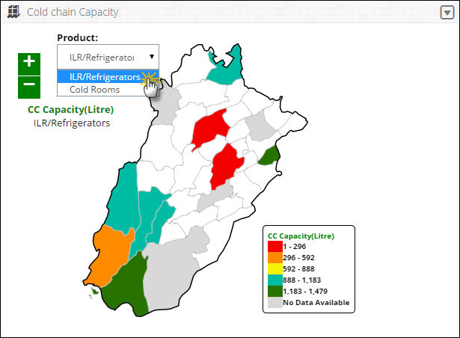

**Vaccine Storage Capacity at +2c to +8c**

Vaccine Storage Capacity at +2c to +8c will be displayed on the Provincial level in the form of a bar graph. The user can view the health facilities list on the vertical axis while the capacity range is shown on the horizontal axis.



**Vaccine Storage Capacity at +20c**

Vaccine Storage Capacity at +20c will be displayed on the Provincial level in the form of a bar graph. The user can view the health facilities list on the vertical axis while the capacity range is shown on the horizontal axis.



**Icepack freezing capacity against routine requirements**

Cold chain equipment management dashboard will also display icepack freezing capacity graph against routine requirements on the Provincial level in the form of a bar graph. The user can view the health facilities list on the vertical axis while the capacity range is shown on the horizontal axis.



### **Campaign Management**

Campaign Management dashboard allows users to view the campaign reports and graphs by clicking on this tab. It will show:

* **Campaign Data Entry Status**

Shows the data entry stats for a selected campaign in the pie chart.

* **Day wise Target vs Coverage**

Shows the day wise comparison of target versus coverage stats.

* **Missed Children Types**

This is the comparison graph of defined different missed as well as unreachable list.

* **Campaign vaccines (vials)**

To show the list of each campaign’s vaccines (vials) which are used in any or all districts in the specified time span.

Users can select the following filter:



* **Campaign:** select the desired campaign from the drop-down list.

Click **Go** to view campaign management dashboard graphs.

**Data Entry Status**

Campaign management dashboard shows the data entry status for each district in a pie chart. Users can view the reported (Data Entered) and non-reported (Remaining) districts in the chart.



Users can also export charts in JPEG, PNG, PDF and SVG format.



**Day Wise Target vs Coverage**

Campaign management dashboard also shows day wise target vs coverage for the selected campaign at the national level.



Click on **Target** or **Coverage** to view the target or coverage bar chart respectively.



Users can also export charts in JPEG, PNG, PDF and SVG format.



**Missed Children Graph**

Campaign management dashboard also shows different type of the missed or unreachable children in a graphical manner.



Click on **Refusal** or **Not Accessible** to view the refusal or not accessible children on the bar graph respectively.



Users can also export charts in JPEG, PNG, PDF and SVG format.



**Campaign Vaccines**

Campaign management dashboard also shows the list of each campaign’s vaccines which are used in any or all districts in the specified time span.



Users can also export charts in JPEG, PNG, PDF and SVG format.



Select the District Level to view the desired Dashboard.

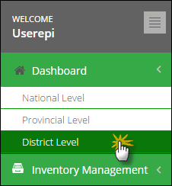

## **District Level Dashboard**

When the user selects the district level, a dashboard screen will be displayed with four tabs.

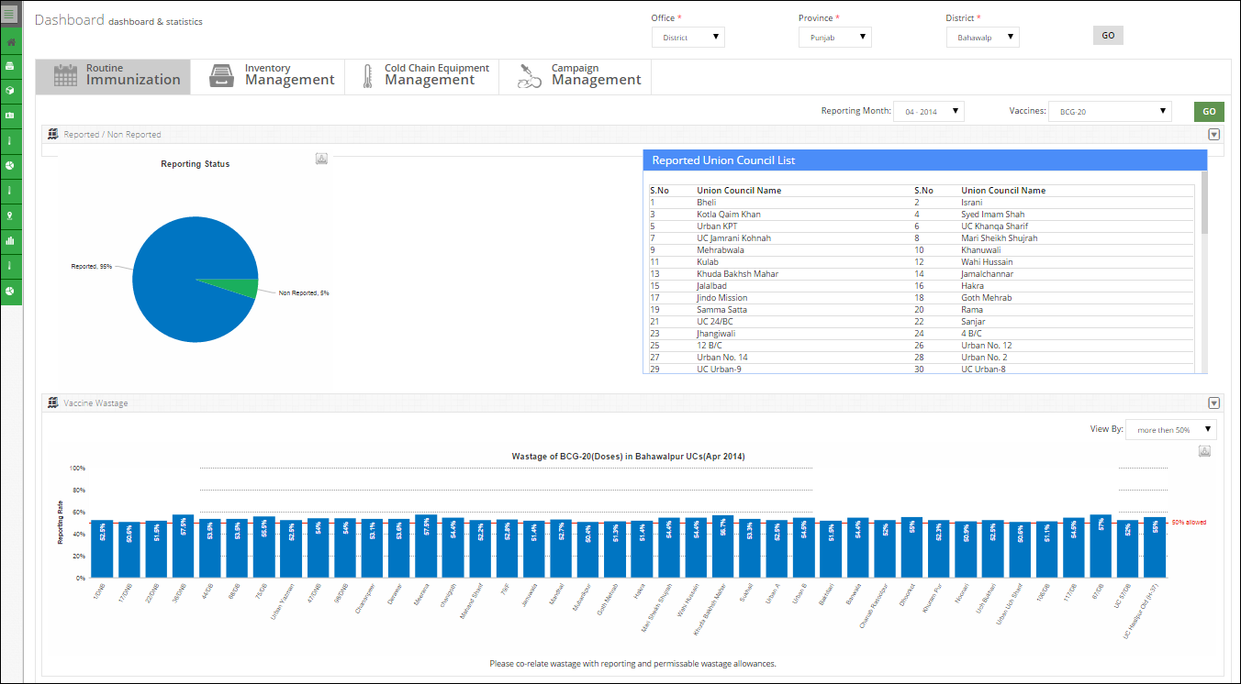

User can select the Office, Province at the top of the dashboard screen. Province and District is selected by default at the district level dashboard. Select the Province and the district and click **GO.**

**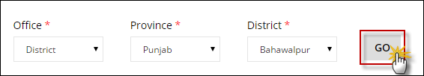**

The following dashboard tabs are available by default.

* Routine Immunization
* Inventory Management
* Cold Chain Equipment Management
* Campaign Management

### **Routine Immunization**

Routine immunization management dashboard allows users to quickly view reports in a graphical manner by clicking on this tab.

* **Vaccine Wastage**

To show the wastage rates of the selected vaccines at the UC level in the selected district.

* **Reporting Status**

To show the reporting and non-reporting rates pie chart for union councils of the selected district and vaccine.

* **Month of Stock (MOS)**

User can view Month of stock status for the selected district (UC wise).

* **Consumption**

Users can view consumption status in term of doses for the selected regions in a district (UC wise).

Users can select the following filters:



* **Reporting Month:** select the reporting month and year from the drop-down list.
* **Vaccines:** select the product from the drop-down list.

Click **Go** to view routine immunization graphs.

**Vaccine Wastage**

Routine immunization management dashboard shows the UC wise vaccine wastages of the selected vaccine for the district. Users can view the bar graph for the wastage rates in each UC.

Select the **View By** from the drop-down menu.

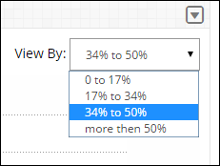

A bar graph for the selected percentage of stock for the selected vaccine in the UCs of the selected district will be displayed.

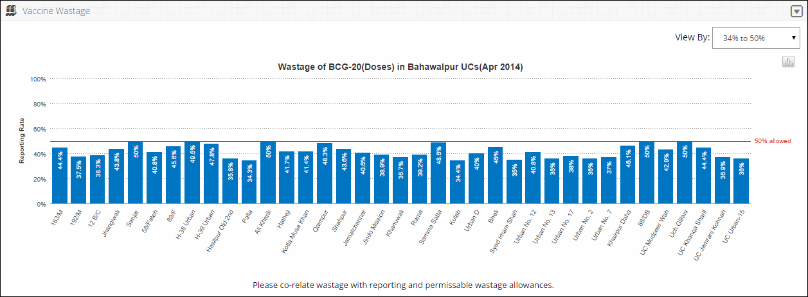

Users can also export graphs in JPEG, PNG, PDF and SVG format.



**Reporting Status**

Routine immunization management dashboard also shows reporting status for each UC in the selected district in the form of a pie chart.

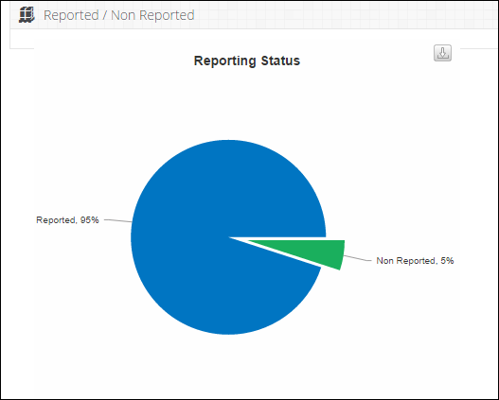

Click the reported or non-reported portion of the pie chart to view the district wise reporting rate.

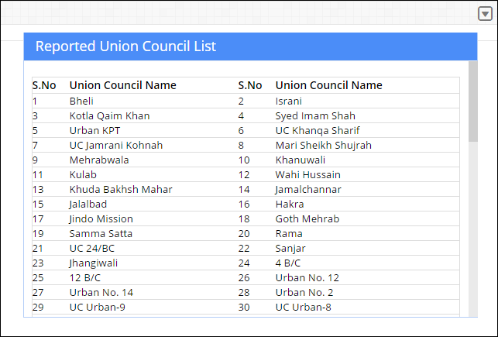

Users can also export charts in JPEG, PNG, PDF and SVG format.



**Month of Stock**

Routine immunization management dashboard also shows the month of stock status for each UC in the selected district in the form of a bar graph.

Select the **View By** from the drop-down menu.



A bar graph for the satisfactory level of stock for the selected vaccine in the districts of the selected province.

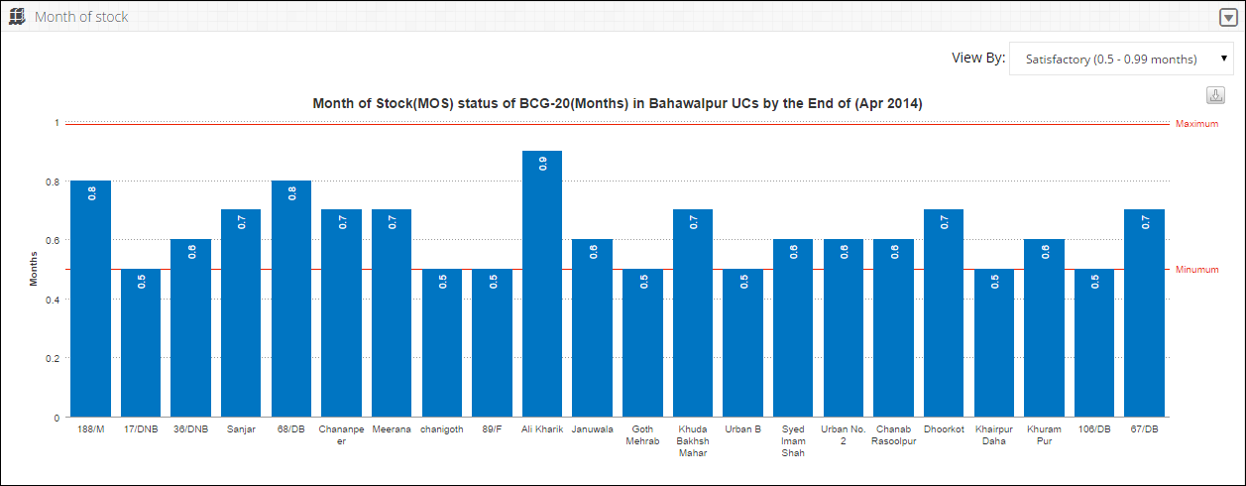

Users can also export charts in JPEG, PNG, PDF and SVG format.



**Consumption Graph**

Routine immunization management dashboard also shows the consumption status of the selected vaccine for each district in the selected province in the form of a bar graph.

Select the **View By** from the drop-down menu.

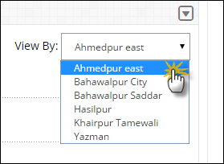

A bar graph for the UCs in the selected region of the district for the selected will be displayed.

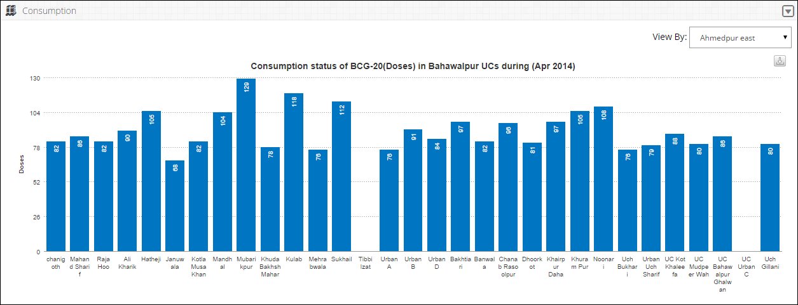

Users can also export charts in JPEG, PNG, PDF and SVG format.



### **Inventory Management**

Inventory management allows users to quickly review reports by clicking on this tab.

* **Stock Status by Item**

Shows the stock status by item for each UC in the selected district.

* **Vaccine vial monitor (VVM) Stage Status**

To show vaccine vial monitor (VVM) stage status at the District level.

* **Stock Status**

To show product wise stock status at the district level e.g. Opening Balance, Receive, Issue and Closing Balance.

* **Month of Stock**

The user can have a bird’s eye view of Month of Stock (MOS) map.

* **Stock Expiry Status**

It shows the stock expiry status pie chart for the selected vaccine.

Users can select the following filters:



* **Reporting Month:** select the reporting month and year from the drop-down list.
* **Vaccines:** select the product from the drop-down list.

Click **Go** to view inventory management dashboard

**Stock Status by Item**

Inventory management dashboard shows the stock status by item for all the districts in the selected province / region. Users can view the pie graph for the stock status (in vials) in each district.



Click the received stock portion of the pie chart to view **Receive From** and **Issue To** list of warehouses.





Users can also export charts in JPEG, PNG, PDF and SVG format.



**Vaccine vial monitor (VVM) Stage Status**

Inventory Management dashboard also allows users to view vaccine vial monitor (VVM) stage status pie chart at the Provincial level. The pie chart will be shown for the selected vaccine and the reporting month for one province / region.



Click on the pie chart to view **VVM Stage Status** list according to the batch.



Users can also export charts in JPEG, PNG, PDF and SVG format.



**Stock Status**

Inventory management dashboard shows the stock status (in doses) for all the vaccine products in the selected district. Users can view the report for the vaccines such as:

* OB (Opening Balance)
* Receive
* Issue
* CB (Closing Balance)



**Month of Stock Map**

Inventory management dashboard also shows month of stock map at the provincial level with the highlighted MOS for the selected district. Users can view the MOS map for the selected month and vaccine.

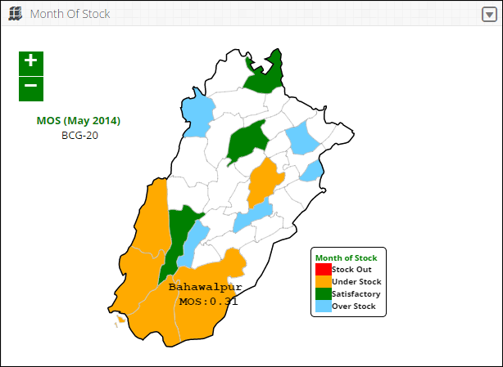

**Stock Expiry Status**

Inventory management dashboard also shows stock expiry status pie chart at the selected district level. Users can view the percentage expiry status of the selected vaccine in months.

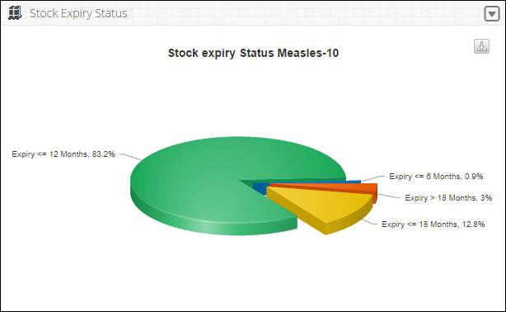

Users can also export the pie chart in JPEG, PNG, PDF and SVG format.



### **Cold Chain Equipment Management**

Cold Chain Equipment Management dashboard allows users to view the cold chain capacity map at the provincial level by clicking on this tab. Cold Chain Capacity will be displayed for the selected province through map.

The user can choose product from the drop-down menu.

* ILR/Refrigerators
* Cold Rooms

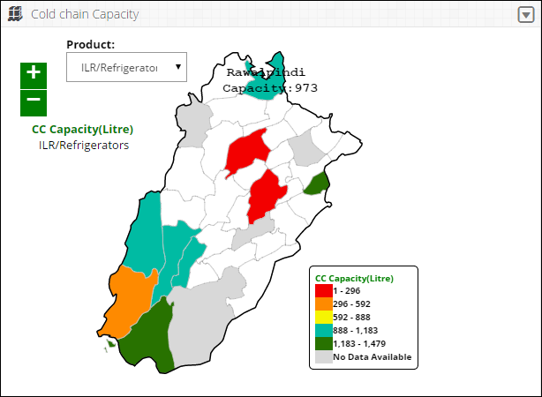

### **Campaign Management**

Campaign Management dashboard allows district level users to view the campaign reports and graphs by clicking on this tab. It will show:

* **Campaign Data Entry Status pie chart**

Shows the data entry stats in the pie chart.

* **Day wise Target vs Coverage bar graph**

The day wise comparison of target versus coverage stats.

* **Missed Children Types bar graph**

This is the comparison graph of defined different missed as well as unreachable list.

* **Campaign vaccines (vials) required in Districts report**

To show the list of each campaign’s vaccines which are used in any or all districts in the specified time span.

Users can select the following filter:



* **Campaign:** select the desired campaign from the drop-down list.

Click **Go** to view campaign management dashboard graphs.

**Data Entry Status**

Campaign management dashboard shows the data entry status for each district in a pie chart. Users can view the reported (Data Entered) and non-reported (Remaining) districts in the chart.



Users can also export charts in JPEG, PNG, PDF and SVG format.



**Day Wise Target vs Coverage**

Campaign management dashboard also shows day wise target vs coverage for the selected campaign at the district level.

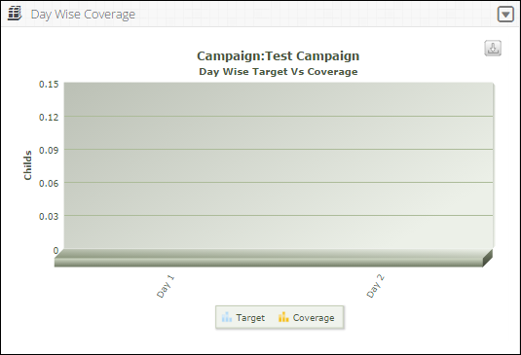

Users can also export charts in JPEG, PNG, PDF and SVG format.



**Missed Children Graph**

Campaign management dashboard also shows different type of the missed or unreachable children in a graphical manner.

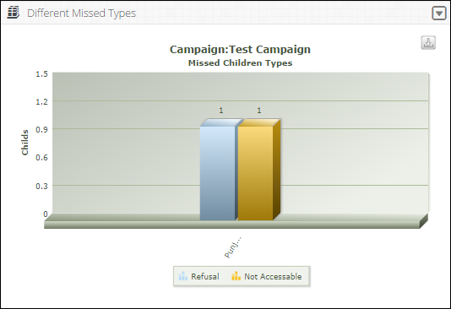

Users can also export charts in JPEG, PNG, PDF and SVG format.



**Campaign Vaccines**

Campaign management dashboard also shows the list of each campaign’s vaccines which are used in any or all UCs in the specified time span.

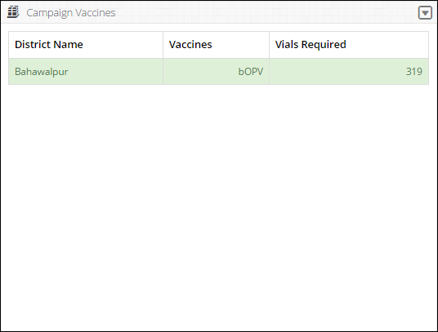

Users can also export charts in JPEG, PNG, PDF and SVG format.



|  |  |
| --- | --- |
| Reports | **5** |
| in Vaccine Logistics Management Information  System | |

This section explains the step-by-step instructions on the reports’ features that can be used by the Vaccine Logistics Management Information system’s users.

# Overview

The Vaccine Logistics Management Information System enables you to login as an authenticated user to view many reports. These users can view analytical reports and stores data for any period using selection filters.

Clicking on **Reports** menu displays the list of Data Reports available in vLMIS including:

**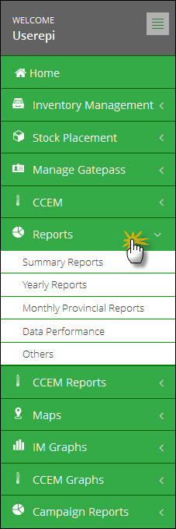**

There are the following different types of report:

* **Summary Reports**: Summary reports provide the summary of stock status and available stock at National and Provincial level.
* **Yearly Reports**: Provide the annual summary of consumption status and available stock of Provincial and District levels.
* **Data Performance**: This report provides the reporting performance summary of warehouses and stores.
* **Others**: provides the stock availability in the Central Provincial Warehouse.

## **Summary Reports**

Click the **Summary Reports** tab to expand the Summary reports as shown in the image below:

**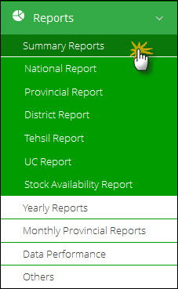**

You can expand and collapse the Summary Reports tab, as required.

### **National Report**

The National Report provides Periodic Consumption, [Average Monthly Consumption](http://115.186.136.214:8081/paklmis_final/plmis_src/reports/content-detail.php?title=pop_amc), Stock on Hand and Months of Stock by each product for a particular month.

Click **National Report** in the menu to open the National Report:

**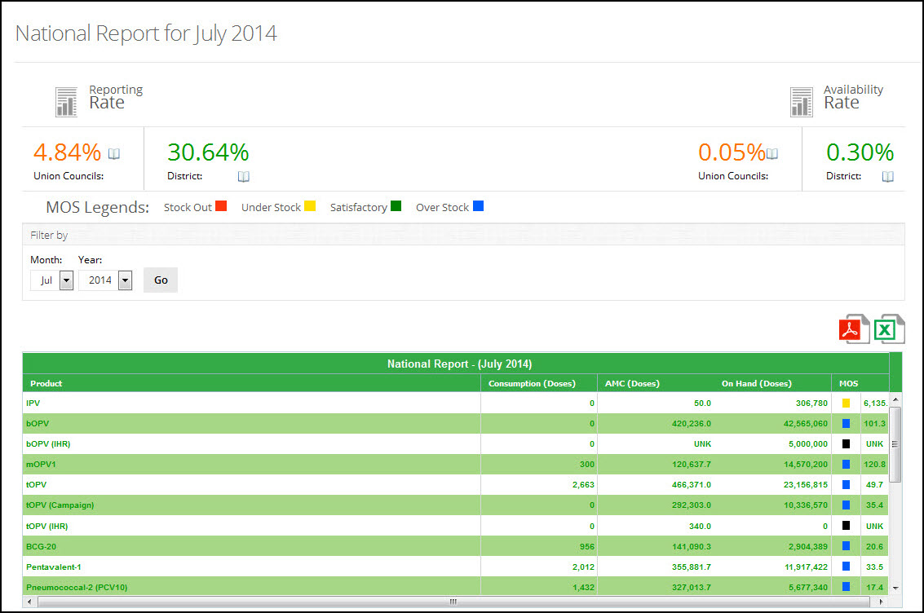**

Use Filter options to filter data in the table below

Table displays National Report of each product

Reporting and Availability Rates are displayed here

The National Summary not only provides the summary statistics but also opens up various options for user to explore further into the data through various links.

The National Report consists of the following screen elements:

**Header bar**

The Header bar displays the **Reporting Rate** of vaccines on the left side and the **Availability Rate** of vaccines on the right side of District and UC.

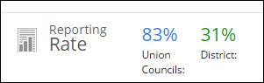

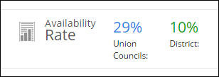

**MOS Legends**

MOS legends display the MOS Stock values:



**Filters**

You can use Month and Year filters to filter values based on Month and Year.

**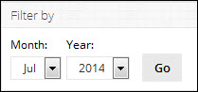**

**Report Table**

* **Products**: displays the list of vaccines.
* **Consumption:** displays the consumption data of vaccines for the last reported month. The data for each vaccine is the sum of all reporting levels.
* **Average Monthly Consumption:** is calculated as average of aggregated consumption of the last three non-zero consumption months.
* **On Hand:** the amount of product on hand in order to monitor stock positions and anticipate stock outs in advance.
* **MOS:** Months of Stock is the estimate of number of months the stock will last. This calculation is based on average monthly consumption.

**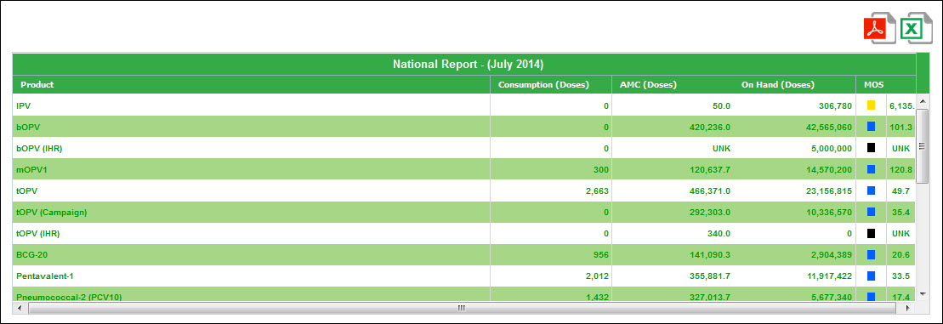**

### **Provincial Report**

The **Provincial Report** displays each province/region’s summary of vaccines consumption and stock availability.

Click **Provincial Report** in the menu to open the ProvincialReport:

**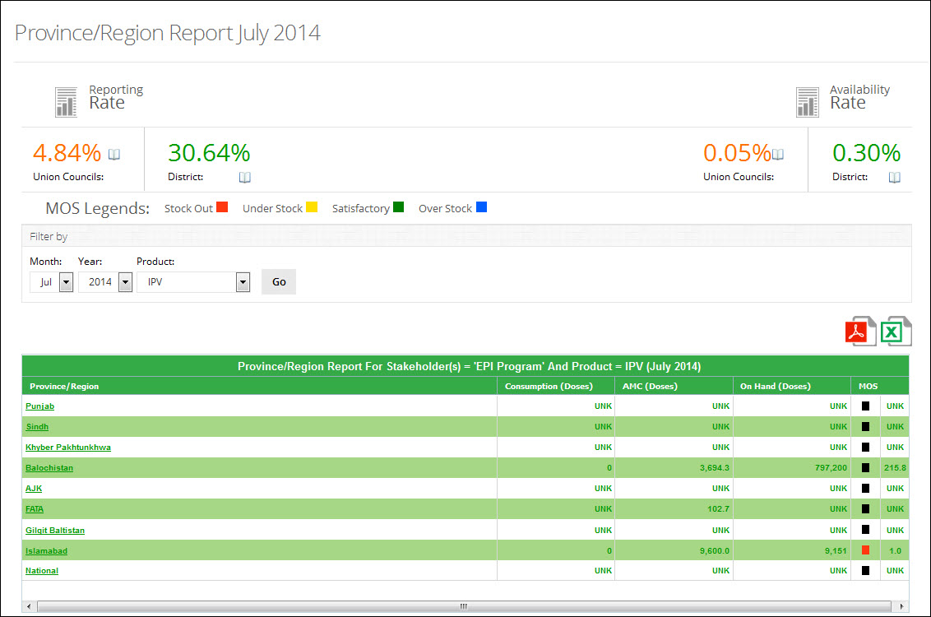**

**Use Filter options to filter data in the table below**

**Table displays Provincial Report for each province / region**

**Reporting and Availability Rates are displayed here**

The Provincial Report can be examined further through the drill down approach of selecting and zoning in the desired data.

The Provincial Report consists of the following screen elements:

**Header bar**

The Header bar displays the **Reporting Rate** of vaccines on the left side and the **Availability Rate** of vaccines on the right side of District and UC.





**MOS Legends**

MOS legends display the MOS Stock values:



**Filters**

You can use **Month**, **Year**, and **Product** filters to filter values in the table.

**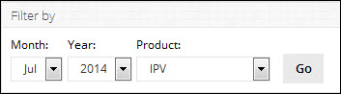**

**Report Table**

* **Province**: displays the list of provinces.
* **Consumption:** displays the consumption data of vaccines for the last reported month. The data for each vaccine is the sum of all reporting levels.
* **Average Monthly Consumption** is calculated as average of aggregated consumption of the last three non-zero consumption months.
* **On Hand:** the amount of product on hand in order to monitor stock positions and anticipate stock outs in advance.
* **MOS:** Month of Stocks is the estimate of number of months the stock will last. This calculation is based on average monthly consumption.  
    
  **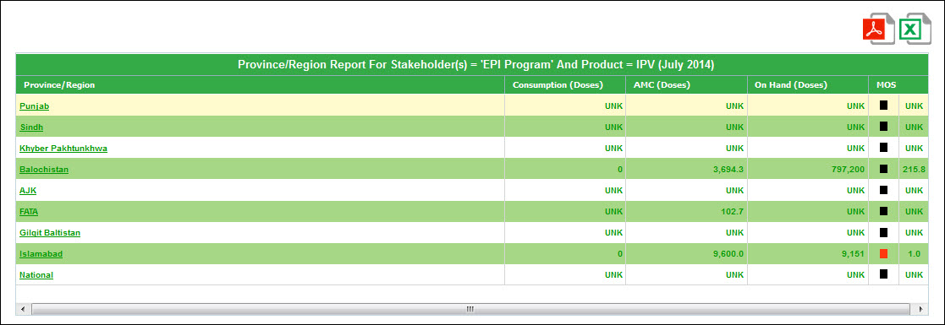**

### **District Report**

The **District Report** displays each District’s summary of vaccines Consumption, Stock Availability, and Months of Stock.

Click **District Report** under Summary Reports tab to open the DistrictReport. The District Report can also be viewed by reviewing the Provincial Reports and then selecting a particular District of interest:

**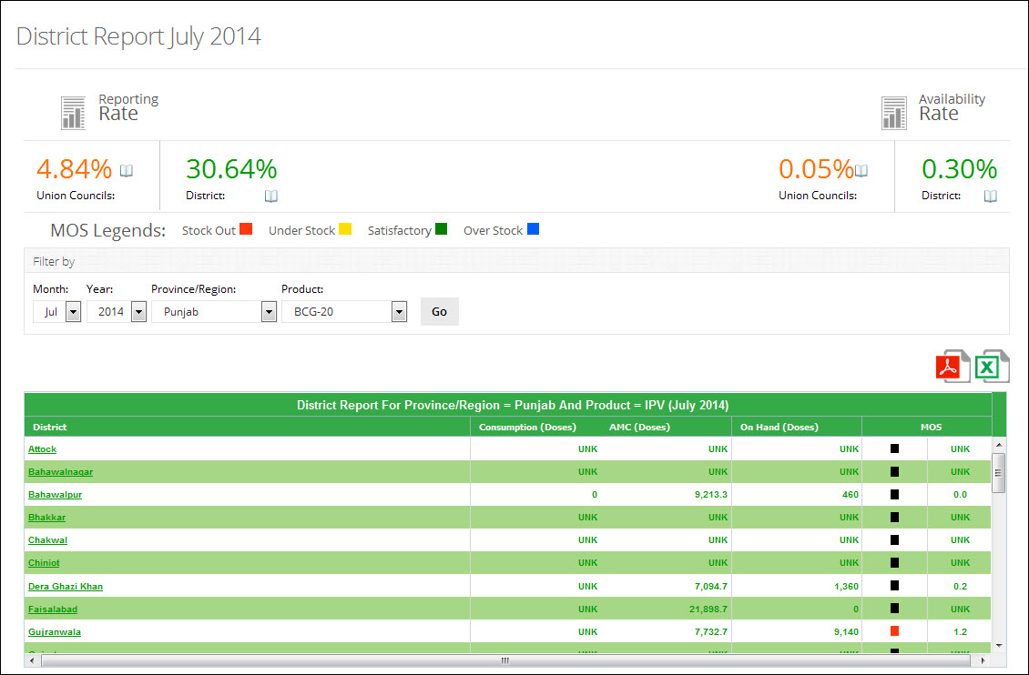**

Table displays District Report for selected product and province.

Reporting and Availability Rates are displayed here

Use Filter options to filter data in the table below

The District Report can be filtered by Province and Product to view the report for Districts in the selected Province.

The District Report consists of the following screen elements:

**Header bar**

The Header bar displays the **Reporting Rate** of vaccines on the left side and the **Availability Rate** of vaccines on the right side of Districts and UCs.





**MOS Legends**

MOS legends display the MOS Stock values:



**Filters**

You can use **Month**, **Year**, **Province/Region** and **Product** filters to filter values in the table.

**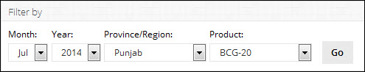**

**Report Table**

* **Products**: displays the list of vaccines.
* **Consumption:** displays the consumption data of vaccines for the last reported month. The data for each vaccine is the sum of all reporting levels.
* **Average Monthly Consumption** is calculated as average of aggregated consumption of the last three non-zero consumption months.
* **On Hand:** the amount of product on hand in order to monitor stock positions and anticipate stock outs in advance.
* **MOS:** Month of Stocks is the estimate of number of months the stock will last. This calculation is based on average monthly consumption.

**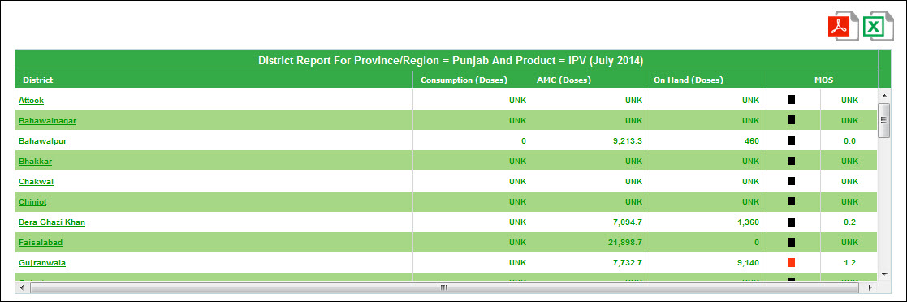**

### **Tehsil Report**

The **Tehsil Report** displays each Tehsil’s summary of vaccines Consumption, Stock Availability, and Months of Stock.

Click **Tehsil Report** under Summary Reports tab to open the TehsilReport. The Tehsil Report can also be viewed by reviewing the Provincial Reports and then selecting a particular Tehsil of interest:

**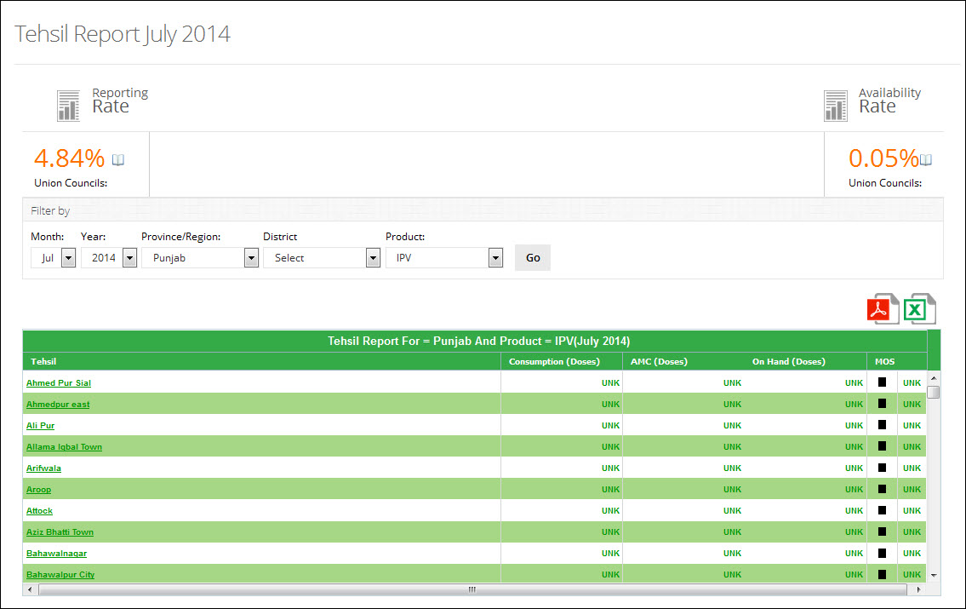**

**Table displays Tehsil Report for the selected product**

**Reporting and Availability Rates are displayed here**

**Use Filter options to filter data in the table below**

The Tehsil Report can be filtered by Province and Product to view the report for Tehsil in each province.

The Tehsil Report consists of the following screen elements:

**Header bar**

The Header bar displays the **Reporting Rate** of vaccines on the left side and the **Availability Rate** of vaccines on the right side of District and UC stores.





**MOS Legends**

MOS legends display the MOS Stock values:



**Filters**

You can use **Month**, **Year**, **Province/Region**, **District** and **Product** filters to filter values in the table.

**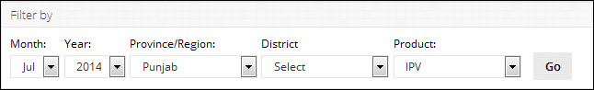**

**Report Table**

* **Products**: displays the list of vaccines.
* **Consumption:** displays the consumption data of vaccines for the last reported month. The data for each vaccine is the sum of all reporting levels.
* **Average Monthly Consumption** is calculated as average of aggregated consumption of the last three non-zero consumption months.
* **On Hand:** the amount of product on hand in order to monitor stock positions and anticipate stock outs in advance.
* **MOS:** Month of Stocks is the estimate of number of months the stock will last. This calculation is based on average monthly consumption.

**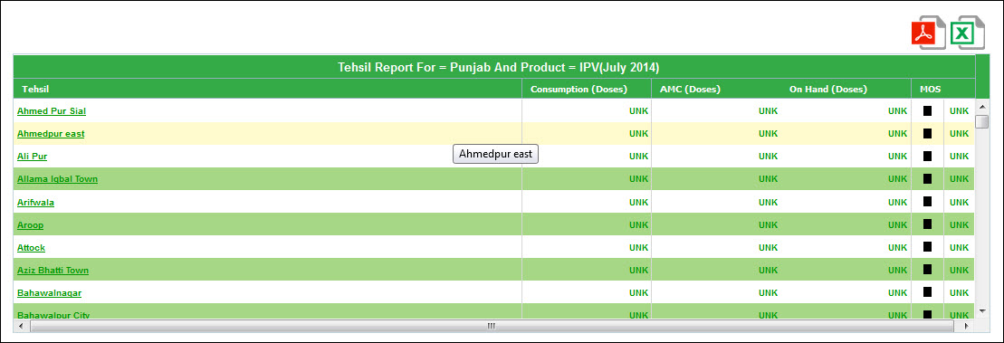**

### **UC Report**

The **UC Report** displays each UC’s summary of vaccines Consumption, Stock Availability, and Months of Stock.

Click **UC Report** under Summary Reports tab to open the UCReport:

**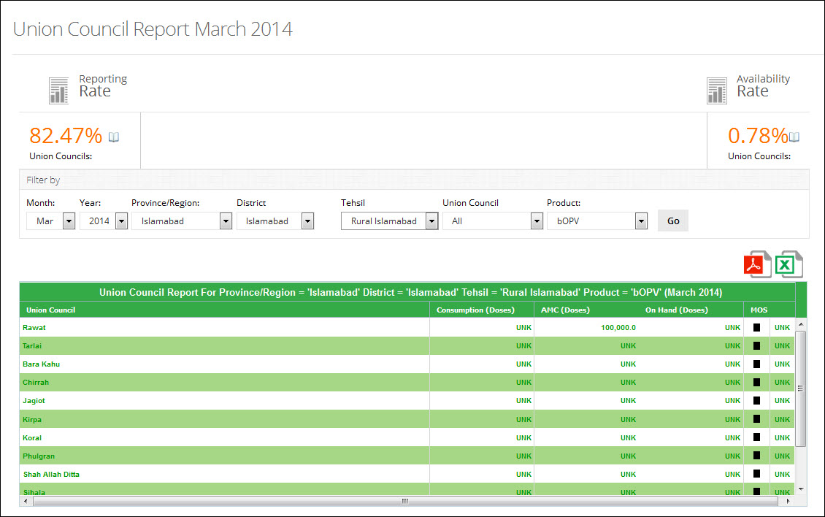**

**Table displays UC Report for the selected product**

**Use Filter options to filter data in the table below**

**Reporting and Availability Rates are displayed here**

The UC Report consists of the following screen elements:

**Header bar**

The Header bar displays the **Reporting Rate** of vaccines on the left side and the **Availability Rate** of vaccines on the right side of District and UC stores.





**MOS Legends**

MOS legends display the MOS Stock values:



**Filters**

You can use **Month**, **Year**, **Province/Region, District, Tehsil, Union Council** and **Product** filters to filter values in the table.

**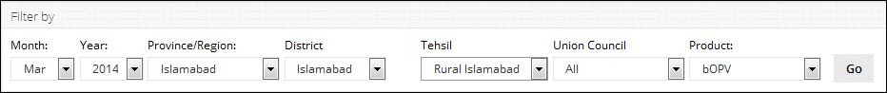**

**Report Table**

* **Products**: displays the list of vaccines.
* **Consumption:** displays the consumption data of vaccines for the last reported month. The data for each vaccine is the sum of all reporting levels.
* **Average Monthly Consumption** is calculated as average of aggregated consumption of the last three non-zero consumption months.
* **On Hand:** the amount of product on hand in order to monitor stock positions and anticipate stock outs in advance.
* **MOS:** Month of Stocks is the estimate of number of months the stock will last. This calculation is based on average monthly consumption.

**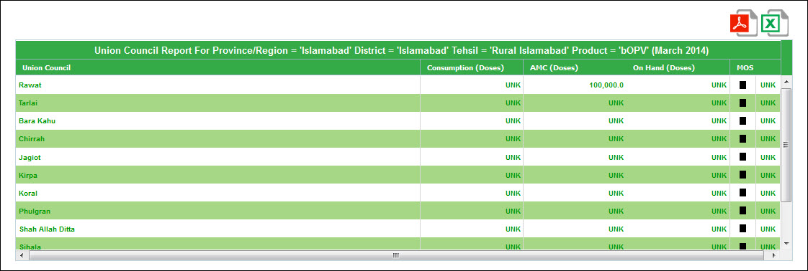**

### **Stock Availability Report**

This report shows the in-country available stock based on the filters applied at all levels of supply chain. Stocks are translated in Months of Stock and calculated from Average Monthly Consumption.

Click **Stock Availability Report** under Summary Report to open the Stock Availability Report.

**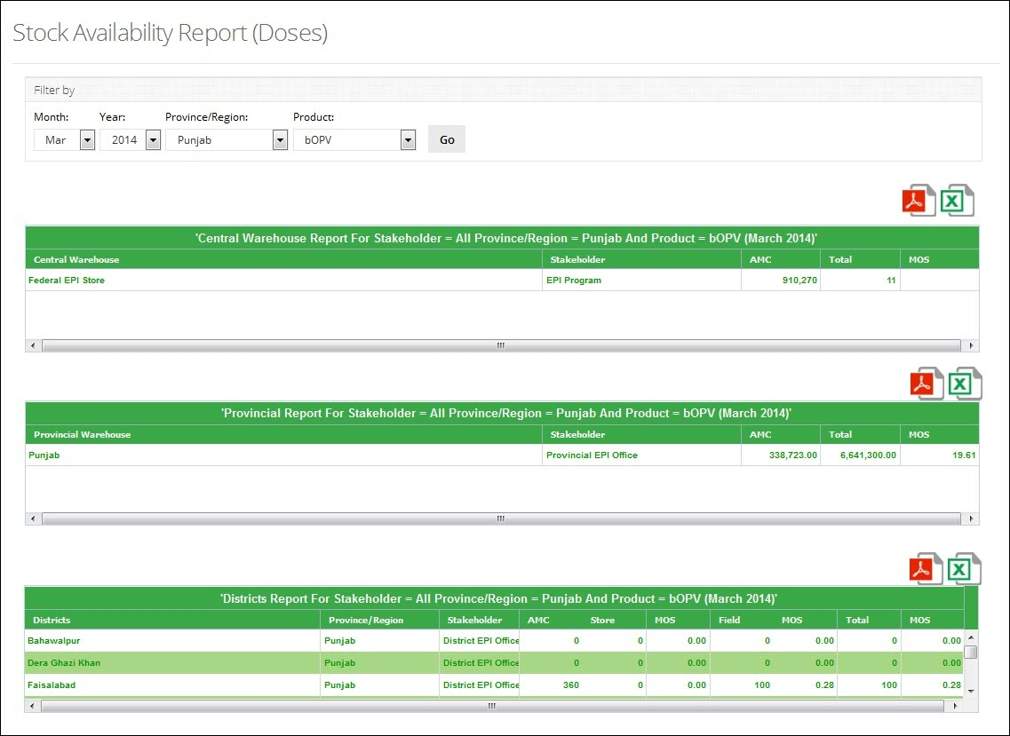**

**Use Filter options to filter data in the table below**

In this report only those warehouses/Districts stores appears who has reported for the period applied to view the report.

The Stock Availability Report consists of the following screen elements:

**Filters**

You can use **Month**, **Year**, **Province/Region** and **Product** filters to filter values in the table.

**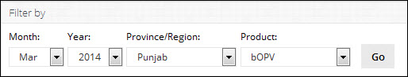**

**Central Warehouse Report Table**

The Central Warehouse Report Table displays the summary of Consumption, Average monthly consumption and MOS for the Central warehouse based on the selected filters in the Filter Table.

**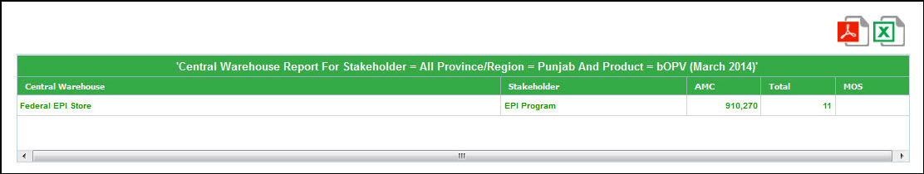**

* **Stakeholder**: displays the stakeholder (EPI Program).
* **Average Monthly Consumption**: average of aggregated consumption of the last three   
  non-zero consumption months.
* **Total:** the total amount of consumed product.
* **MOS:** Month of Stocks is the estimate of number of months the stock will last. This calculation is based on average monthly consumption.

**Provincial Warehouse Report Table**

The Provincial Warehouse Report Table displays the summary of Consumption, Average monthly consumption and MOS for the Provincial Warehouse based on the selected Province in the Filter Table.

**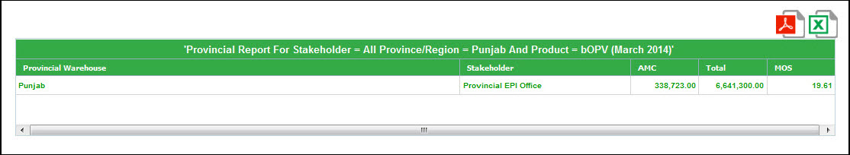**

* **Stakeholder**: displays the stakeholder (EPI Program).
* **Average Monthly Consumption**: average of aggregated consumption of the last three   
  non-zero consumption months.
* **Total:** the total amount of consumed product in the province.
* **MOS:** Month of Stocks is the estimate of number of months the stock will last. This calculation is based on average monthly consumption.

**District Warehouse Report Table**

The District Warehouse Report Table displays the summary of Consumption summary of store and field for each district in the selected Province.

**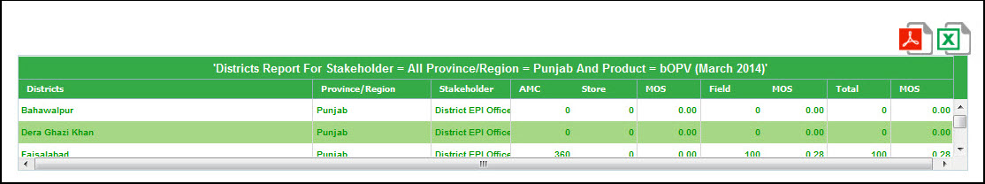**

* **District**: displays the districts if the selected Province.
* **Province**: displays the Province.
* **Stakeholder**: displays the stakeholder (EPI Program).
* **AMC**: average of aggregated consumption of the last three non-zero consumption months for the district store.
* **Store**: the consumption of the district store.
* **MOS**: Months of Stock is the estimate of number of months the stock will last in district store. This calculation is based on average monthly consumption.
* **Field**: the consumption of vaccines in field.
* **MOS:** Months of Stock is the estimate of number of months the stock will last in field. This calculation is based on average monthly consumption.
* **Total:** the total amount of consumed product in the district for district store and field.
* **MOS:** Months of Stock is the estimate of number of months the stock will last. This calculation is based on average monthly consumption.

## **Yearly Reports**

Click the **Yearly Reports** tab to expand the Yearly Reports as shown in the image below:

**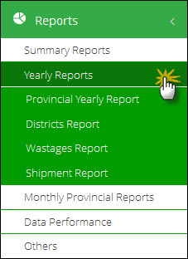**

You can expand and collapse the Yearly Reports tab, as required.

### **Provincial Yearly Report**

This report provides Provincial yearly report month-wise based on the indicator and the selected year. There are three main indicators that can be viewed i.e. Issued (Consumption), Stock on Hand and received. User can filter report on the basis of month, stakeholder and Province/Region.

Click **Provincial Report** under Yearly Report to open the Provincial Report.

**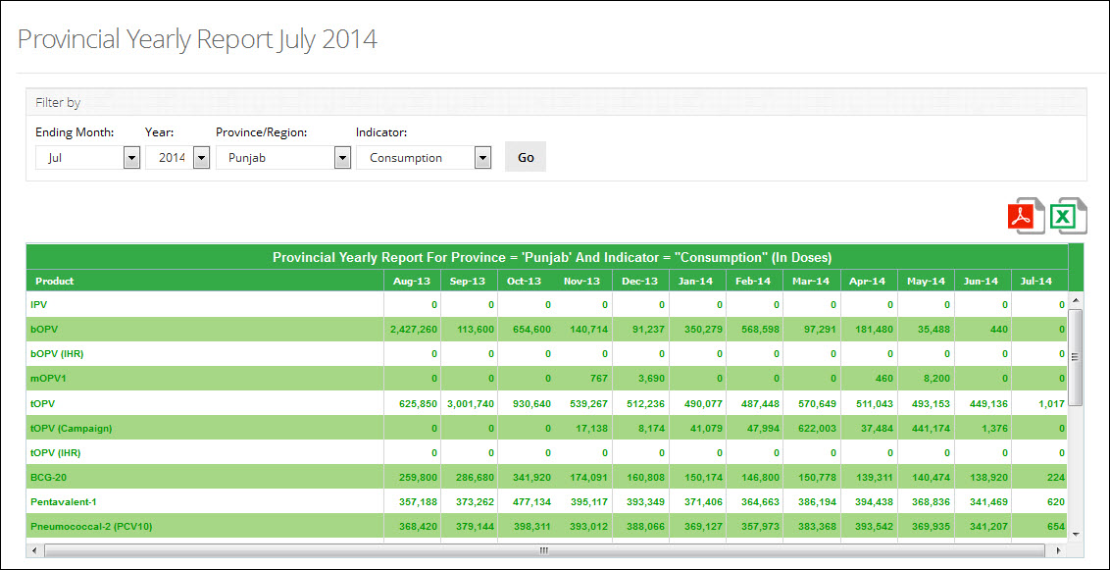**

**Use Filter options to filter data in the table below**

**Filters**

You can use **Month**, **Year**, **Province/Region** and **Indicator** filters to filter values in the table:

**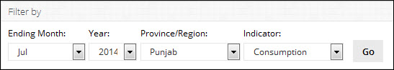**

**Report Table**

**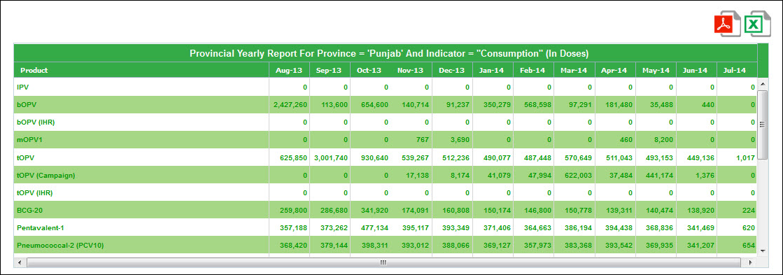**

### **District Report**

This report provides District’s Yearly Summary of consumption. The consumption summary is displayed month-wise based on the indicator and the selected year. There are three main indicators that can be viewed i.e. Issued (Consumption), Stock on Hand and received. User can filter report on the basis of Year, Province/Region and Product.

Click **District Report** under Yearly Report to open the District Report.

**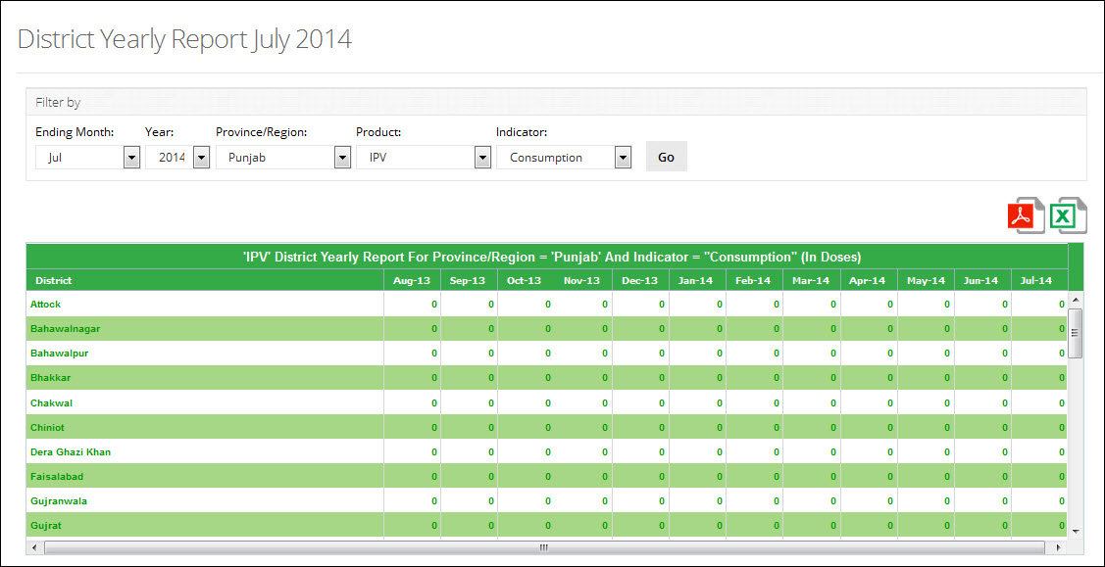**

**Table displays District Report of the selected product**

**Use Filter options to filter data in the table below**

**Filters**

You can use **Month**, **Year**, **Province/Region**, **Product** and **Indicator** filters to filter values in the table:

**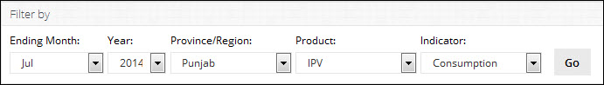**

**Report Table**

**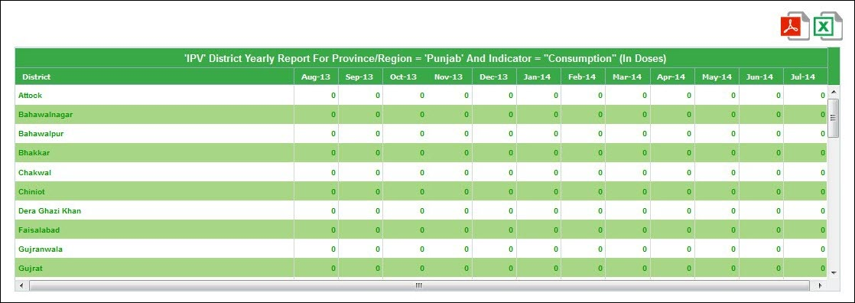**

### **Wastage Report**

This report provides District’s Yearly Summary of wastage and reporting rate. It provides a report for the calculated wastages of each product. This is calculated by comparing the used percentage of a product with a predefined acceptance wastage percentage which is unique for each product.

There is a filter to view wastages of products province wise individually or all provinces collectively. System provides an option to export report to PDF and Excel format.

Application provides product-wise wastage report for each district. User will be able to filter wastage of any product at any location level i.e. district, tehsil store or health facility. Screen below shows the wastage report. The entries colored red are those which exceed the acceptance limit percentage.

**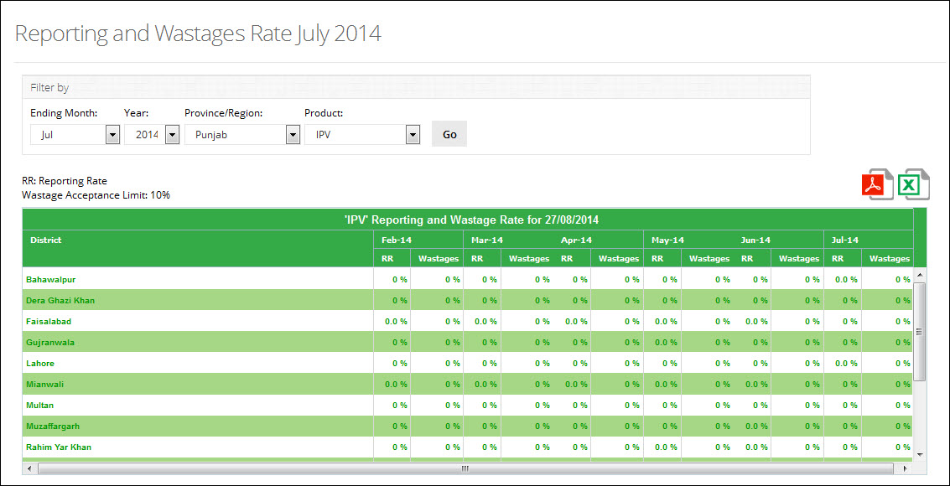**

**Table displays Wastage Report of the selected product**

**Use Filter options to filter data in the table below**

**Filters**

You can use **Ending Month**, **Year**, **Province/Region** and **Product** filters to filter values in the table:

**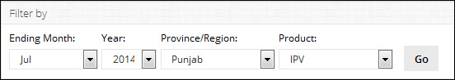**

**Report Table**

**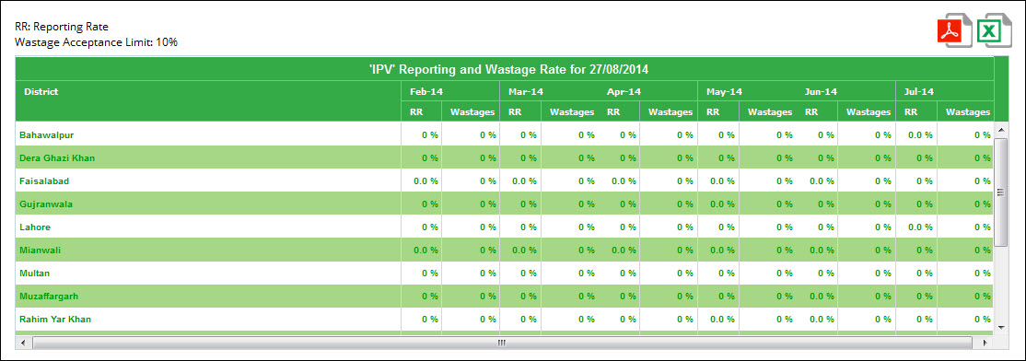**

### **Shipment Report**

This report provides a yearly summary of warehouse shipment report. It provides a report of all issued and received stock province and national. It gives the status of issued stock i.e. received or pending and a detail of each voucher.

Report provides a detailed view of all transactions showing the stores to which the stock is issued, or from where it is received. Detail view shows a status transactions to provide the user with latest updated on issued/received transaction.

It also provides information of each transaction voucher containing the detail of products that were issued/received in a particular transaction.

This report provides a dynamic filter of year which will show last six months of the selected ending year. It also shows filters to view stock transactions based on store types i.e. central, provincial, district and tehsil.

Click **Shipment Report** under Yearly Report to open the desired Report.

**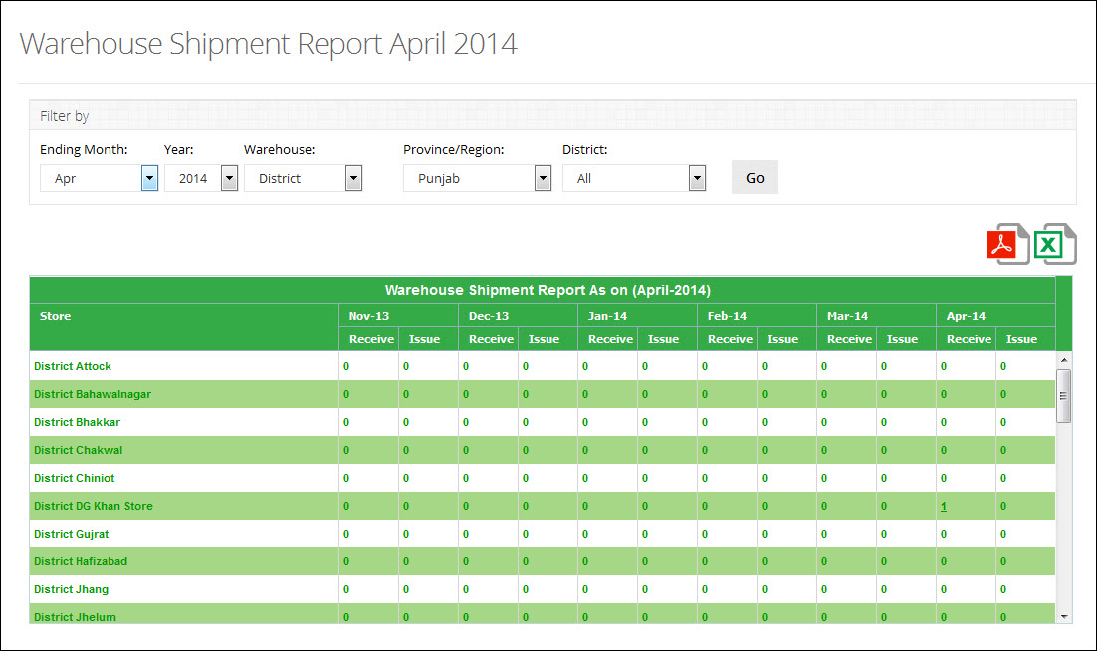**

**Table displays Shipment Report of the selected product**

**Use Filter options to filter data in the table below**

Below screenshot shows the report grid with transaction count in a particular month for every store.

**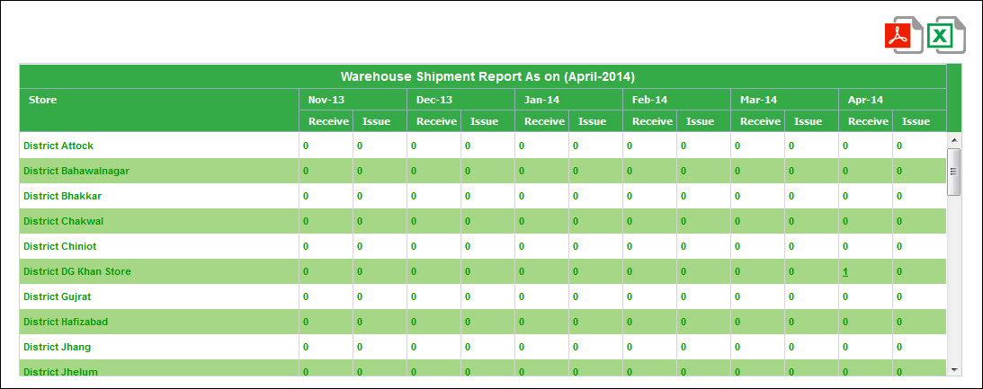**

**Transaction Details**

On clicking the number of received stock in the month of February, the report shows a detail of transactions containing the store where the stock transaction was done.

**Voucher Details**

Transaction Voucher will be shown when a user clicks the transaction number this voucher can be used for reference.

## **Monthly Provincial Reports**

Click Monthly Provincial Reports tab to expand the options as shown in the image below:

**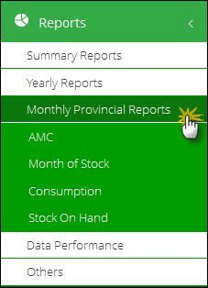**

You can expand and collapse the monthly provincial reports tab, as required.

### **AMC**

This report shows the provincial/regional store’s average monthly consumption in a particular month. User can select Month and Year filters to view AMC (Average Monthly Consumption) in each province/region for every product. This report is a good monitoring tool for Mangers at Provincial and Federal level to view the average consumption for each month.

**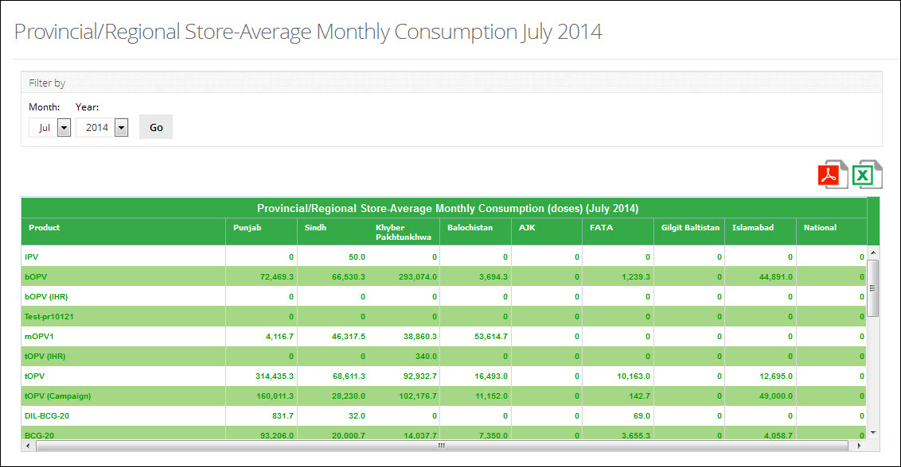**

**Table displays AMC Report of the selected month**

**Use Filter options to filter data in the table below**

### **Month of Stock**

This report shows the provincial/regional store MOS in a particular month. User can select Month and see the month of stock statistics for each product in the province/region.

**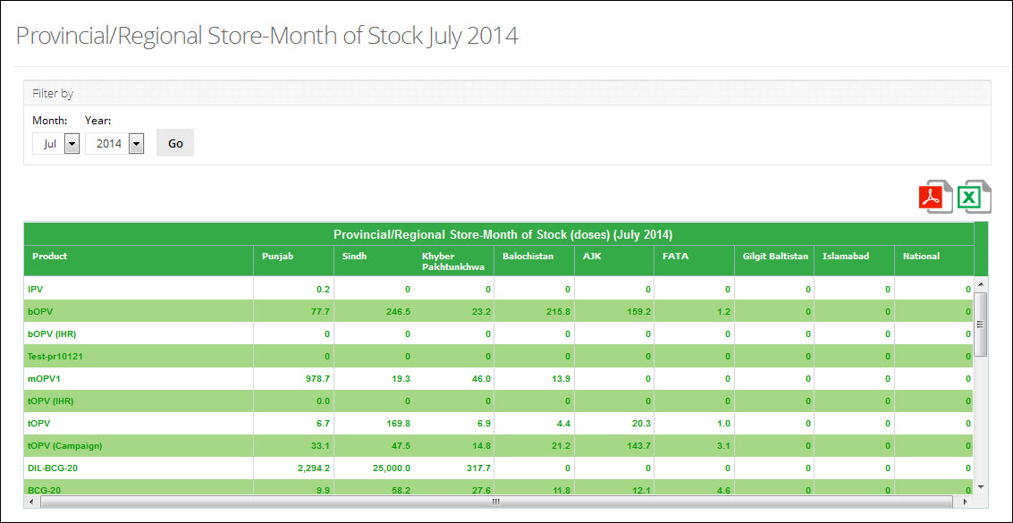**

**Table displays Month of Stock Report of the selected month**

**Use Filter options to filter data in the table below**

### **Consumption**

This report shows the provincial/regional store’s stock consumption in a particular month. User can select Month and Year filters to view stock consumption in each province/region for every product.

**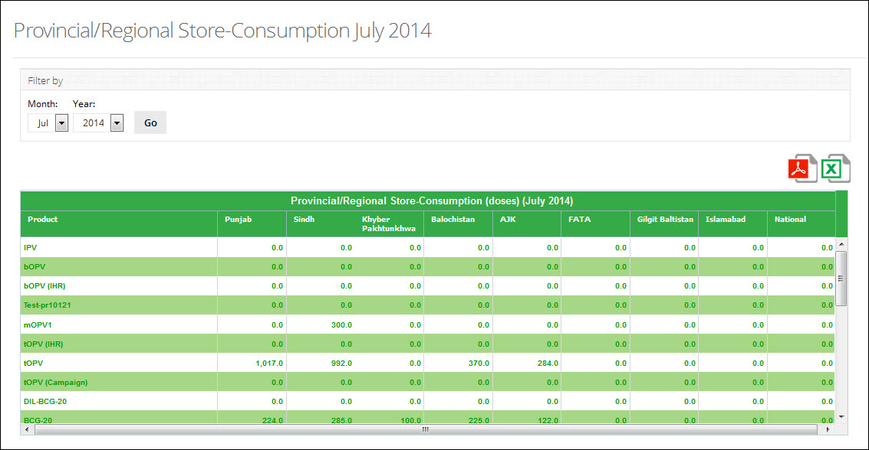**

**Table displays Consumption Report of the selected month**

**Use Filter options to filter data in the table below**

### **Stock on Hand**

This report shows the stock on hand statistics for each province/region in a particular month. Users can select Month and Year to show the stock on hand report.

**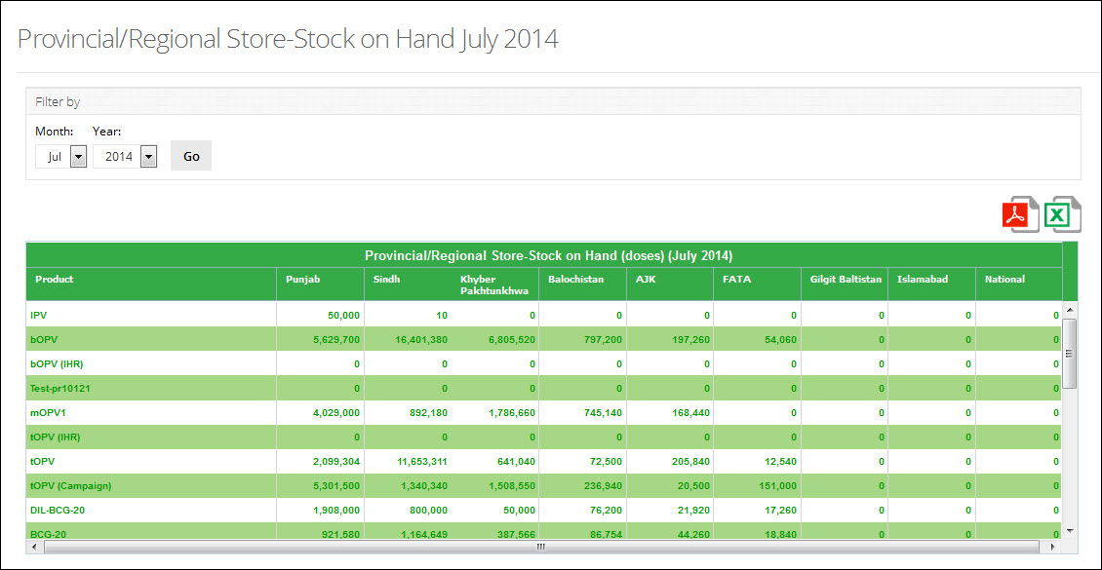**

**Table displays Stock on Hand Report of the selected month**

**Use Filter options to filter data in the table below**

## **Data Performance**

Click **Data Performance** tab to expand the Non Reported Districts Report as shown in the image below:

**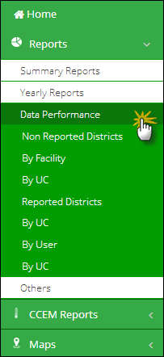**

You can expand and collapse the Data Performance tab, as required.

### **Reported Provinces**

This report shows the number of reported UCs of different warehouses and stores for last six months in a Province. User can select Month and Year to show total and reported UCs in each province. This report is a good monitoring tool for Mangers at Provincial and Federal level to view the information about non-reported districts.

**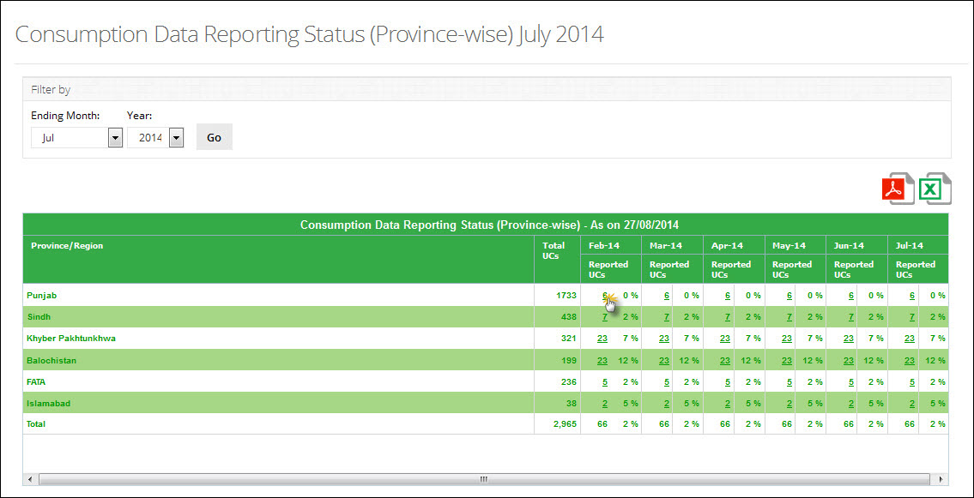**

**Table displays Consumption Data Report for Provinces**

**Use Filter options to filter data in the table below**

Click reported UCs count for each province to open the reported districts by UC in another tab.

**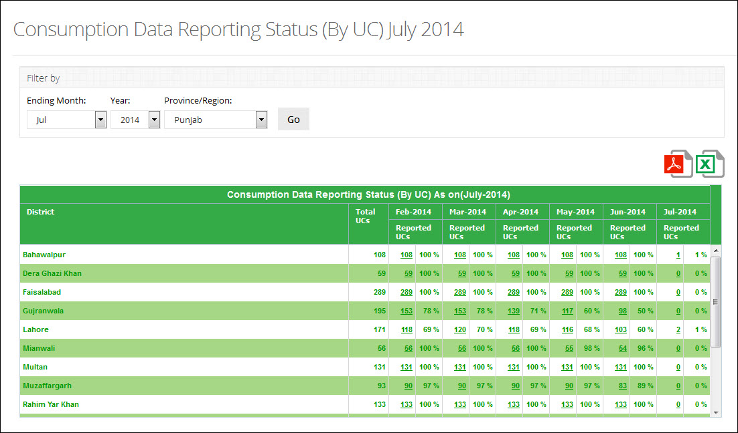**

**Table displays Consumption Data Report for Districts**

**Use Filter options to filter data in the table below**

### **Non Reported Districts**

This report shows the non-reported warehouses and stores of a district in a particular month. User can select Month, Year, Province/Region and District. This report is a good monitoring tool for Mangers at Provincial and Federal level to view the information about non-reported districts. This report shows:

1. Total Warehouses
2. Total Non-Reported Warehouses
3. Reporting Rate

The report can be further refined by selecting the following filters:

1. By Facility
2. By UC

#### **By Facility**

This report shows a detail of total and non-reported facilities within a province. It also shows an aggregate of the percentage reported facilities at the end. A line graph is provided that shows consumption of a district over the last six months. A detail of non-reported facilities is also provided, which shows both reported and non-reported facilities.

**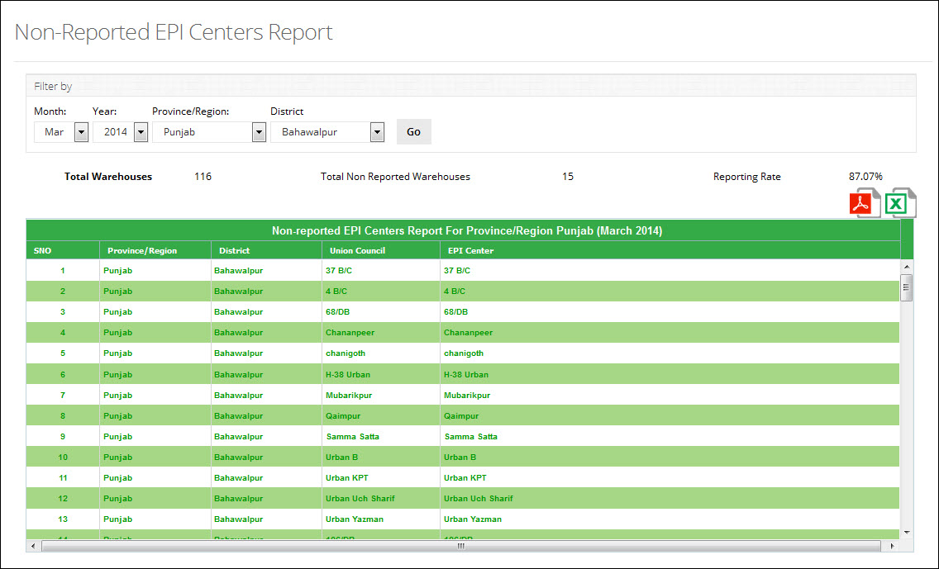**

**Table displays Non Reported EPI Centers Report**

**Use Filter options to filter data in the table below**

#### **By Union Council**

This report shows a detail of total and non-reported UCs within a province. It also shows an aggregate of the percentage reported UCs at the end. A line graph is provided that shows consumption of a district over the last six months. A detail of non-reported UCs is also provided, which shows both reported and non-reported.

**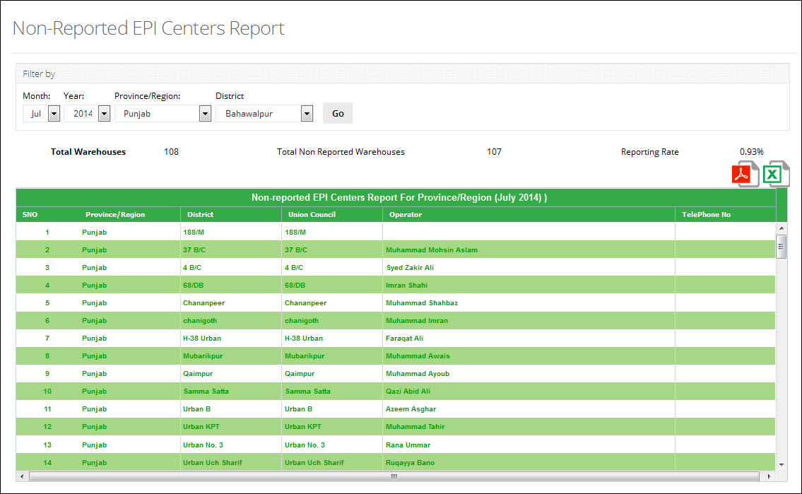**

**Table displays Non Reported EPI Centers Report**

**Use Filter options to filter data in the table below**

### **Reported Districts**

This report shows the reporting rate of different warehouses and stores in a particular month. User can select Month, Year and Province/Region. This report is a good monitoring tool for Mangers at Provincial and Federal level to view the information about non-reported districts. The report can be further refined by selecting the following filters:

1. By UC
2. By User
3. By Facility

#### **By Union Council**

This report shows a detail of total and reported UCs within a province. It also shows an aggregate of the percentage reported UCs at the end. A line graph is provided that shows consumption of a district over the last six months. A detail of reported UCs is also provided, which shows both reported and non-reported.

**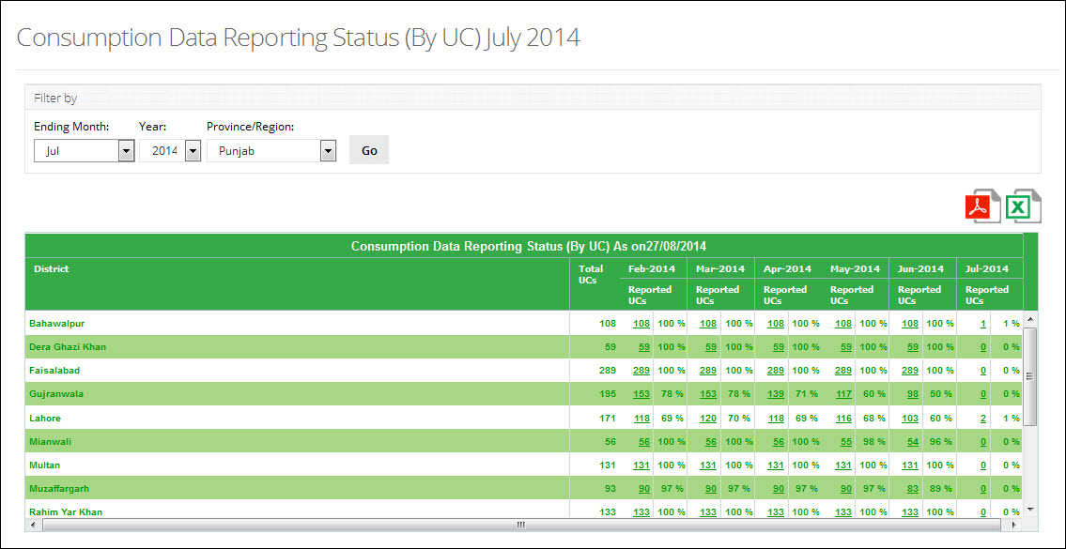**

**Table displays Consumption Data Status Report**

**Use Filter options to filter data in the table below**

#### **By User**

This report shows a detail of total and reported UC Users within a province. It also shows an aggregate of the percentage reported users at the end. A line graph is provided that shows consumption of a district over the last six months. A detail of reported users is also provided, which shows assigned UCs to that users and also user details both reported and non-reported.

**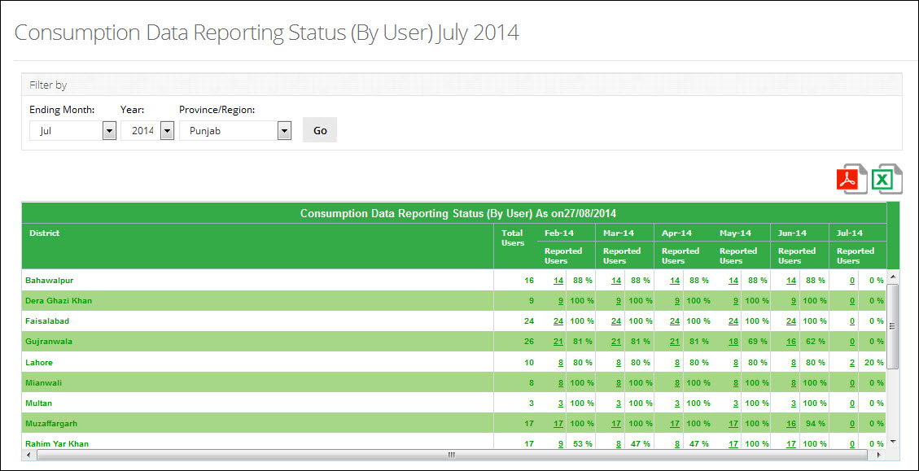**

**Table displays Consumption Data Status Report**

**Use Filter options to filter data in the table below**

#### **By Facility**

This report shows a detail of total and reported facilities within a province. It also shows an aggregate of the percentage reported facilities at the end. A line graph is provided that shows consumption of a district over the last six months. A detail of reported facilities is also provided, which shows both reported and non-reported facilities.

**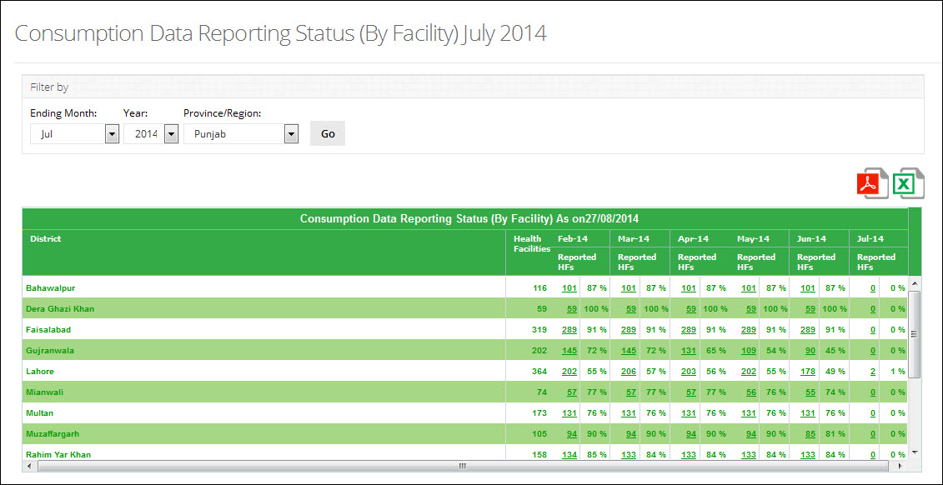**

**Table displays Consumption Data Status Report**

**Use Filter options to filter data in the table below**

## **Others**

Click **Others** tab to expand the Central Provincial Warehouse Yearly Report as shown in the image below:

**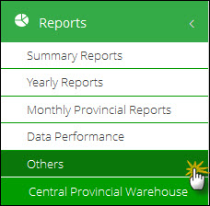**

You can expand and collapse the **Others** tab, as required.

**Federal Provincial Warehouse**

This report shows the monthly values of different inventory indicators i.e. Issued, Stock on Hand and received stock of public/private stakeholder’s central or provincial warehouse / stores. User can filter report on the basis of month, stakeholder and type of store i.e. Provincial and Central warehouse.

Click **Central/Provincial** under **Others** to open the Central/Provincial Warehouse Report.

**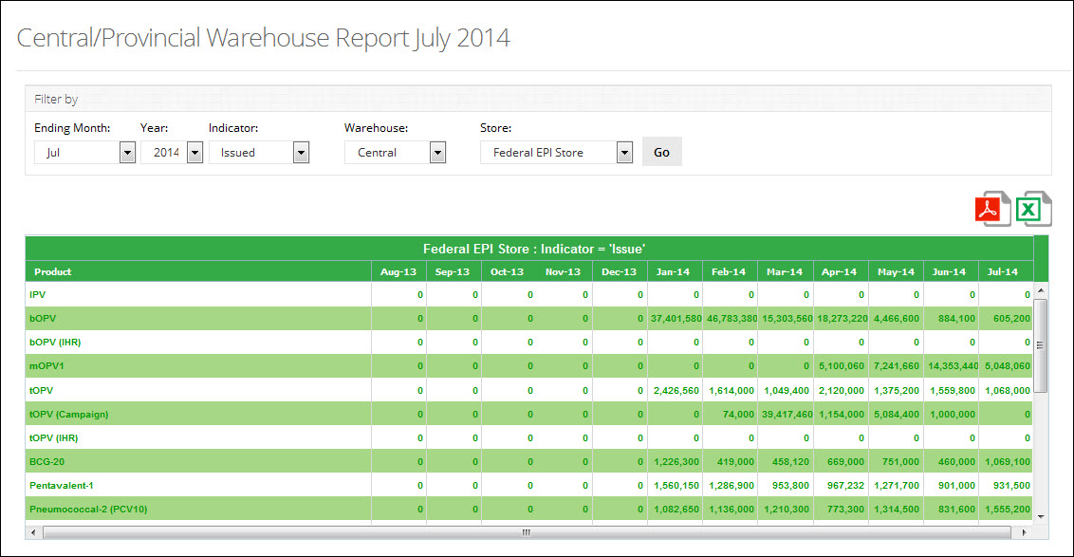**

**Table displays Central/Provincial Warehouse Report**

**Use Filter options to filter data in the table below**

# CCEM Reports

The CCEM Reports section provides a list of frequently used reports that are generated quickly at the central level to help national cold chain managers to analyze the cold chain equipment. All CCEM reports can be found in the main menu which can be generated for a regional subset or a select health facility type.

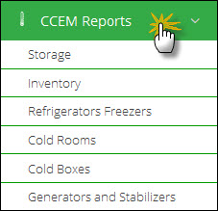

## **Storage**

The storage menu can be viewed by selecting the “Storage” tab in the sub-menu. The drop down menu will be displayed as follows:

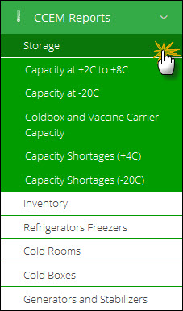

#### **Capacity at +2c to +8c**

User can select following filters according to their requirements. Available filters are as follows:

1. Facility Type
2. Office
3. Province
4. District

Click **Search.**

**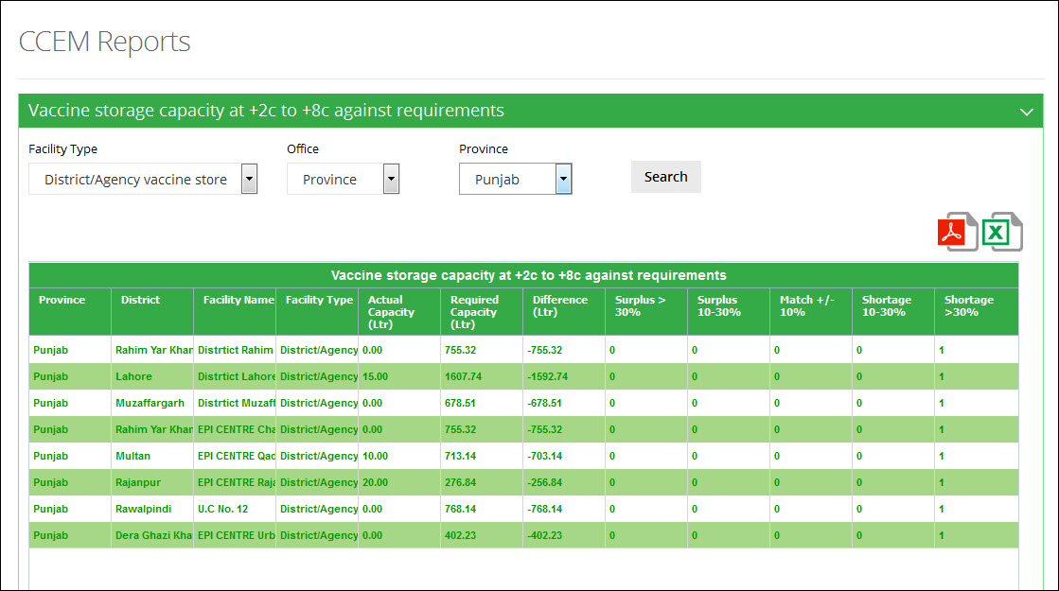**

**Use Filter options to filter data in the table below**

#### **Capacity at -20c**

User can select following filters according to their requirements. Available filters are as follows:

1. Facility Type
2. Office
3. Province
4. District

Click **Search.**

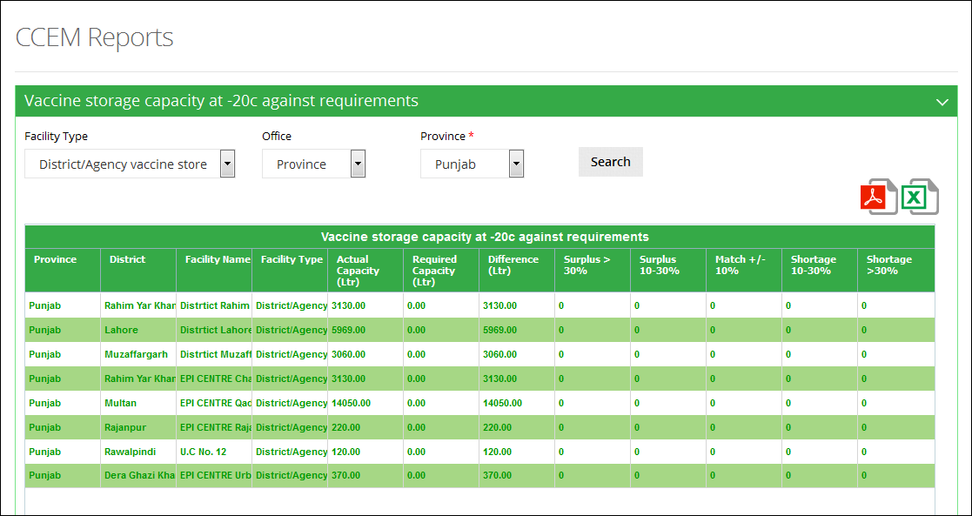

**Use Filter options to filter data in the table below**

#### **Cold-box and Vaccine Carrier Capacity**

User can select following filters according to their requirements. Available filters are as follows:

1. Facility Type
2. Office
3. Province
4. District

Click **Search.**

**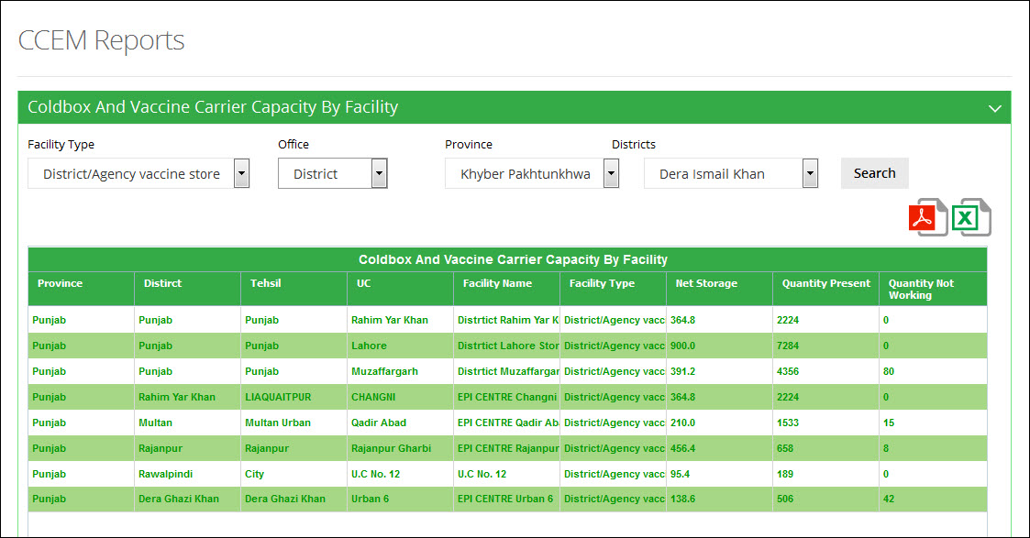**

**Use Filter options to filter data in the table below**

#### **Capacity Shortages (+4C)**

User can select following filters according to their requirements. Available filters are as follows:

1. Facility Type
2. Office
3. Province
4. District

Click **Search.**

**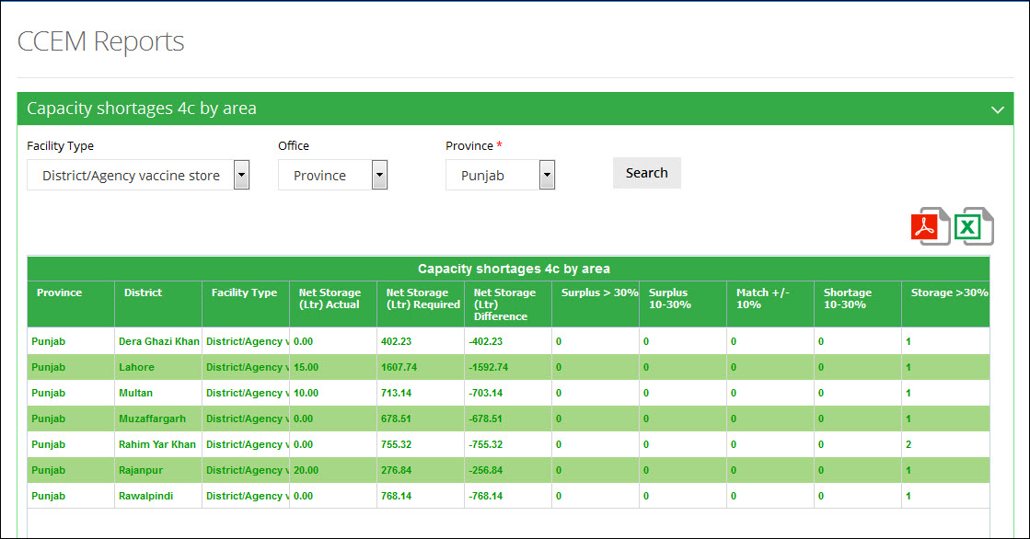**

**Use Filter options to filter data in the table below**

#### **Capacity Shortages (-20C)**

User can select following filters according to their requirements. Available filters are as follows:

1. Facility Type
2. Office
3. Province
4. District

Click **Search.**

**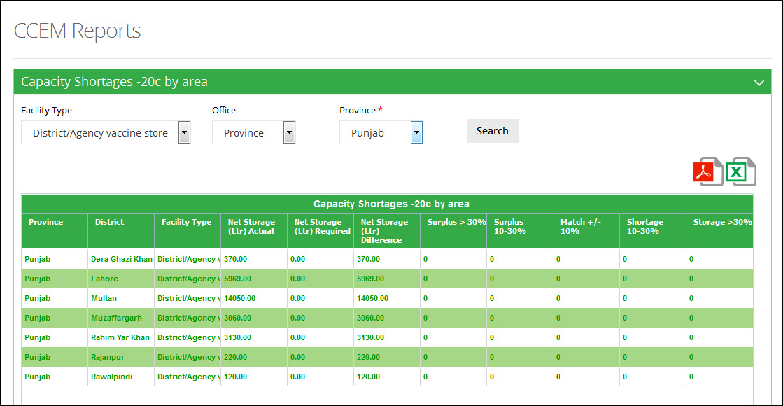**

**Use Filter options to filter data in the table below**

## **Inventory**

The inventory menu can be viewed by selecting the “Inventory” tab in the sub-menu. The drop down menu will be displayed as follows:

**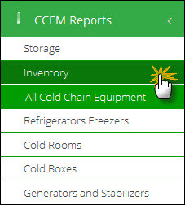**

#### **All Cold Chain Equipment**

User can select following filters according to their requirements. Available filters are as follows:

1. Facility Type
2. Office
3. Province
4. District

Click **Search.**

**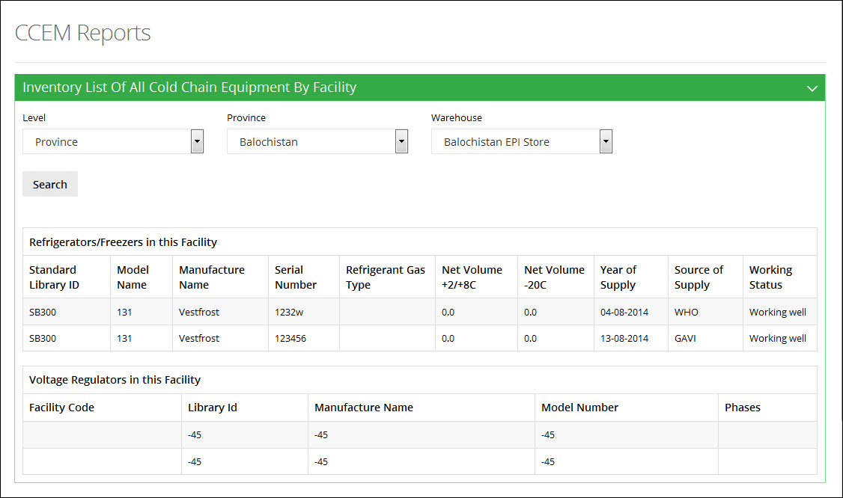**

**Use Filter options to filter data in the table below**

## **Refrigerators Freezers**

The refrigerators freezers menu can be viewed by selecting the “Refrigerators Freezers” tab in the sub-menu. The drop down menu will be displayed as follows:

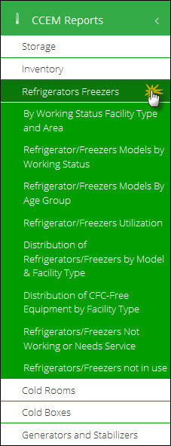

#### **By Working Status Facility Type and Area**

User can select following filters according to their requirements. Available filters are as follows:

1. Facility Type
2. Office
3. Province
4. District

Click **Search.**

A report for refrigerator/freezers according to the working status, facility type and area will be displayed.

**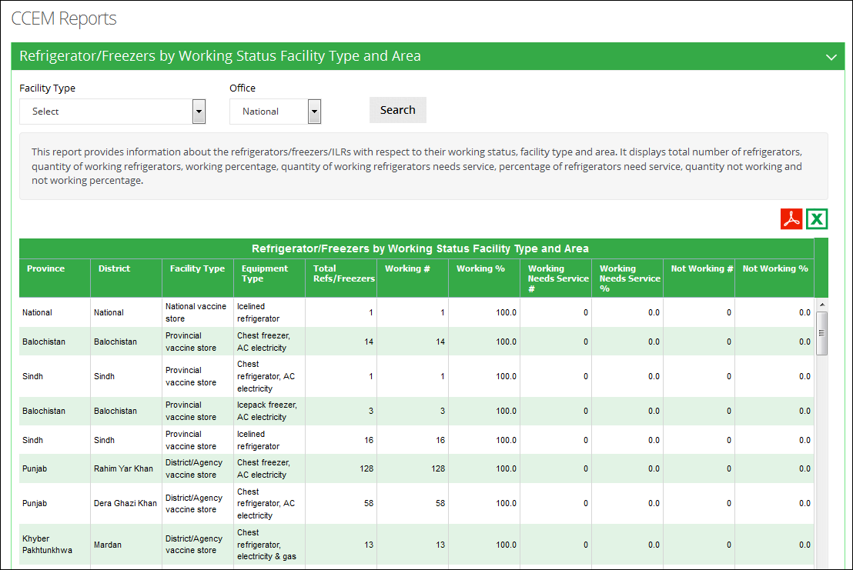**

**Use Filter options to filter data in the table below**

#### **Refrigerators/Freezers Models by Working Status**

User can select following filters according to their requirements. Available filters are as follows:

1. Facility Type
2. Office
3. Province
4. District

Click **Search.**

A report for the refrigerator/freezers models available according to the working status is displayed.

**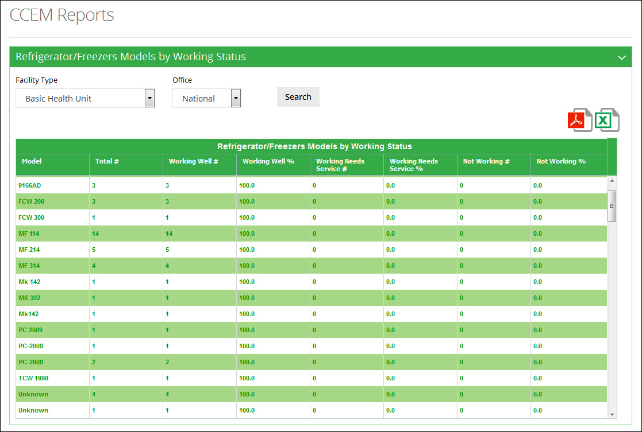**

**Use Filter options to filter data in the table below**

#### **Refrigerators/Freezers Models by Age Group**

User can select following filters according to their requirements. Available filters are as follows:

1. Facility Type
2. Office
3. Province
4. District

Click **Search.**

A report for refrigerator/freezers models according to the age group will be displayed.

**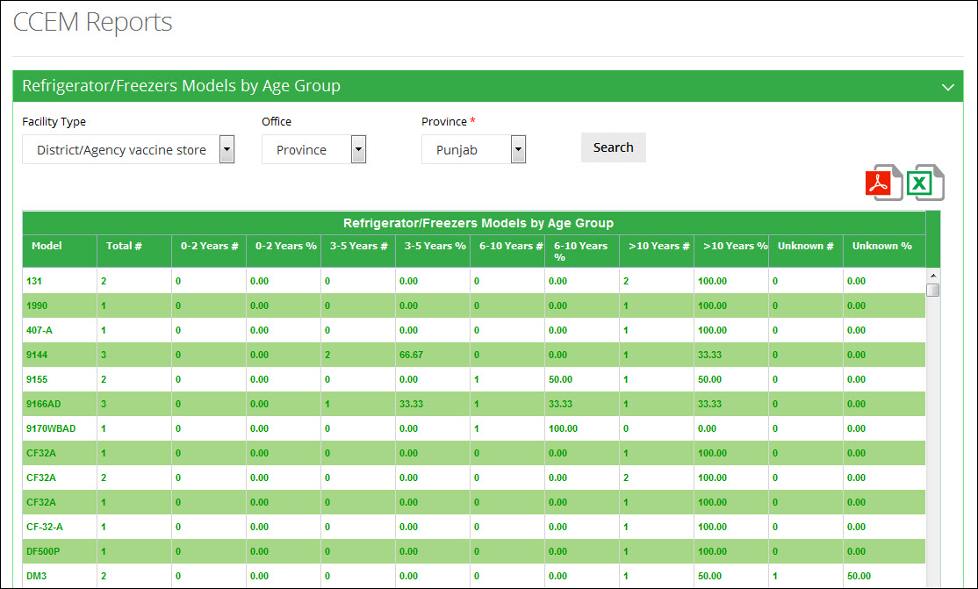**

**Use Filter options to filter data in the table below**

#### **Refrigerators/Freezers Utilization**

User can select following filters according to their requirements. Available filters are as follows:

1. Facility Type
2. Office
3. Province
4. District

Click **Search.**

A report about the utilization of refrigerator/freezers in the selected province / district will be displayed.

**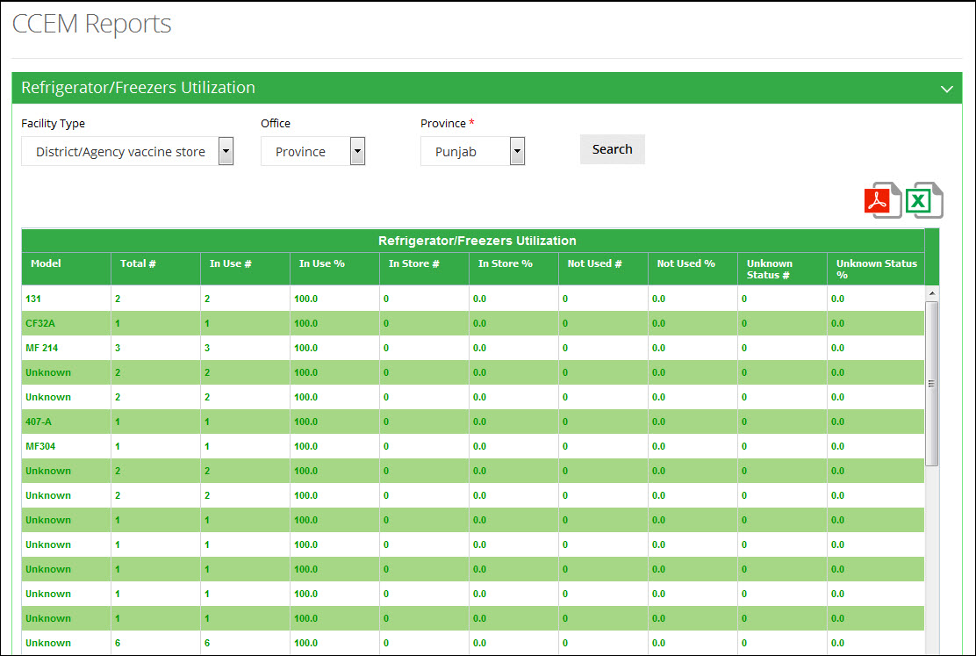**

**Use Filter options to filter data in the table below**

#### **Distribution of Refrigerators/Freezers by Model & Facility Type**

User can select following filters according to their requirements. Available filters are as follows:

1. Office
2. Province

Click **Search.**

A report for the distribution of refrigerator/freezers according to the model and facility type will be displayed.

**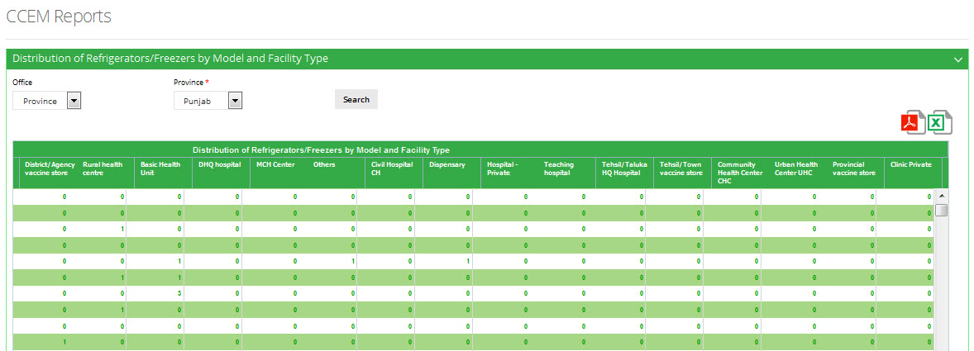**

#### **Distribution of CFC-Free Equipment by Facility Type**

User can select following filters according to their requirements. Available filters are as follows:

1. Facility Type
2. Office
3. Province
4. District

Click **Search.**

**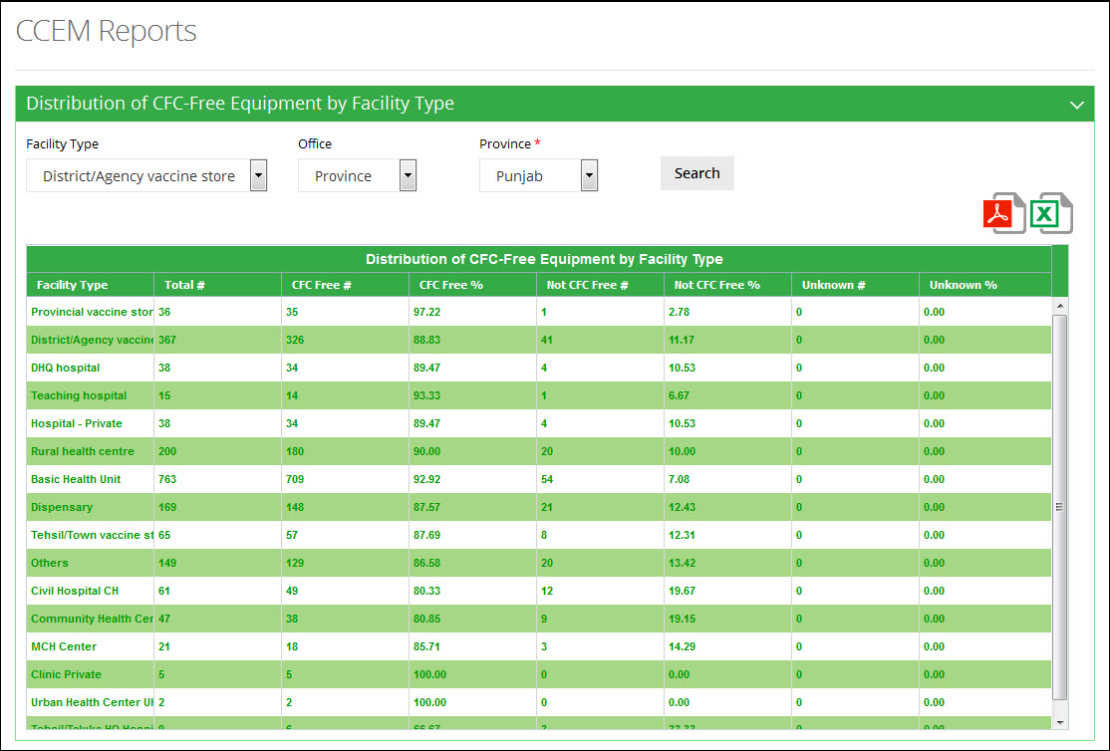**

#### **Refrigerators/Freezers Not Working or Needs Service**

User can select following filters according to their requirements. Available filters are as follows:

1. Facility Type
2. Office
3. Province
4. District

Click **Search.**

**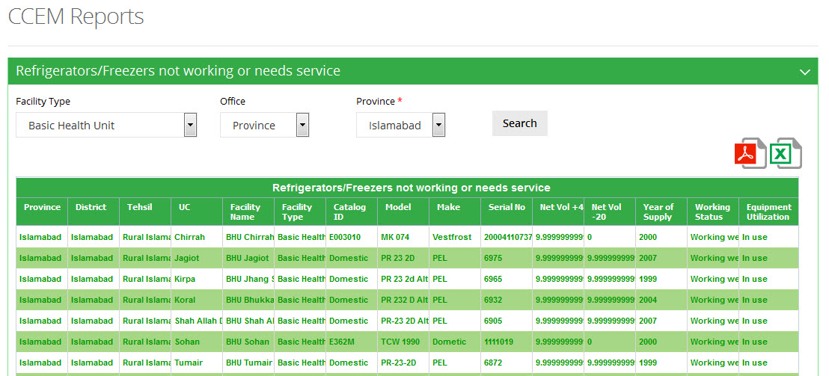**

#### **Refrigerators/Freezers not in use**

User can select following filters according to their requirements. Available filters are as follows:

1. Office
2. Province

Click **Search.**

**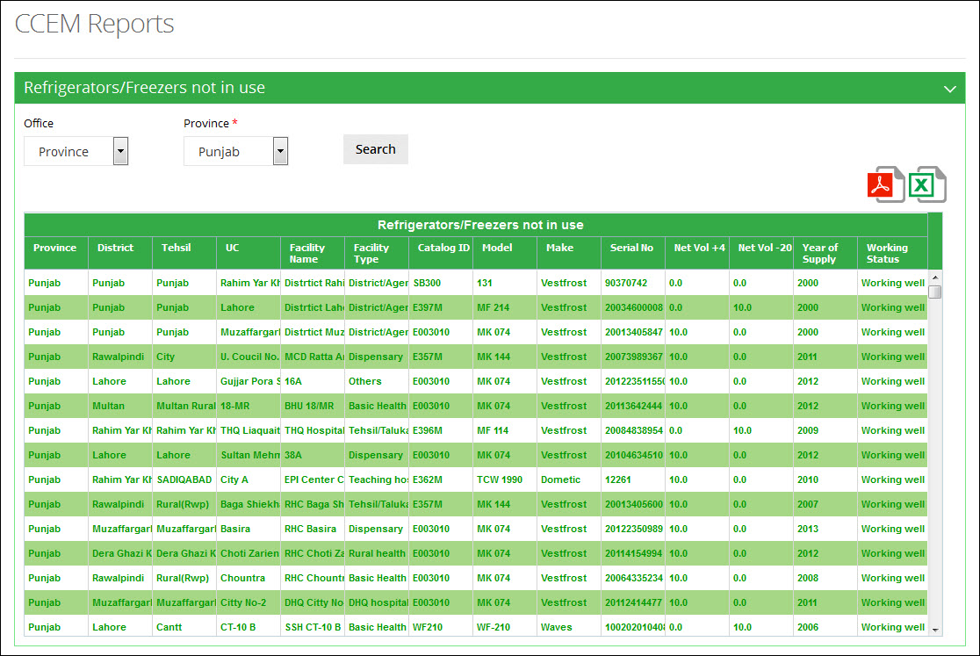**

## **Cold Rooms**

This menu can be viewed by selecting the “Cold Rooms” tab in the sub-menu. The drop down menu will be displayed as follows:

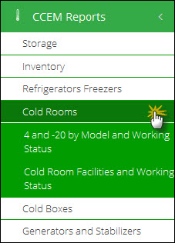

#### **4 and -20 by Model and Working Status**

User can select following filters according to their requirements. Available filters are as follows:

1. Facility Type
2. Office
3. Province
4. District

Click **Search.**

**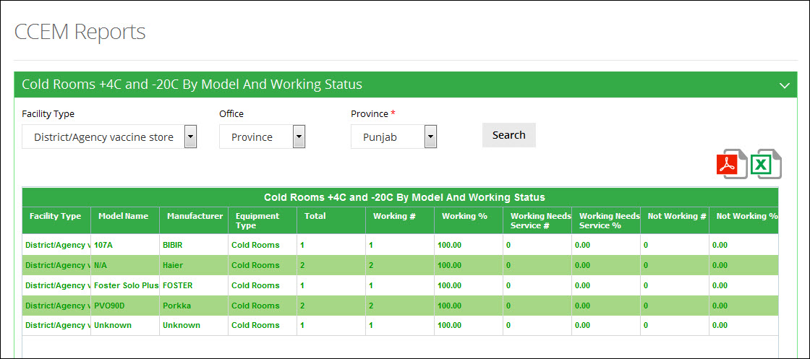**

#### **Cold Room Facilities and Working Status**

User can select following filters according to their requirements. Available filters are as follows:

1. Facility Type
2. Office
3. Province
4. District

Click **Search.**

**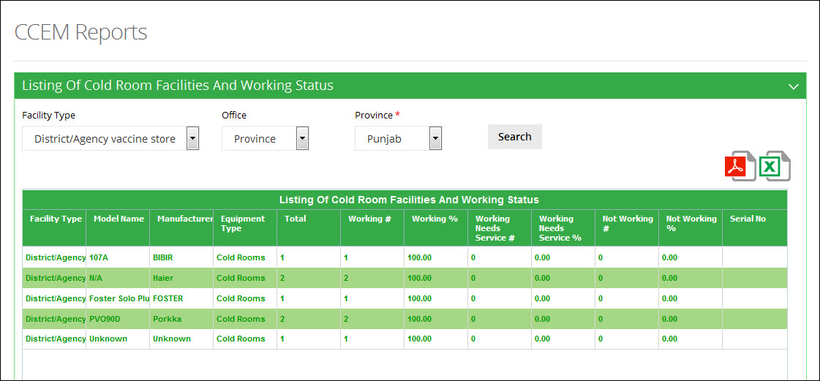**

## **Cold Boxes**

This menu can be viewed by selecting the “Cold Boxes” tab in the sub-menu. The drop down menu will be displayed as follows:

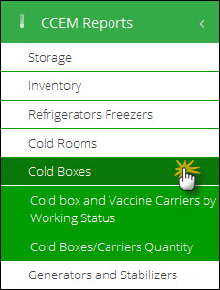

#### **Cold box and Vaccine Carriers by Working Status**

User can select following filters according to their requirements. Available filters are as follows:

1. Facility Type
2. Office
3. Province
4. District

Click **Search.**

**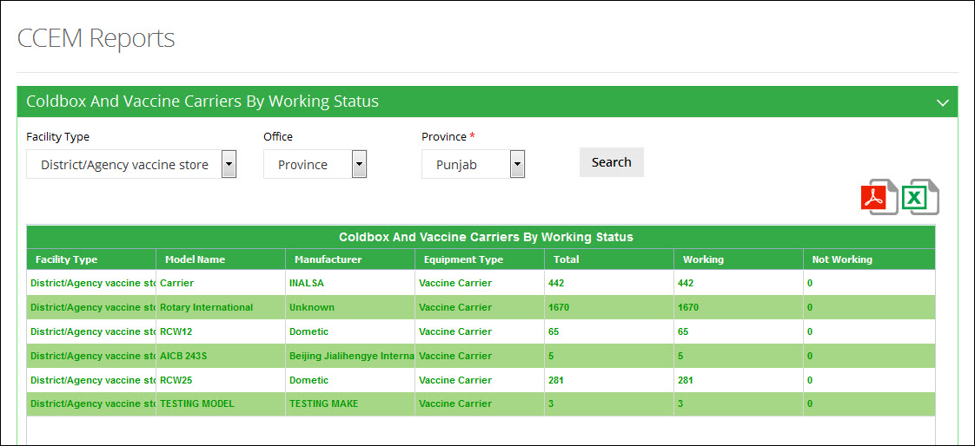**

#### **Cold Boxes/Carriers Quantity**

User can select following filters according to their requirements. Available filters are as follows:

1. Facility Type
2. Office
3. Province
4. District

Click **Search.**

**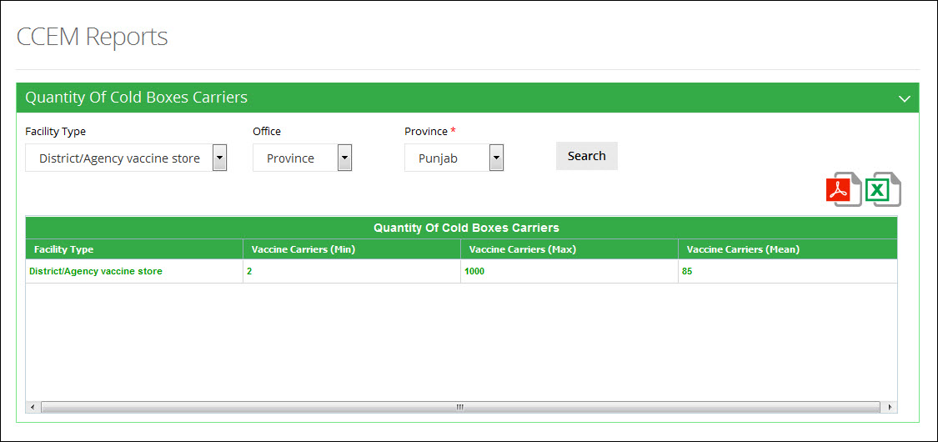**

## **Generators and Stabilizers**

This menu can be viewed by selecting the “Generators and Stabilizers” tab in the sub-menu. The drop down menu will be displayed as follows:

**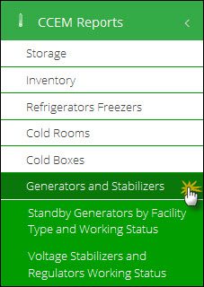**

#### **Standby Generators by Facility Type and Working Status**

User can select following filters according to their requirements. Available filters are as follows:

1. Facility Type
2. Office
3. Province
4. District

Click **Search.**

**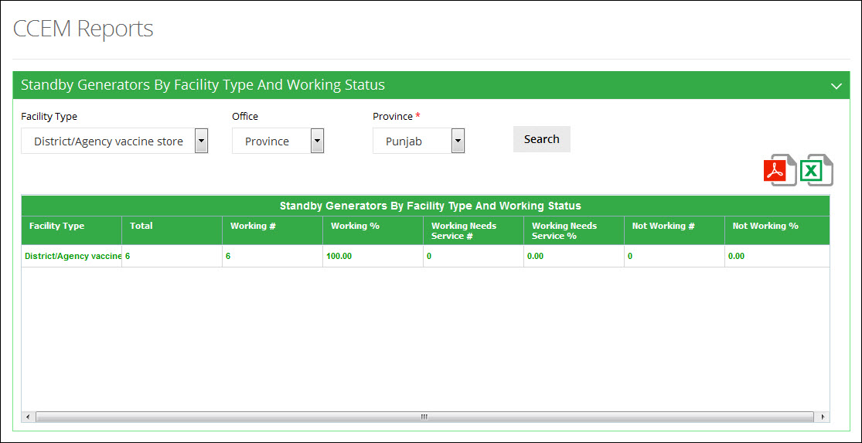**

#### **Voltage Stabilizers and Regulators Working Status**

User can select following filters according to their requirements. Available filters are as follows:

1. Facility Type
2. Office
3. Province
4. District

Click **Search.**

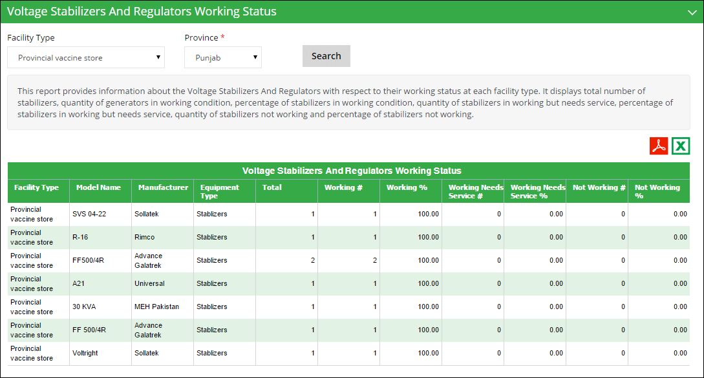

**Use Filter options to filter data in the table below**

# Campaign Reports

Users can also view the campaign reports from the Campaigns main-menu.

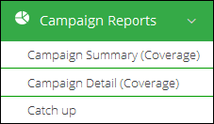

## **Campaigns Summary (Coverage)**

This report helps user to get list of all campaigns in a summary form. The list can be generated on all parameters required for adding a campaign.

Select **Province** and the **Year** for which you want to view report.

A list of districts for the selected province will be displayed along-with the analytical report for the data.

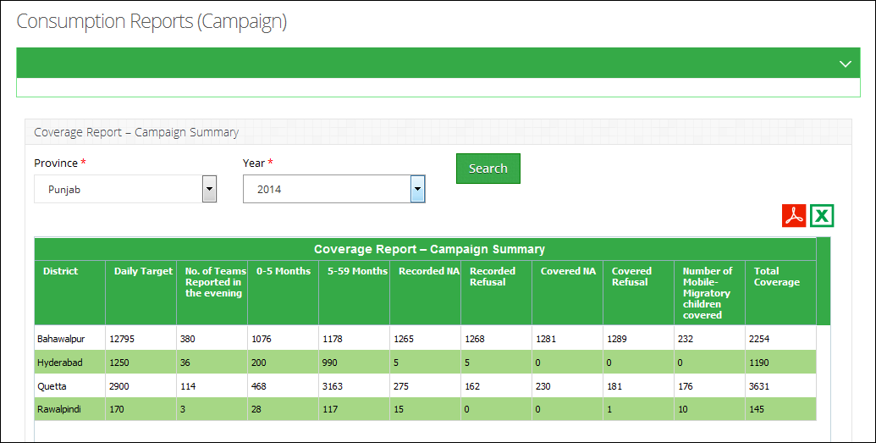

## **Campaigns Detail (Coverage)**

This report helps user to get list of all campaigns in detailed form. The list can be generated on all parameters required for adding a campaign.

Select **Province,** **District** and the **Campaigns** for with you want to view the report.

A list of tehsils for the selected district will be displayed along-with the analytical report for the data for each tehsil.

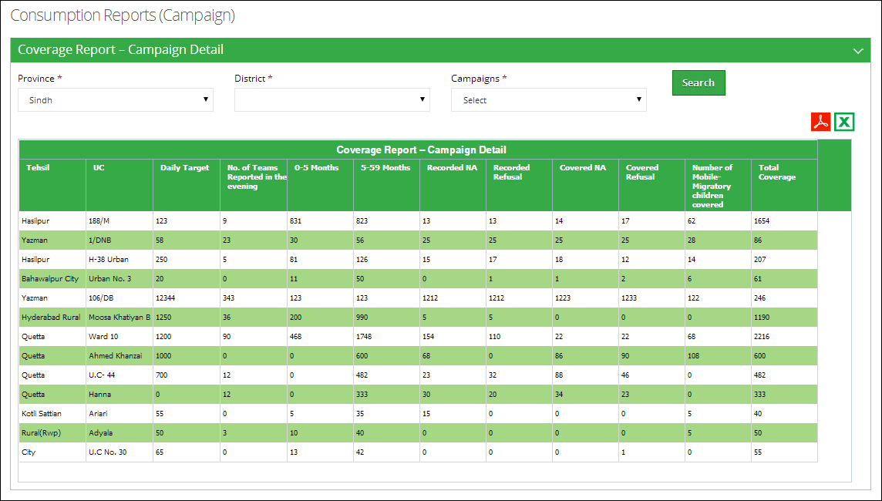

## **Catch-Up**

It is a monitoring report to find how much this campaign has been effective on the tehsil level.

Select **Province,** **District** and the **Campaigns** for with you want to view the report.

A list of tehsils for the selected district will be displayed along-with the analytical report for the data for each tehsil.

**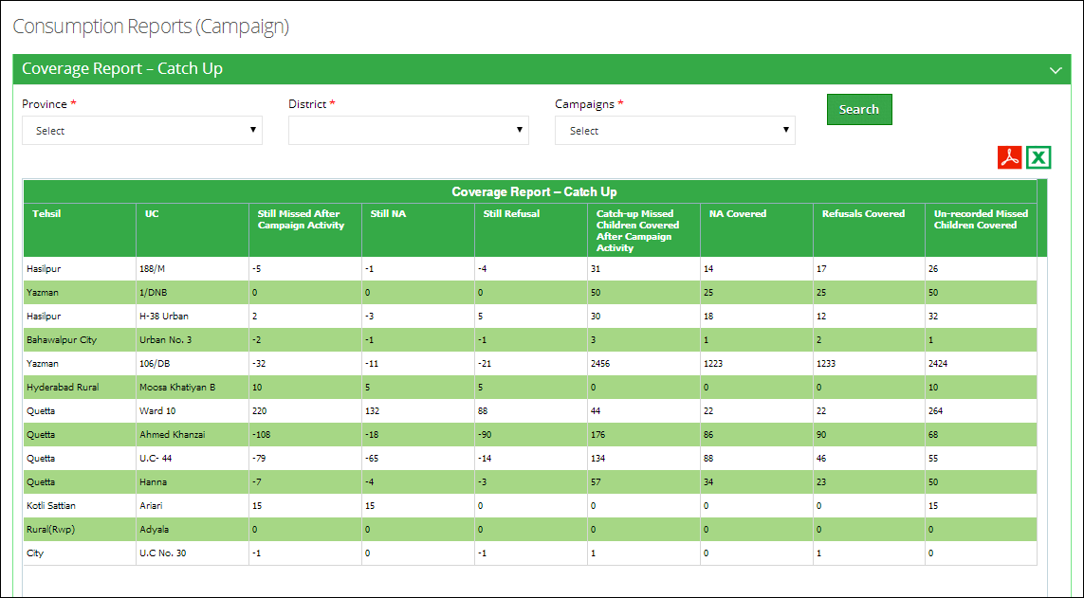**

## **Lot Quality Assurance Sampling (LQAS) Report**

Lot Quality Assurance Sampling (LQAS) report is a monitoring report to find the effectiveness of a campaign.

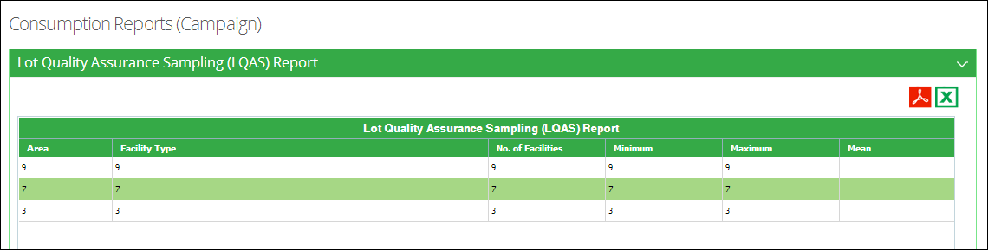

|  |  |
| --- | --- |
| Maps | **6** |
| in Vaccine Logistics Management Information System | |

This section explains the step-by-step instructions on the maps features that can be used by the Vaccine Logistics Management Information system’s users.

# Overview

The Vaccine Logistics Management Information System enables you to login as an authenticated user to view these maps. These users can view geographical maps and stores data for any period using selection filters.

## **Why Web Mapping is important?**

One of the main values of web mapping is its ability to highlight the reach and impact of the Government of Pakistan on the reliability and effective supply of commodities across the country with the rapid growth and acceptance of web mapping. It is seen as a very effective method of presenting data and engaging the use of data in decision making and transparency. Thus, the aim of this activity is to turn routine logistic data into interactive web maps which show the impact and encourage the use of logistics data in decision making. These interactive maps would be made available through the Government of Pakistan website and the routine maps would use data from Contraceptive Logistics Management Information System (cLMIS) or Vaccines Logistics Management Information System (vLMIS). The expected outcome is to add value and increase the use of the existing information disseminates by Government of Pakistan through the web-based LMIS by providing the information a more captivating approach, to both promote the importance of supply chain and use of data in decision making. How these interactive mapping adds value is how they can intuitively engage the user in providing the data in a known context - in this case the map of Pakistan - and thus, begin to understand the map based on their existing understanding of Pakistan. By providing the data in a known context, it facilitate the user in been able to interpret the information been displayed. Below are some identified ways that this has it will add value:

* Understanding of the spatial distribution of commodities, where are stock shortages? And are next other districts with stock shortages or not?
* Improve ability of Managers to target actions, which districts do I need to monitor more closely?
* Easily Share data with other key stakeholders, for use as a discussion piece with stakeholders on what the current status is and what the planned actions are. For example, greater monitoring of activities in District X.

## **Web mapping in Pakistan**

The use of web mapping in Pakistan has been growing over the past 5 years both publicly and within the government of Pakistan. One example of web mapping in Pakistan is the Sindh Basic Education Program (<http://sbep.gos.pk>). This is a good example of how web mapping is been used within Pakistan to encourage the use of data in decision making. The web-mapping application been described in this document is to be built on the wealth of logistics data of Contraceptives, Vaccines and TB/DMIS products. In essence, this application is used to provide dynamic maps using logistics indicators such as, MOS, SOH, Consumption, CYP, Reporting rate etc. to help inform decision makers about the status of the supply chain.

This application will be helpful for the health managers at all levels of administrative tiers for planning, identification of possible supply chain problems and new areas of improvements. In addition, GIS dashboards combined with other reports and graphs of LMIS application will give quick overview of monthly situation of commodities and reporting status. This would be a good epidemiological tool to combine outputs of web-mapping application with other sources for data for research activities.

## **Survey of Pakistan**

Recently, the President of Pakistan promulgated the Survey and Mapping Act 2013 but this act does not adversely impact on this web mapping activity as the primary focus of this activity is about the unregistered direct collection of primary spatial data as described here “To stop unqualified/unregistered firms to take part in surveying and mapping activities that can pose a security risk to the state”. However, the other part of the act states that ***“Survey of Pakistan shall establish and maintain National Spatial Data infrastructure NSDI … to ensure consistent mechanism of maintenance, dissemination and sharing geospatial data among all users … to enhance and improve objective decision making.”*** This activity falls into this category and therefore since, the output of this is to be housed on the Government of Pakistan website, we need to use geospatial data that is either from Survey of Pakistan or exactly matches the maps of Survey of Pakistan. So, the impact of the expanded role of the Survey of Pakistan should be seen as defining the geospatial data that should be used for the web mapping - in this case the province, district and tehsil boundaries - and how to represent the disputed territories.

The LMIS also has the capability of generating easy to interpret maps with color codes. These interactive maps would be made available through the Government of Pakistan website and help in increasing the use of the existing information disseminates by Government of Pakistan through the web-based vLMIS by providing the information a more captivating approach, to both promote the importance of supply chain and use of data in decision making.

## **Maps**

These maps can be viewed by selecting the “Maps” tab in the menu. The drop down menu will be displayed as follows:

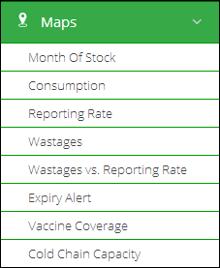

Once the indicator for which the map is to be viewed is selected, the user will be directed towards a page to select from various filters.

#### **Month of Stock Map**

Month of Stock (MOS) map provides many filter options to the user. User can select Month, Year, Province/Region, Product as well as Level to analyze MOS for each district in the selected province. The detailed information can be seen once the user clicks a particular district on the map.

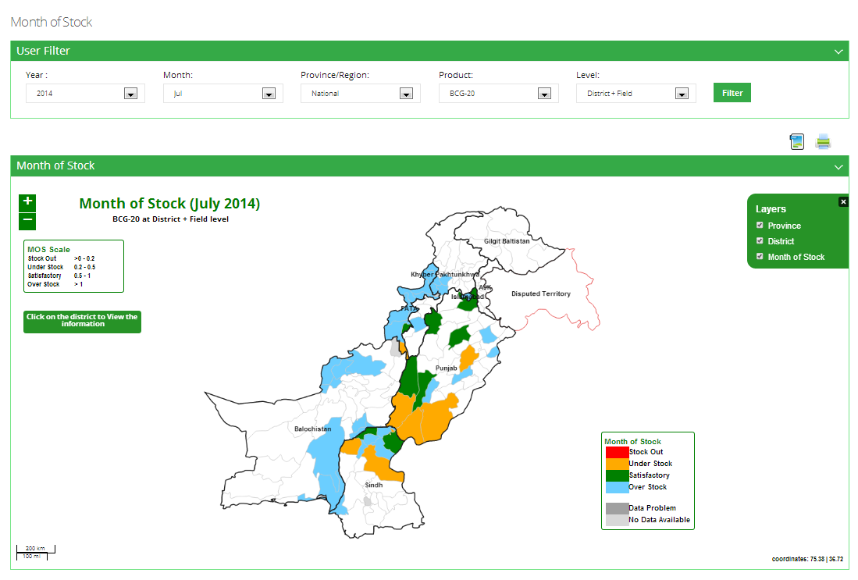

#### **Consumption Map**

Consumption map provides user with filter options such as Month, Year, Province/Region, Product as well as Type (Consumption and Avg. Monthly Consumption) to analyze product consumption for each district in the selected province. The detailed information can be seen once the user clicks a particular district on the map.

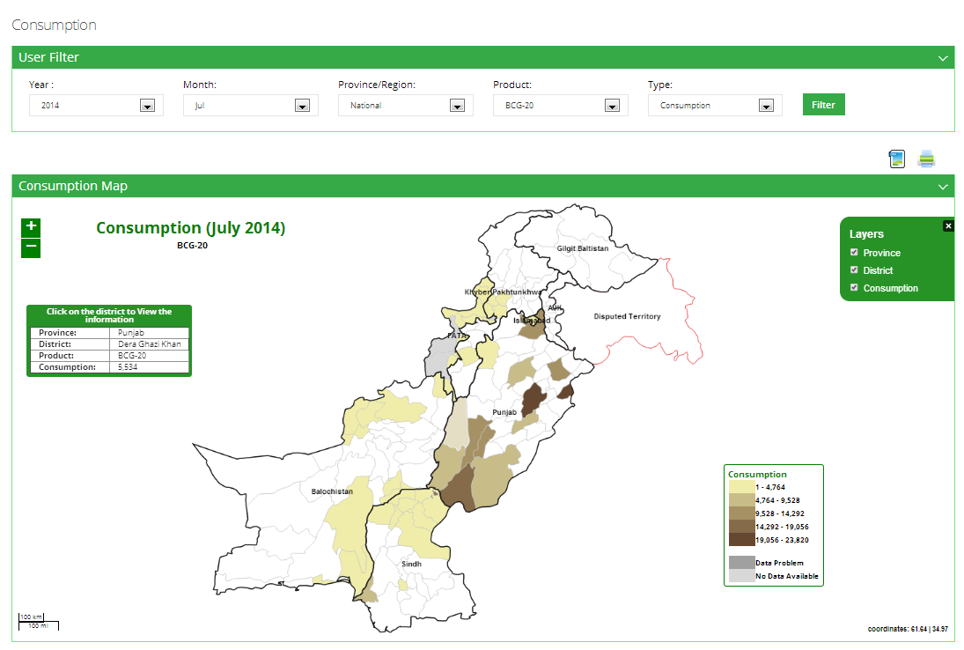

#### **Reporting Rate Map**

Reporting rate map shows the number of stores and facilities which have provided the report for each district. User can see filter options such as Month, Year, Province/Region and Product to analyze the reporting rate for each district in the selected province based on the number of facilities in that district. The detailed information can be seen once the user clicks a particular district on the map.

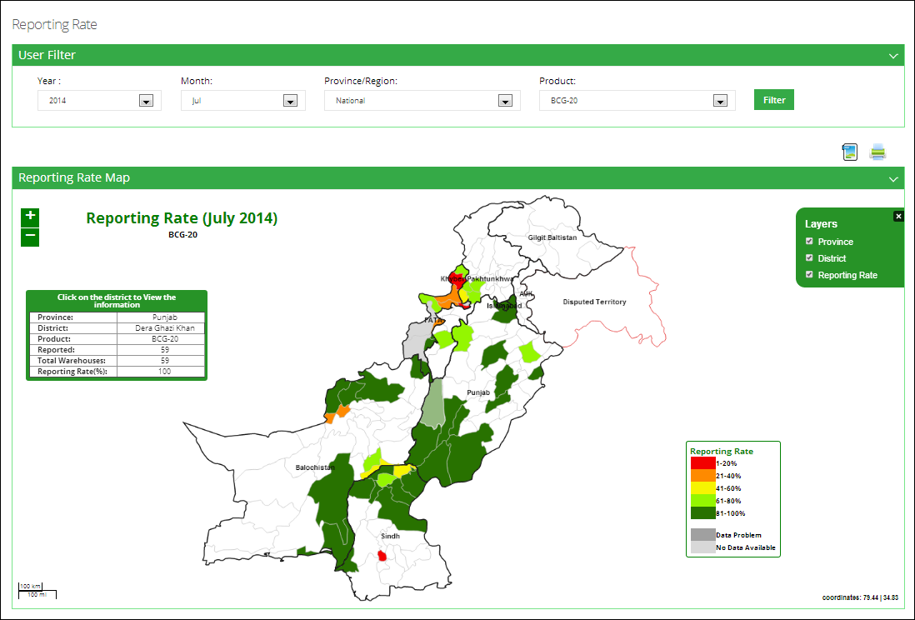

#### **Wastages Map**

Wastages map shows the wastages within the stores / facilities which have been provided in the report for each district. User can see filter options such as Month, Year, Province/Region and Product to analyze the wastage rate for each district in the selected province based on the number of facilities in that district. The detailed information can be seen once the user clicks a particular district on the map.

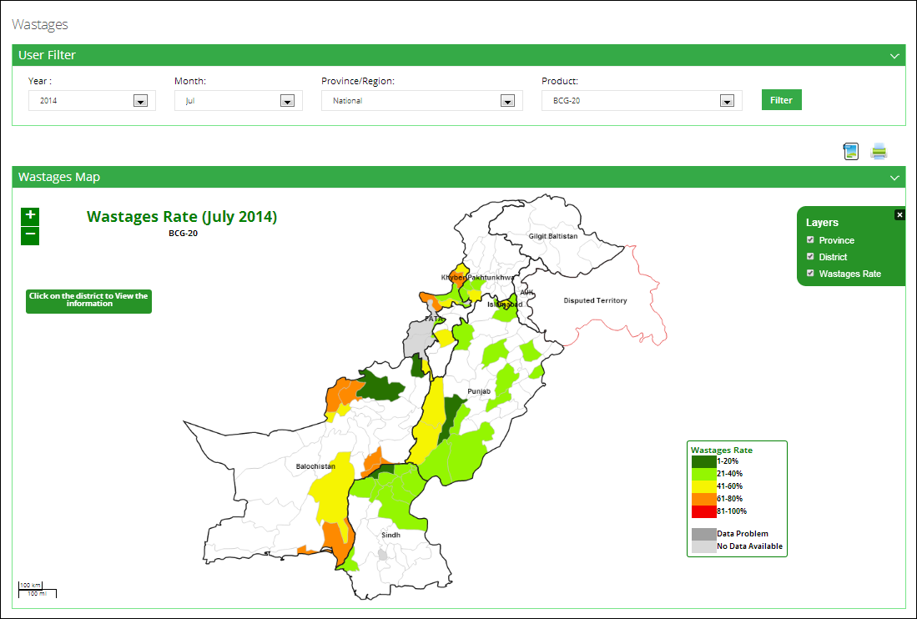

#### **Wastages vs. Reporting Rate Map**

This map shows the wastages vs. the reporting rate within the stores / facilities which have been provided in the report for each district. User can see filter options such as Month, Year, Province/Region and Product to analyze the wastages vs. reporting rate for each district in the selected province based on the number of facilities in that district. The detailed information can be seen once the user clicks a particular district on the map.

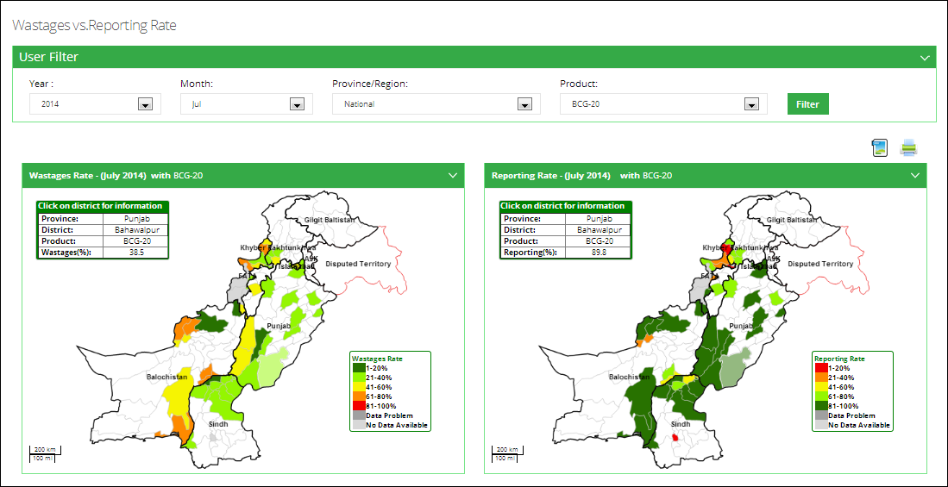

#### **Expiry Alert Map**

This map shows the expiry alert rate within the stores / facilities which have been provided in the report for each district. User can see filter options such as Month, Year, Province/Region and Product to analyze the expiry rate for each district in the selected province based on the number of facilities in that district. The detailed information can be seen once the user clicks a particular district on the map.

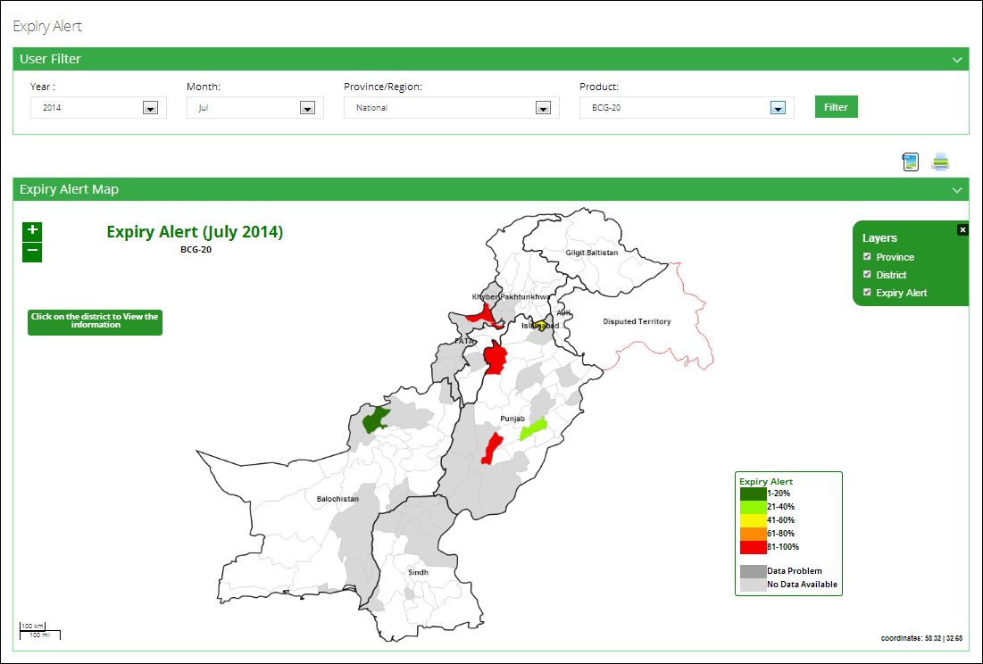

#### **Vaccine Coverage Map**

This map shows the vaccine coverage within the selected province in each district. User can see filter options such as Month, Year, Province/Region and Product to analyze the vaccine coverage for each district in the selected province based on the number of facilities in that district. The detailed information can be seen once the user clicks a particular district on the map.

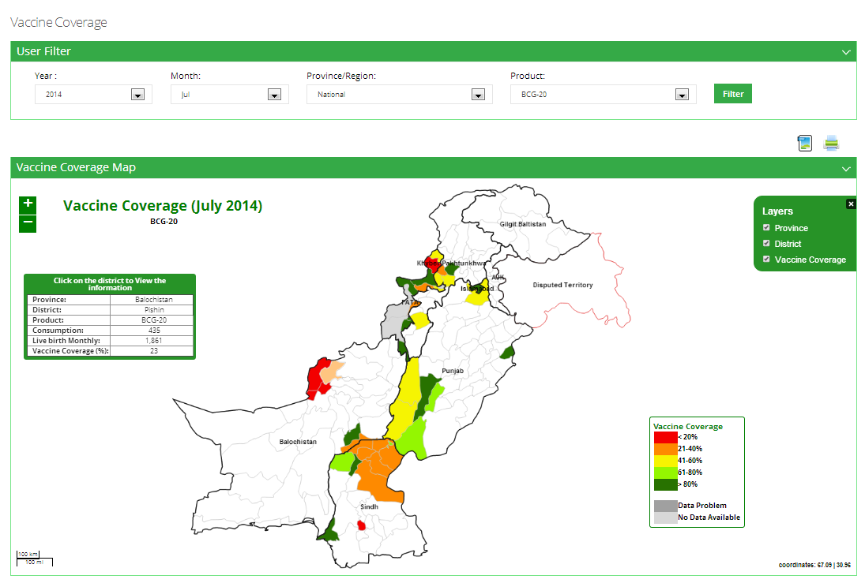

#### **Cold Chain Capacity Map**

This map shows the cold-chain capacity of each district within the selected province. User can see filter options such as Province/Region and Type of refrigerators or cold rooms to analyze the cold chain capacity rate for each district in the selected province based on the number of facilities in that district. The detailed information can be seen once the user clicks a particular district on the map.

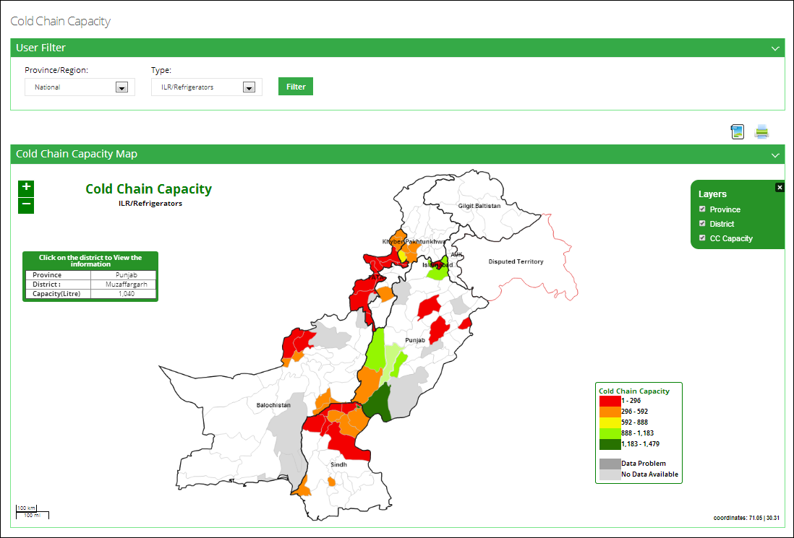

|  |  |
| --- | --- |
| Graphs | **7** |
| in Vaccine Logistics Management Information System | |

This section explains the step-by-step instructions on the graphs features that can be used by the Vaccine Logistics Management Information system’s users.

The Vaccine Logistics Management Information System enables you to login as an authenticated user to view these graphs. These users can view IM graphs and CCEM graphs to view data for any period using selection filters.

# IM Graphs

Clicking on **IM Graph** menu displays the list of Graphs available in vLMIS as shown in the image below:

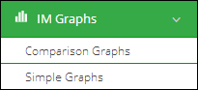

There are the following different types of graph reports:

* **Comparison Graphs**: enables you to compare different indicators.
* **Simple Graphs**: enables you to view different graph reports using indicators.

## **Comparison Graphs**

The Comparison Graph Report provides representation of data in a visual format that can help you see overall trends easily based on indicators, geographical options and time interval.

Click **Comparison Graphs** under Graphs tab to open the desired page:

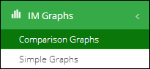

The Graph Report includes the following:

* Side bar for filter selection.
* Graph View for displaying the generated Graph.

The Comparison Graph Report consists of the following screen elements:

**Selection Bar**

The Selection Bar in the Comparison Graph Report includes different filters and select option to compare graphs to generate reports.

Clicking the **Indicators** drop-down displays the indicator options:  
  
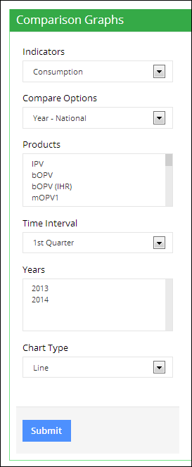

User can select one of the following options from the list:

* **Consumption**: select this option to plot a graph for Monthly Consumption.
* **Average Monthly Consumption**: select this option to plot a graph for Average Monthly Consumption.
* **Month of Stock**: select this option to plot a graph for Months of Stock.
* **Stock On Hand – UC**: select this option to plot graph for Stock in Hand for UC.
* **Stock on Hand – District**: select this option to plot graph for Stock in Hand for District.
* **Stock on Hand – Total**: select this option to plot graph for Total Stock in Hand.

Clicking the Compare Options drop-down displays the following options:

* **Year - National**: selects only National level data.
* **Year - Provincial**: selects only Provincial level data.
* **Year - District**: selects only District level data.
* **Geographical – Provincial:** selects the provincial level geographical data.
* **Geographical – District:** selects the district level geographical data.

**Year – National**

Selecting Years – National in the list enables you to compare National level data for the selected years, and displays the Years list as shown in the image below:

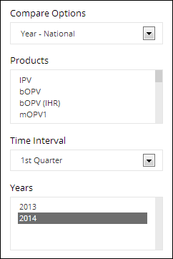

You can select multiple list entries (years) from the **Years** list for side by side comparison of National level data for the selected years.

Comparison Line Graph for Average Monthly Consumption, Time Interval and Years selected is displayed below:

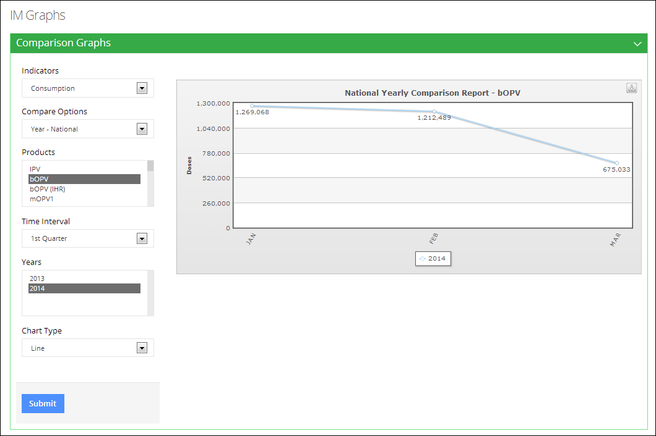

Comparison Bar Graph for Consumption, Time Interval and Years selected is displayed below:

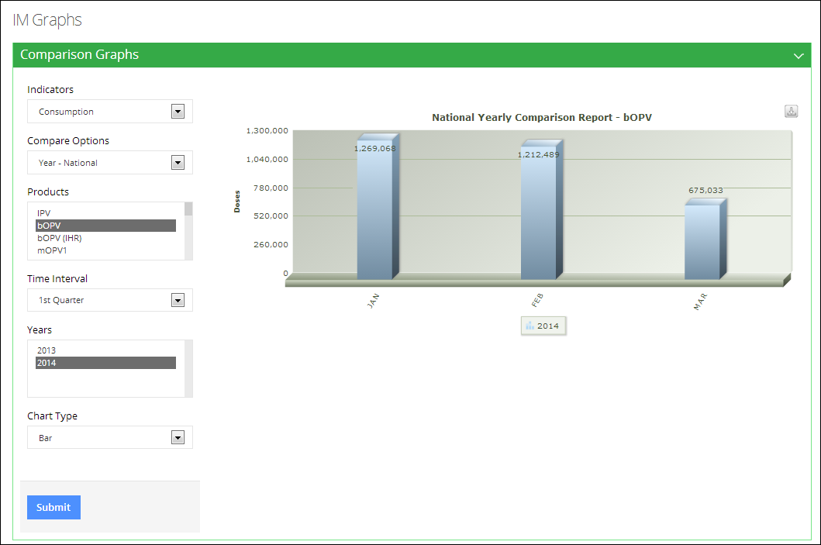

**Year – Provincial**

Selecting **Years – Provincial** in the list enables you to compare Provincial level data for the selected years, and displays the **Years** list as shown in the image below:

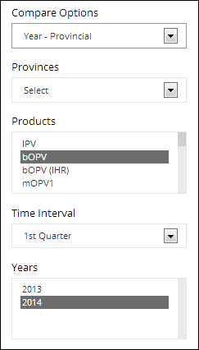

You can select multiple list entries (years) from the **Years** list for side by side comparison of Provincial level data for the selected years. You also need to select the required province as shown in the image above.

Comparison Line Graph for **Vaccine’s** Months of Stock, Time Interval and Years selected is displayed below:

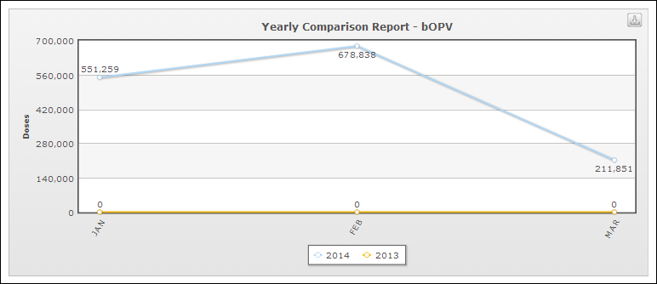

Comparison Bar Graph for **Vaccine’s** Months of Stock, Time Interval and Years selected is displayed below:

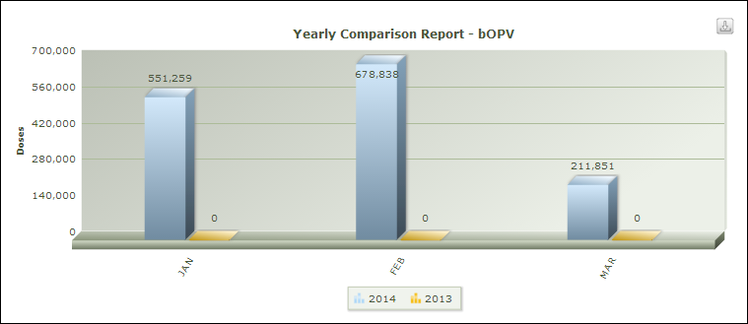

**Year – District**

Selecting **Years – District** in the list enables you to compare District level data for the selected years, and displays the **Years** list as shown in the image below:

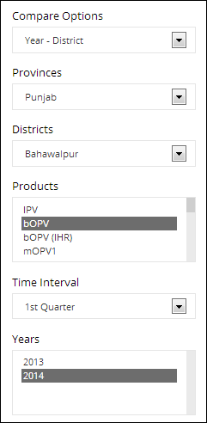

Comparison Bar Graph for **MOPV3** for **Vaccine’s** Months of Stock, Time Interval and Years selected is displayed below:

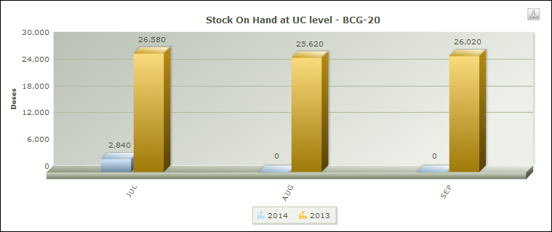

Comparison Line Graph for **MOPV3** for **Vaccine’s** Months of Stock, Time Interval and Years selected is displayed below:

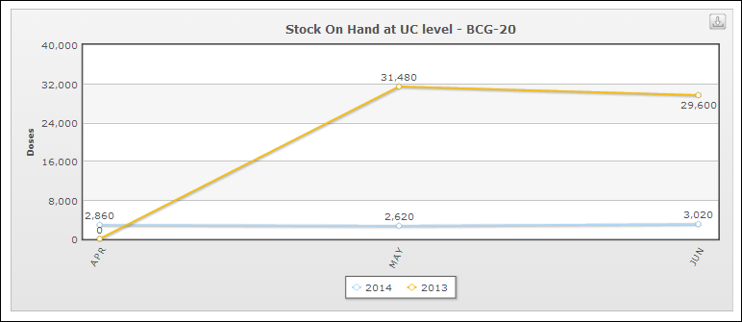

**Geographical – Provincial**

Selecting **Geographical – Provincial** in the list enables you to compare Provincial level data side by side for the selected time interval.

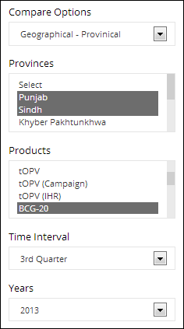

Comparison Bar Graph for **MOPV3** for **Vaccine’s** Months of Stock, Time Interval, Province and Years selected is displayed below:

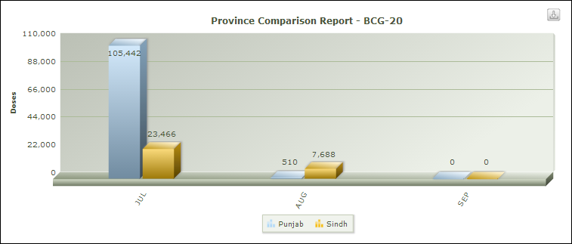

**Geographical – District**

Selecting **Geographical – District** in the list enables you to compare District level data side by side for the selected time interval.

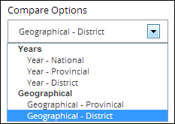

Users can also select one or multiple options in the Products list. To select multiple Products, click on the required product, press the **CTRL** key on the keyboard, and then click on the required products in the list.

Click the **Time Interval** drop-down to display the following options:

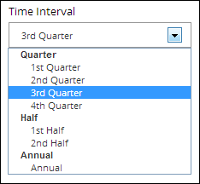

Select the required time period for which you want to generate the graph report.

Users can also select multiple years in the **Year** menu. To select multiple years, click on the required product, press the **CTRL** key on the keyboard, and then click on the required products in the list.

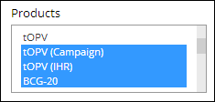

The **Chart Type** drop-down list enables you to select either Bar or Line chart for plotting format options. Select the required type.

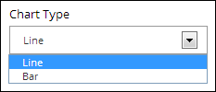

After selecting the required options, click **Submit** to generate the graph report.  
  
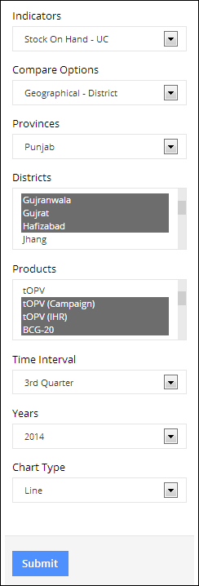

If the user selects bar chart, the graph displays as shown below:

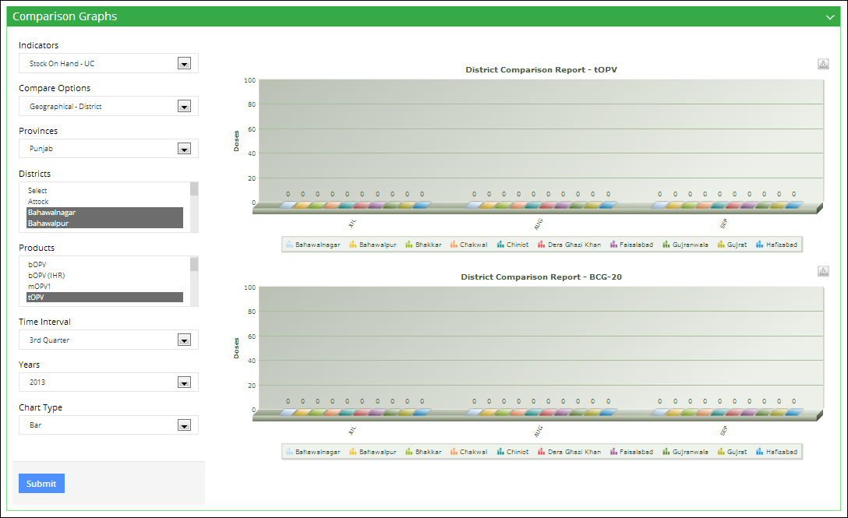

If the user selects Line chart, the graph displays as shown below:

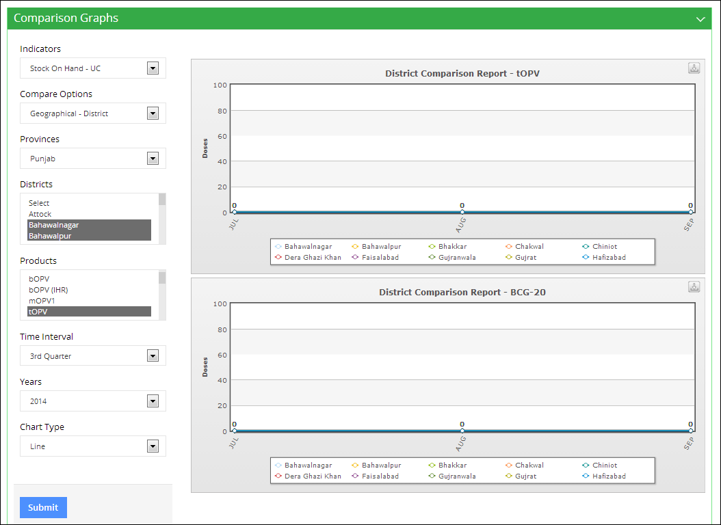

## **Simple Graphs**

The Simple Graph Report provides representation of data in a visual format that can help you see overall trends easily based on indicators, geographical options and time interval.

Click **Simple Graphs** under Graphs tab to open the desired page:

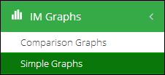

The Graph Report includes the following:

* Side bar for filter selection.
* Graph View for displaying the generated Graph.

The Simple Graph Report consists of the following screen elements:

**Selection Bar**

The Selection Bar in the Simple Graph Report includes different filters and select option to generate graphs.

Clicking the **Indicator** drop-down displays the indicator options:  
  
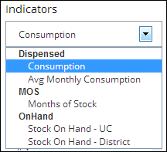

User can select one of the following options from the list:

* **Consumption**: select this option to plot a graph for Monthly Consumption.
* **Average Monthly Consumption**: select this option to plot a graph for Average Monthly Consumption.
* **Month of Stock**: select this option to plot a graph for Months of Stock.
* **Stock On Hand – UC**: select this option to plot graph for Stock in Hand for UC.
* **Stock on Hand – District**: select this option to plot graph for Stock in Hand for District.
* **Stock on Hand – Total**: select this option to plot graph for Total Stock in Hand.

Clicking the Geographical Options drop-down displays the following options:

* **National**: selects only National level data.
* **Provincial**: selects only Provincial level data.
* **District**: selects only District level data.

You can select one or multiple options in the Products list. To select multiple Products, click the required product, press the **CTRL** key on the keyboard, and then click on the required products in the list.  
  
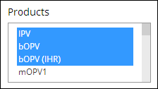

Clicking the **Time Interval** drop-down displays the following options:  
  
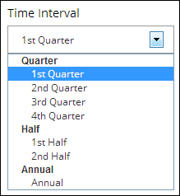

Select the required time period for which you want to generate the graph report. Clicking the **Year** drop-down displays the years for which data is available. Select the required year.  
  
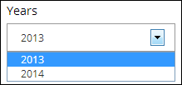

The **Chart Type** drop-down list enables you to select either Bar or Line chart for plotting format options. Select the required type.  
  
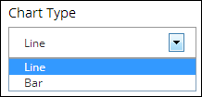

After selecting the required options, click **Submit** to generate the graph report.  
  
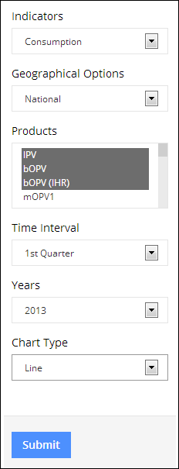

A generated bar graph is shown in the image below:

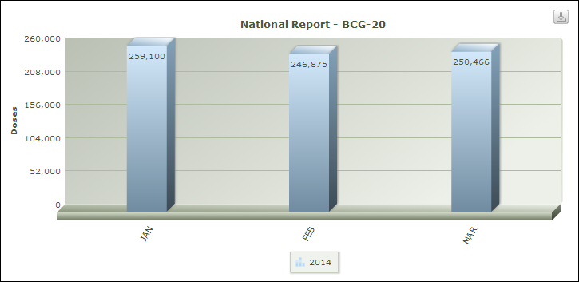

# CCEM Graphs

Clicking on **CCEM Graph** menu displays the list of Graphs related to cold-chain equipment management, as shown in the image below:

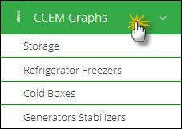

There are the following different types of graph reports:

* **Storage**: enables you to compare different indicators to determine capacity.
* **Refrigerator Freezers**: enables you to the status of refrigerators and freezers.
* **Cold Boxes:** enables you to determine the status of cold-boxes.
* **Generators Stabilizers:** enables you to determine the status of generators and stabilizers.

## **Storage**

Clicking on **Storage** sub-menu displays the list of Graphs related to storage management, as shown in the image below:

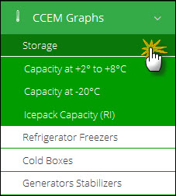

#### **Capacity at +2c to +8c**

User can select following filters according to their requirements. Available filters are as follows:

1. Facility Type
2. Office
3. Province
4. District

Click **Search.**

The desired graph is displayed as follows:

**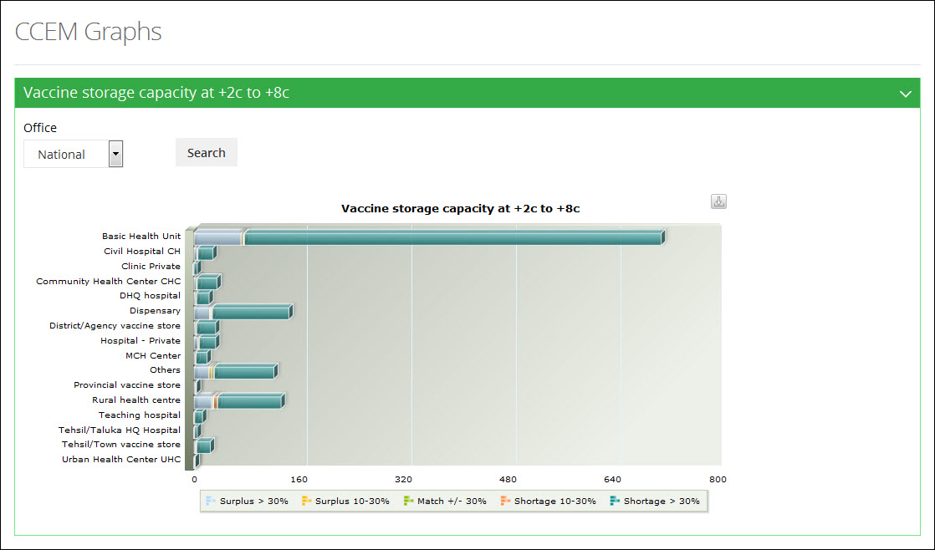**

#### **Capacity at -20C**

User can select following filters according to their requirements. Available filters are as follows:

1. Office
2. Province
3. District

Click **Search.**

The desired graph is displayed as follows:

**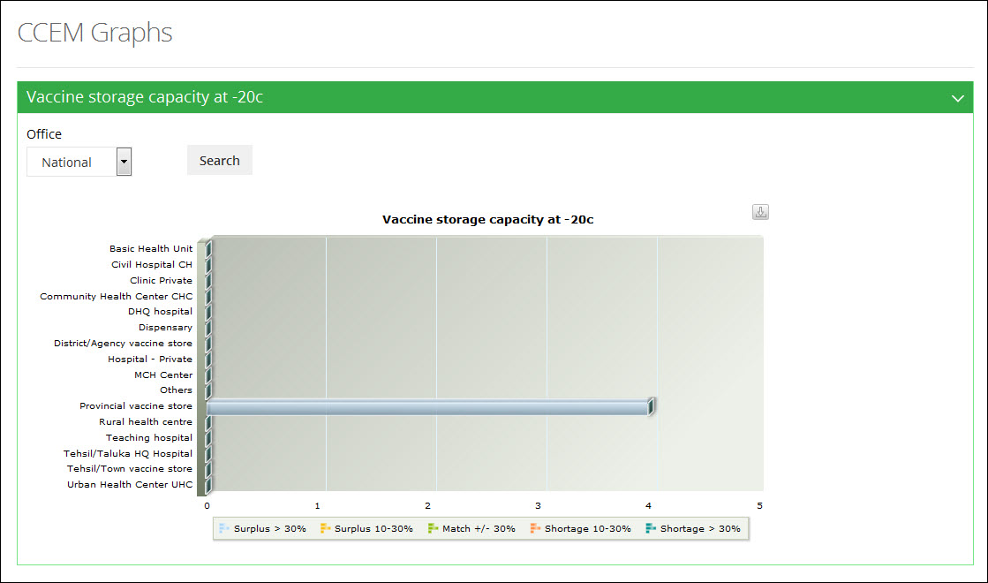**

#### **Icepack Capacity (RI)**

User can select following filters according to their requirements. Available filters are as follows:

1. Office
2. Province
3. District

Click **Search.**

The desired graph is displayed as follows:

**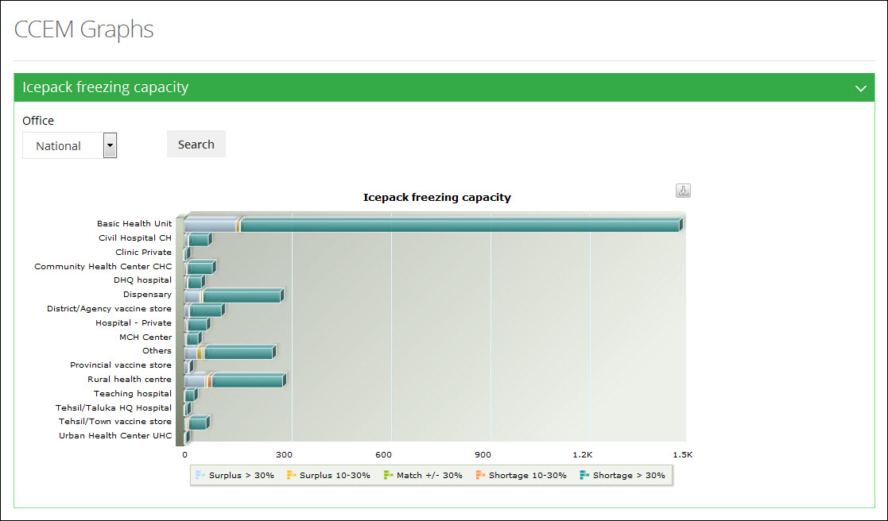**

## **Refrigerator Freezers**

Clicking on **Refrigerator Freezers** sub-menu displays the list of Graphs related to cold-chain equipment management, as shown in the image below:

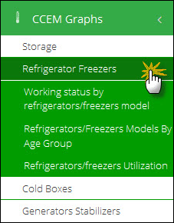

#### **Working Status by Refrigerators Model**

User can select following filters according to their requirements. Available filters are as follows:

1. Facility Type
2. Office
3. Province
4. District

Click **Search.**

The desired graph is displayed as follows:

**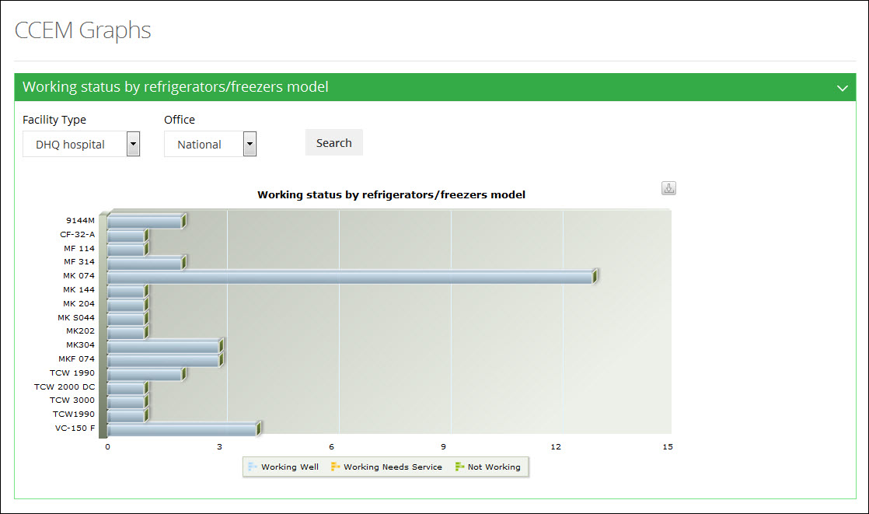**

#### **Refrigerators / Freezers Model By Age Group**

User can select following filters according to their requirements. Available filters are as follows:

1. Office
2. Province
3. District

Click **Search.**

The desired graph is displayed as follows:

**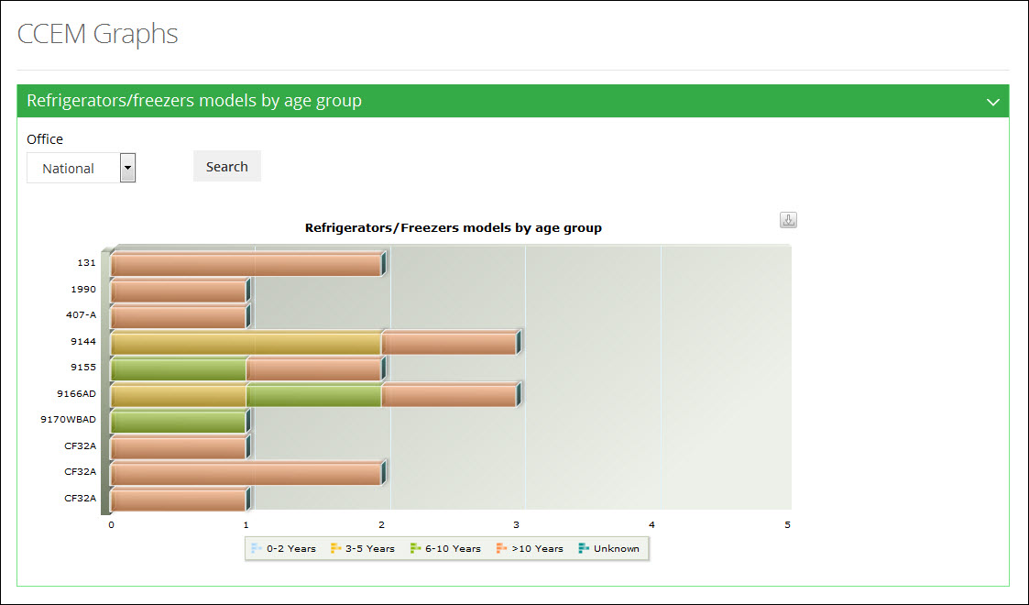**

#### **Refrigerators / Freezers Utilization**

User can select following filters according to their requirements. Available filters are as follows:

1. Facility Type
2. Office
3. Province
4. District

Click **Search.**

The desired graph is displayed as follows:

**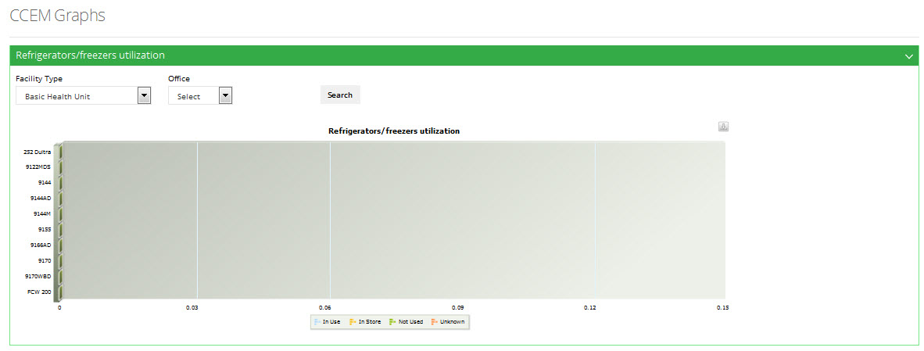**

## **Cold Boxes**

Clicking on **Cold Boxes** sub-menu displays the list of Graphs related to cold-chain equipment management, as shown in the image below:

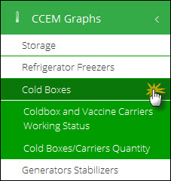

#### **Cold-box and Vaccine Carriers Working Status**

User can select following filters according to their requirements. Available filters are as follows:

1. Office
2. Province
3. District

Click **Search.**

The desired graph is displayed as follows:

**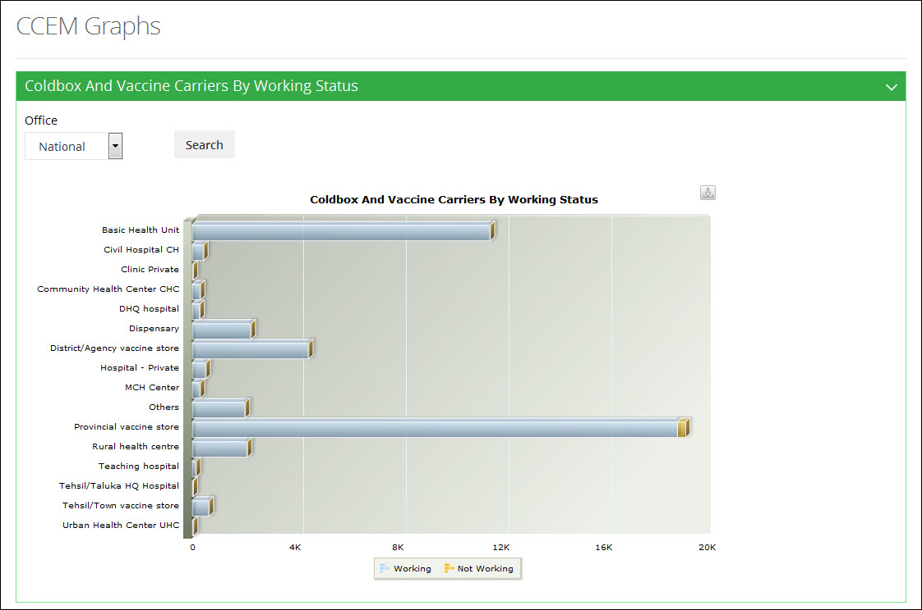**

#### **Cold-boxes / Carrier Quantity**

User can select following filters according to their requirements. Available filters are as follows:

1. Office
2. Province
3. District

Click **Search.**

The desired graph is displayed as follows:

**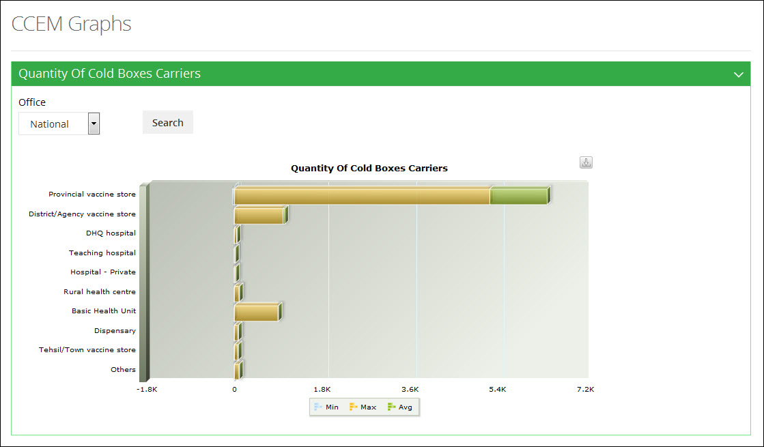**

## **Generators Stabilizers**

Clicking on **Generators Stabilizers** sub-menu displays the list of Graphs related to cold-chain equipment management, as shown in the image below:

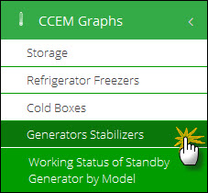

#### **Working Status of Standby Generator by Model**

User can select following filters according to their requirements. Available filters are as follows:

1. Office
2. Province
3. District

Click **Search.**

The desired graph is displayed as follows:

**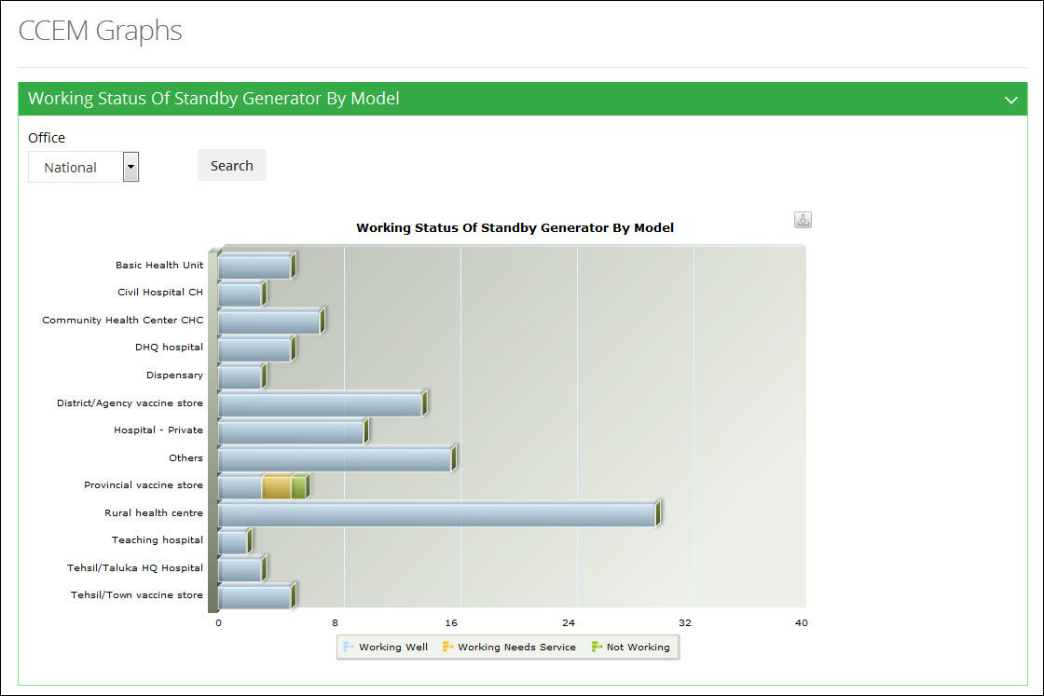**

|  |  |
| --- | --- |
| EPI Users | **8** |
| in Vaccine Logistics Management Information System | |

This section explains the overview of the EPI Users (National and Provincial) and describes the tasks need to be performed using Vaccine Logistics Management Information System.

|  |
| --- |
| **EPI Users (National and Provincial)**  The EPI Users at the National and Provincial level work in recording and maintains the daily consumption of vaccines. Each month, the data is compiled and then entered in Vaccine Logistics Management Information System. Moreover, the cold-chain assets current working status and stock adjustments are also maintained in vLMIS. |

**EPI Users – National / Provincial**

The EPI Users maintains and manages the warehouse’s monthly inventory at the National as well as Provincial level, by recording the stock consumption on daily basis. The data is then compiled and updated monthly on vLMIS. This data includes the inventory management along-with stock placement and gate pass issue. EPI users can also update the cold chain assets status of the warehouse/store. EPI User can also view the Reports, Maps and Graphs features of the Vaccine Logistics Management Information System.

Logging in to the EPI User - National account displays the account’s Home page screen by default, as shown in the image below:

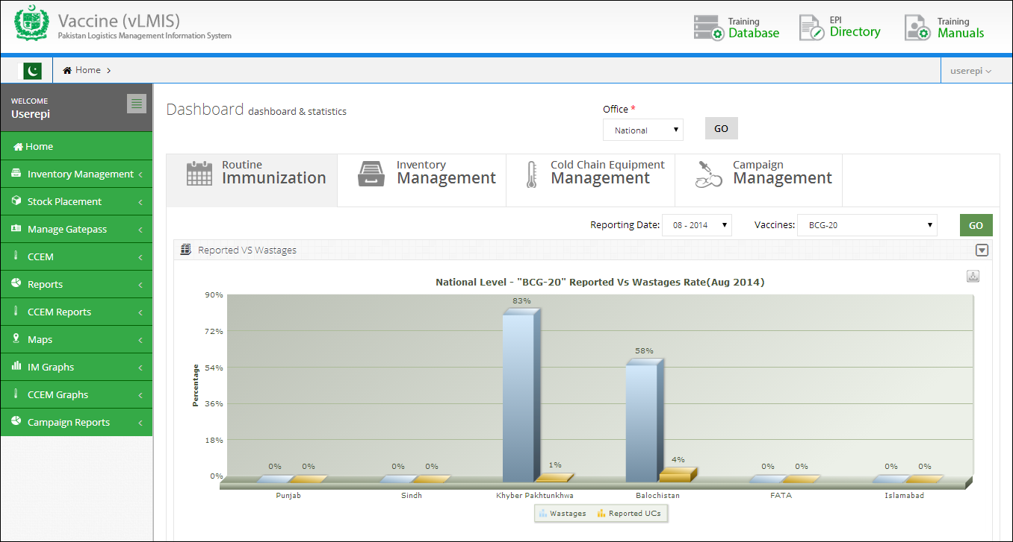

Logging in to the EPI User - Provincial account displays the account’s Home page screen by default, as shown in the image below:

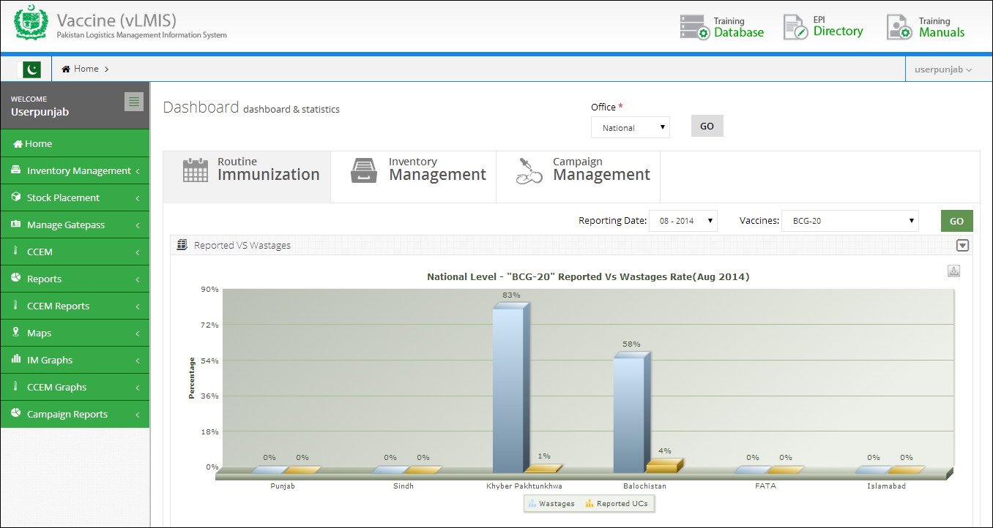

On the left side of the dashboard screen, the EPI user will see the following tabs:

**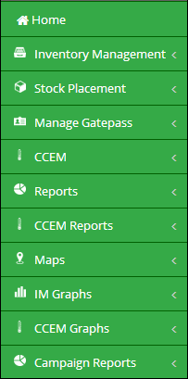**

User can sign out of the application by using the following link on the right side of the screen.  
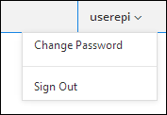

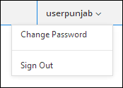

The EPI User (National and Provincial) screen includes the following features:

* **Dashboards:** User can view dashboards containing graphs, maps and analytical reports by using this tab.
* **Inventory Management:** enables the user to manage the stock in the inventory. National users can also issue stock to provincial, district and tehsil level stores / facilities.
* **Stock Placement:** enables the user to manage stock locations within the warehouse / store.
* **Manage Gate Pass:** enables the national user to issue gate passes to transfer stock to another location.
* **CCEM**: enables the account user to report the cold chain asset’s status of the assigned warehouse/stores, which helps identify the working condition of the cold-chain machine.
* **Reports**: user can view the data analysis reports for data analysis. Refer to the “Reports” section for details.
* **CCEM Reports**: user can view the data analysis reports for cold chain equipment. Refer to the “CCEM Reports” section for details.
* **Maps:** enables user to view the geographical maps. Refer to the “Maps” section for details.
* **IM Graphs:** user can view graph comparison reports for comparing and analyzing data. Refer to the “IM Graphs” section for details.
* **CCEM Graphs:** user can view CCEM graphs for analyzing data. Refer to the “CCEM Graphs” section for details.
* **Campaign Reports**: user can also view analytical reports for the campaigns being conducted. Refer to the “Campaign Reports” section for details.

# Dashboards

Refer to the “Dashboards” section of the user manual.

**Inventory Management**

Inventory Management feature enables the User to manage the inventory for the respective warehouses and stores/facilities.

Inventory Management is a component of supply chain management and supervises the flow of goods from manufacturers to warehouses and from these facilities to the point of utilization. One of the key functions of inventory management is to keep a detailed record of each new or returned product as it enters or leaves a warehouse. Inventory Management feature enables the Store User to manage the inventory within warehouse.

Click **Inventory Management** tab from the main-menu. A list of inventory management options with be displayed.

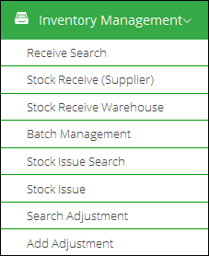

User can perform the following:

* **Stock Receive (Supplier)**: National, provincial and district users can receive stock directly from supplier. Tehsil users are not provided with this option.
* **Stock Receive (Warehouse)**: All users can also receive stock from other warehouses.
* **Receive Search**: users can search the received stock from other warehouses or suppliers.
* **Stock Issue**: The stock is issued to other warehouses/stores on demand.
* **Stock Issue Search**: users can search the issued stock to other warehouses/stores.
* **Batch Management**: When stock is received, the user marks the batches with latest expiry date as ‘Running’, so that this stock can be issued first.
* **Add Adjustment**: If stock is lost or recovered, user can add adjustments in vLMIS.
* **Search Adjustment**: User can search the added adjustments for a selected duration.

## **Stock Receive (Supplier)**

The EPI user (National and Provincial) can receive stock from suppliers and then distribute the stock to the Provincial, District and Tehsil stores on demand. To receive stock from supplier:

1. Sign in to the user account.  
   The User Home Page displays.
2. Under **Inventory Management**, click **Stock Receive (Supplier)**.

The Stock Receive from Supplier screen displays.

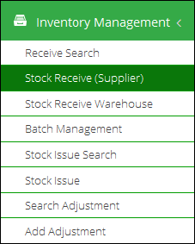

1. The Stock Receive from Supplier screen displays.  
     
   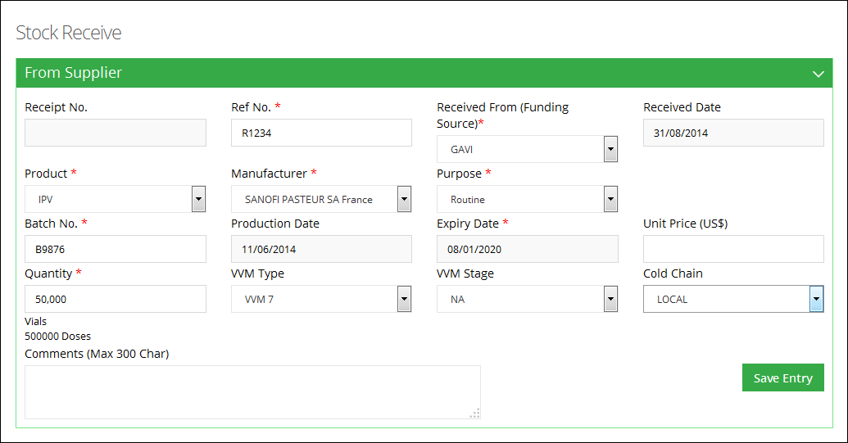
2. Specify the following information:
   * **Receipt No**: is an automatically generated number for identifying the receive transaction.
   * **Ref No.**: specify the reference number.
   * **Received Date:** Click on Receive date to expand the date picker tool.   
       
     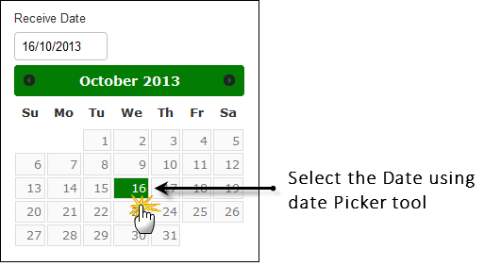
   * **Received From (Funding Source)**: Select the supplier for the product.
   * **Product**: select the product from the list.
   * **Manufacturer:** select the manufacturer from the list.
   * **Purpose:** specify the purpose of stock receive. If the selected purpose is campaign, specify the campaign for which stock is required.
   * **Batch No:** specify the batch number for the product.
   * **Production Date:** Click on Production date to expand the date picker tool, or type-in the required date using format dd/mm/yyyy.
   * **Expiry Date:** Click on Expiry date to expand the date picker tool, or type-in the required date using format dd/mm/yyyy.
   * **Unit Price:** specify the price in US$.
   * **Quantity:** specify the quantity of the product.
   * **VVM Type:** specify the VVM (Vaccine Vial Monitor) Type.
   * **VVM Stage:** specify the VVM stage.

|  |  |
| --- | --- |
| C:\Users\isbah.zulfiqar\Desktop\1382615592_file_edit.png | A vaccine vial monitor (VVM) is a label containing a heat-sensitive material which is placed on a vaccine vial to register cumulative heat exposure over time. The combined effects of time and temperature cause the inner square of the VVM to darken, gradually and irreversibly. A direct relationship exists between the rate of color change and temperature:  The lower the temperature, the slower the color change, the higher the temperature, the faster the color change. |

* + **Cold Chain:** select the cold-chain.

1. Click **Save Entry** for details.

The entry moves to the Issue List. You can add new entries, as required. All of the entries will be displayed in the Issue List.  
  
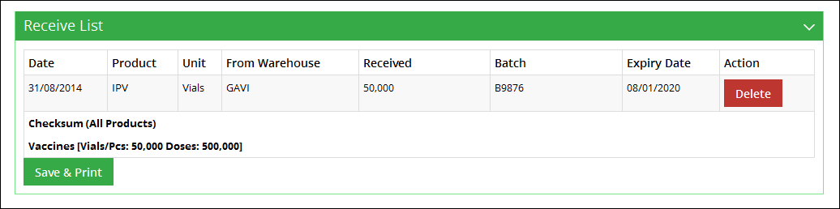

1. Click **Save & Print**.  
   The Receive order is saved and printed.

## **Stock Receive (Warehouse)**

EPI user (National and Provincial) can also receive stock from other warehouses of lower geographical levels e.g. Central Store can receive stock from Provincial store. The stock might be returned to the upper geographical level based on requirements.

To receive stock from warehouse:

1. Sign in to the user account.  
   The User Home Page displays.
2. Under **Inventory Management**, click **Stock Receive (Warehouse)**.

The Stock Receive from Warehouse screen displays.

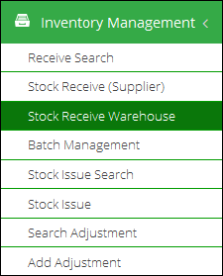

1. Add **Issue Number** to search for the required entry in database.  
     
   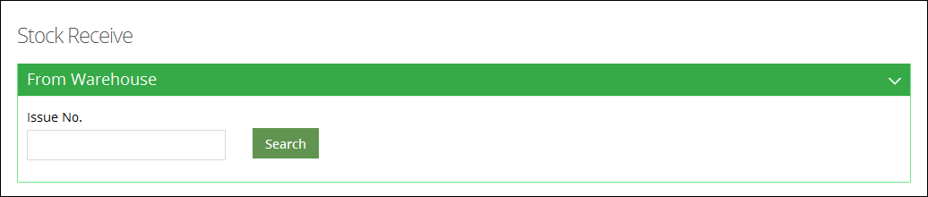

The required issued entry displays.

1. Review the issued product’s details. The table includes:
   * **Product**: displays the product name.
   * **Batch:** displays the batch number for the product.
   * **Quantity:** displays the issued quantity.
   * **VVM Stage:** displays the VVM stage.

|  |  |
| --- | --- |
| C:\Users\isbah.zulfiqar\Desktop\1382615592_file_edit.png | A vaccine vial monitor (VVM) is a label containing a heat-sensitive material which is placed on a vaccine vial to register cumulative heat exposure over time. The combined effects of time and temperature cause the inner square of the VVM to darken, gradually and irreversibly. A direct relationship exists between the rate of color change and temperature:  The lower the temperature, the slower the color change, the higher the temperature, the faster the color change. |

* + **Adjusted Quantity:** if the received quantity is different than the issued quantity, you can enter the adjusted quantity in this text box.
  + **Adjustment:** specify the adjustment type:
  + **Receive Reference**: specify the receive reference.
  + **Receive Date:** Click on Receive date to expand the date picker tool and specify the received date.

1. Check the  icon in the end of the row and then click **Save & Print**.  
   The entry is received and added to the inventory.

## **Stock Receive Search**

To search for a receive entry:

1. Sign in to the user account.  
   The User Homepage displays.
2. Under **Inventory Management**, click **Stock Receive Search**.  
   The Stock Receive Search page displays.

**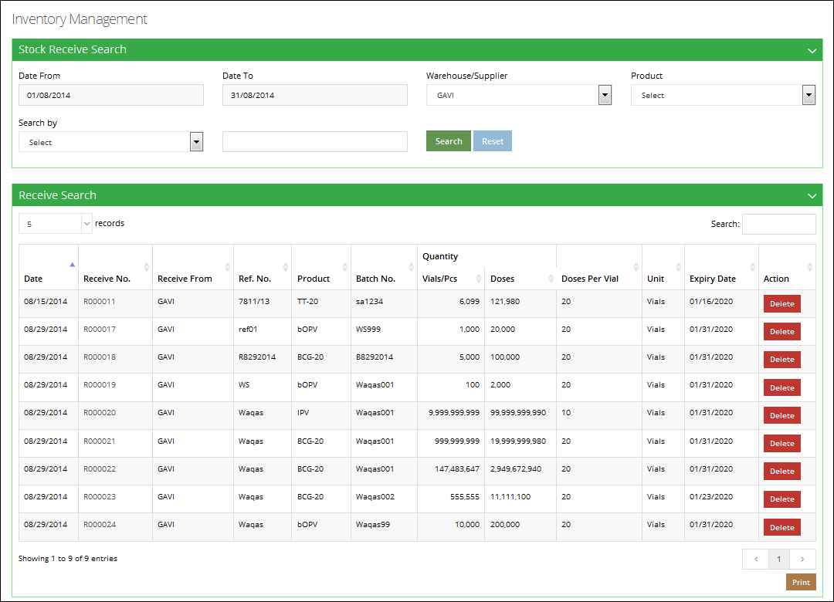**

1. Specify the following filters:
   * **Date From**, **Date To**:Click on date to expand the date picker tool.   
       
     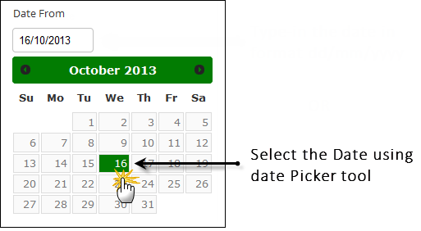
   * **Search By**: Specify the unique identifier you want to search by.

The options include:

* **Receive No**: if you know the receive number, select this option and specify the Issue No in the adjacent text box.
* **Receive Ref.**: To search using the Receive Ref, select this option and then specify the Issue Ref in the adjacent text box.
* **Batch No:** To search using the Batch No., select this option and then specify the Batch No in the adjacent text box.
  + **Warehouse Supplier**: select the warehouse supplier. This is optional field.
  + **Product:** select the required vaccine from the list.

1. Click **Search**.  
   The required entries are displayed in the Receive List.  
     
   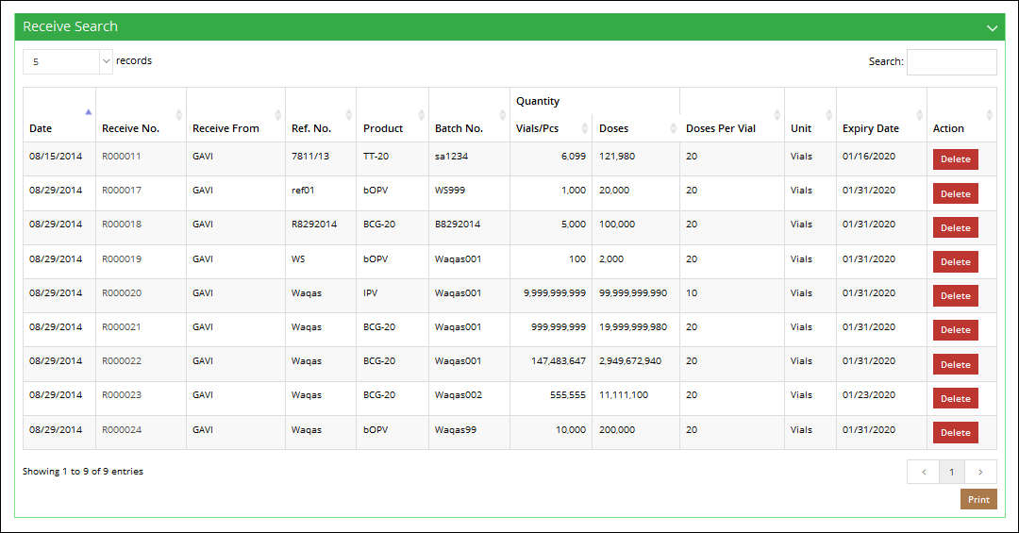

## **Batch Management**

Once the vaccines stock is received in warehouse, each package is identified by its Batch Number and Expiry Date. Each batch is sorted by its expiry date by the rule of “First Expiry First Out”. When batches are added to vLMIS, the account user usually assigns the batches with latest expiry date as ‘Running’. The running batches are issued first.

To Manage Batches:

1. Sign in to the user account.  
   The User Home Page displays.
2. Under **Inventory Management**, click **Batch Management**.

The Batch Management page displays. You can print the list of available stock by clicking **Summary.**

1. In order to mark the status of the batch, you can specify search criteria to search for the required batch as follows:
   * **Vaccine**: select the required vaccine from the list.
   * **Status**: specify the status of the batch that you are searching for.

* **Running**: Only the batches with the status “Running” can be issued.
* **Stacked**: Stacked batches represent that they are stacked in the warehouse and cannot be issued.
* **Finished**: batches have finished.
  + **Batch No.**: Optionally, specify the Batch No of the required batch.
  + **Ref. No.**: Optionally, specify the Ref. No. of the required batch.

1. Click **Search**.  
   The Search results are displayed in a table.

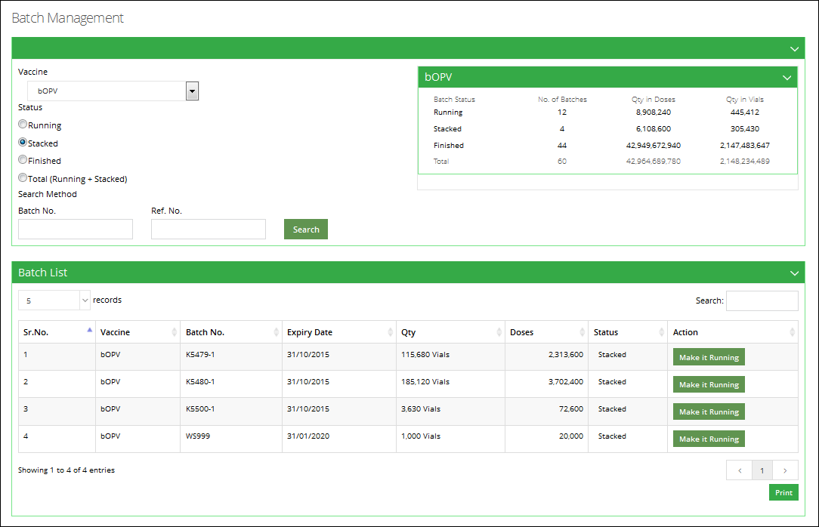

1. You can review the batch status and change it by clicking the button adjacent to it.

|  |  |
| --- | --- |
| C:\Users\isbah.zulfiqar\Desktop\1382615592_file_edit.png | Remember that in order to issue batches, you have to first set their status to ‘Running’. |

1. Click **Print**.  
   The Batch List will be printed.

## **Stock Issue**

National and Provincial users can issue stock to other warehouse/stores. Stock can be issued directly to the stores / facilities.

To issue stock:

1. Sign in to the user account.  
   The User Home Page displays.
2. Under **Inventory Management**, click **Stock Issue**. The New Issue page displays.  
     
   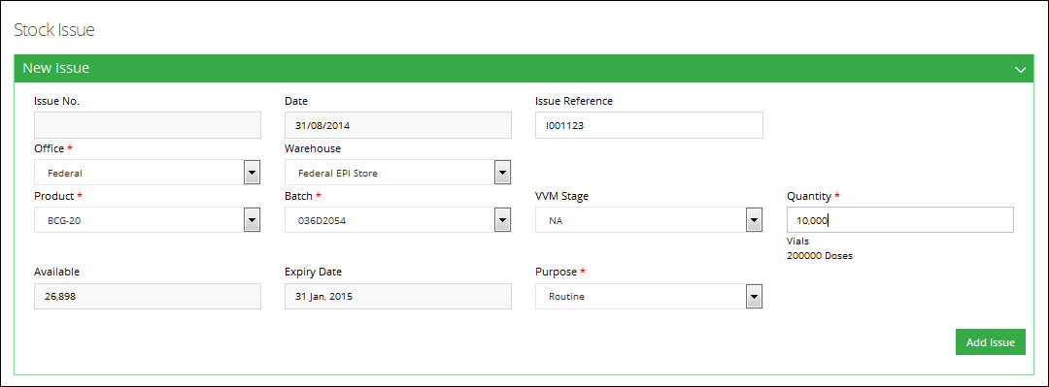
3. In order to issue a vaccine batch, specify the following information:
   * **Issue No**: is an automatically generated number for identifying the issue transaction.
   * **Date:** Click on date to expand the date picker tool.   
       
     
   * **Issue Reference**: specify the receive reference.
   * **Office**: In this drop-down, select the office to which you want to issue the product. On selecting the **Office**, the **Province** drop-down is displayed. On selecting the Province, the **Issue To** drop-down displays the relevant warehouse store names in the selected province. Select the required warehouse/store.
   * **Product**: select the product from the list.
   * **Batch:** specify the batch number for the selected product.
   * **VVM Stage:** specify the VVM stage.

|  |  |
| --- | --- |
| C:\Users\isbah.zulfiqar\Desktop\1382615592_file_edit.png | A vaccine vial monitor (VVM) is a label containing a heat-sensitive material which is placed on a vaccine vial to register cumulative heat exposure over time. The combined effects of time and temperature cause the inner square of the VVM to darken, gradually and irreversibly. A direct relationship exists between the rate of color change and temperature:  The lower the temperature, the slower the color change, the higher the temperature, the faster the color change. |

* + **Quantity:** specify the issue quantity. Make sure it is less than the available quantity of the batch.
  + **Available:** displays the available quantity.
  + **Expiry Date:** Click on Expiry date to expand the date picker tool, or type-in the required date using format dd/mm/yyyy.
  + **Purpose:** Add the purpose for which stock is being issued. In case of a campaign, the name of the campaign should also be specified.

1. Click **Add Issue** to add the issue entry to the Issue list.  
     
   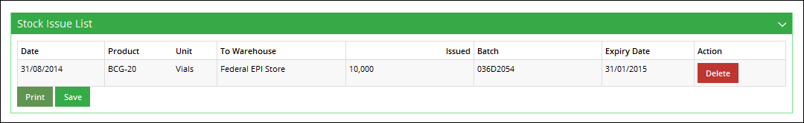
2. Click **Save**.  
   The Issue entry is saved.
3. Click **Print** to print the Issue Voucher.

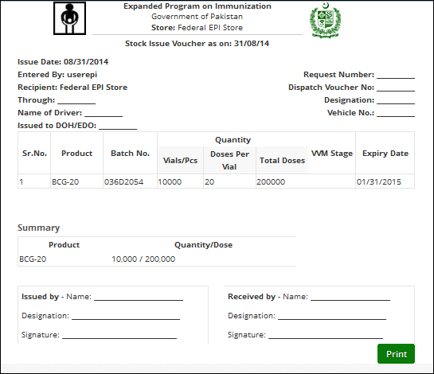

## **Stock Issue Search**

To search for an issue entry:

1. Sign in to the User account.  
   The User Home Page displays.
2. Under **Inventory Management**, click **Stock Issue Search**.  
   The Stock Issue Search page displays.
3. Specify the following filters:
   * **Search By**: Specify the unique identifier you want to search by. The options include:

* **Issue No**: if you know the issue number, select this option and specify the Issue No in the adjacent text box.
* **Issue Ref.**: To search using the Issue Ref, select this option and then specify the Issue Ref in the adjacent text box.
* **Batch No.:** To search using the Batch No., select this option and then specify the Batch No in the adjacent text box.
  + **Warehouse Supplier:** select the warehouse supplier. This is optional field.
  + **Product:** select the required vaccine from the list.
  + **Date From**, **Date To**:Click on date to expand the date picker tool.   
      
    

1. Click **Search**.  
   The required entries are displayed in the Issue List.

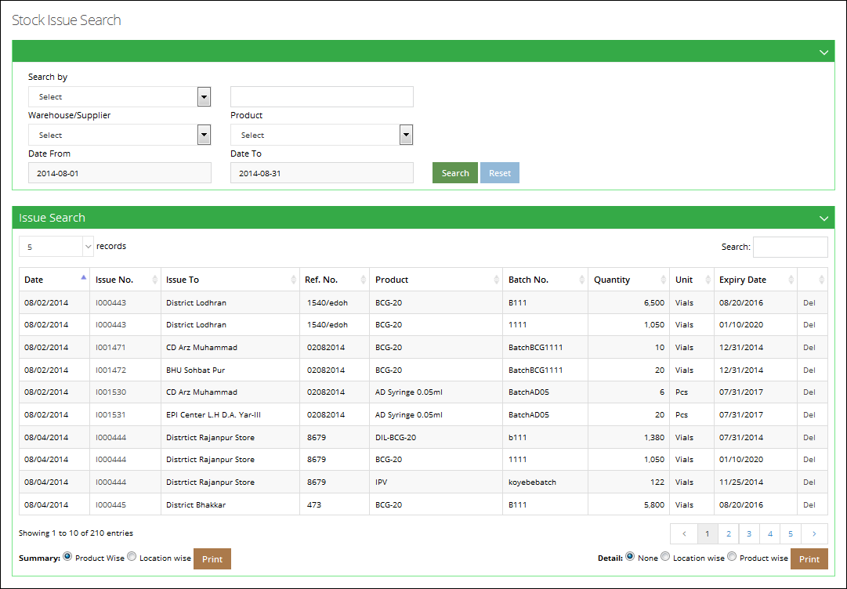

1. Click **Print** to print the displayed list.

## **Search Adjustments**

Every now and then you'll want to update the number of items in stock manually. Perhaps you've lost or damaged items, or you have received less inventory than expected. You can add stock adjustments for managing you inventory.

To search for Adjustments:

1. Sign in to the user account.  
   The User Home Page displays.
2. Under **Inventory Management**, click **Search Adjustments**.  
   The Search Adjustments page displays.
3. Specify the search criteria:
   * **Adjustment No**.: is an automatically generated unique identifier for the adjustment.
   * **Adjustment Type:** specify the adjustment type.
   * **Product:** select the required vaccine from the list.
   * **Date From, Date To**: Click on date to expand the date picker tool.
4. Click **Search**.  
   The Search result displays.

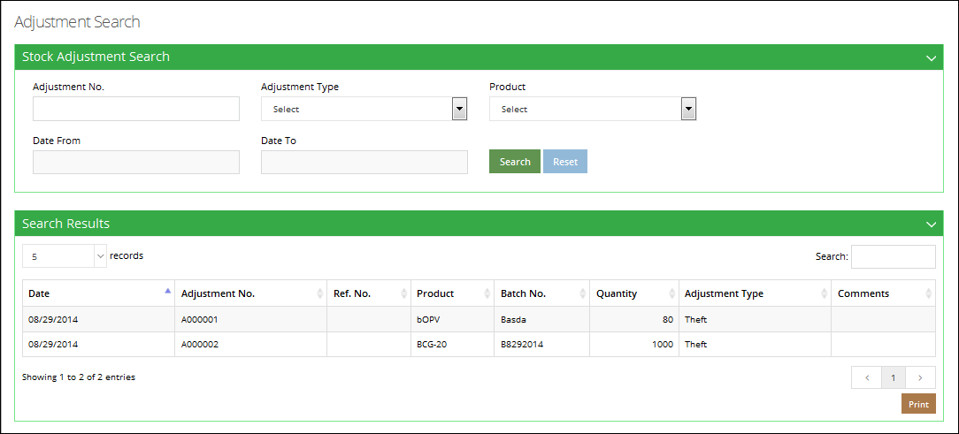

## **Add Adjustment**

To add new Adjustments:

1. Sign in to the user account.  
   The User Home Page displays.
2. Under **Inventory Management**, click **New Adjustments**.  
   The New Adjustments page displays.

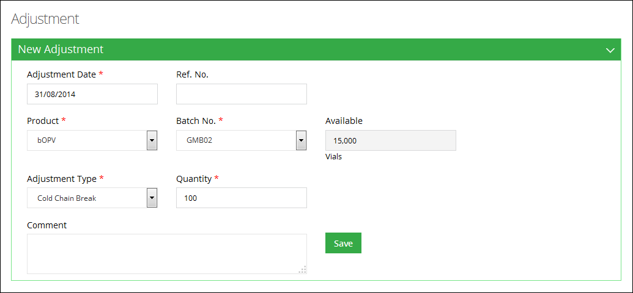

1. Specify the following filters:

* **Adjustment No.:** is an automatically generated unique identifier for the adjustment.
* **Adjustment Date**: Click on date to expand the date picker tool.   
    
  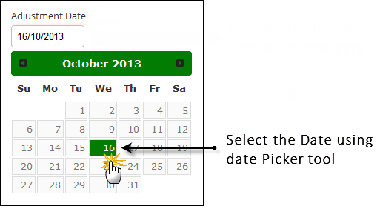
* **Ref No.**: enter the Ref. No. of the adjustment.
* **Product:** select the required vaccine from the list.
* **Batch:** specify the batch number for the product.
* **Available:** displays the available quantity.
* **Adjustment Type:** specify the adjustment type.
* **Quantity:** specify the quantity to be adjusted.
* **Comment**: Add comments, if any.

1. Click **Save** to save adjustment.

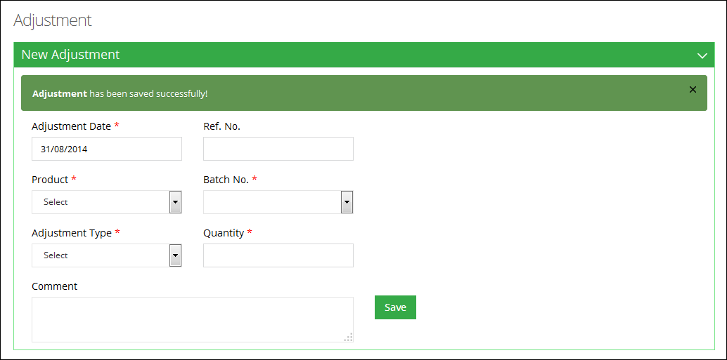

**Stock Placement**

EPI Users (National and Provincial) can also manage stock placement and the location of stock within the warehouse and stores / facilities. This allows users to not only manage the locations of stock but also be able to access the stock from within the application. Inventory Management feature enables the Store User to manage the inventory within warehouse.

**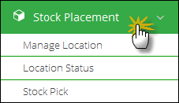**

Stock Placement feature enables the EPI User to manage the stock within the warehouse. The Store User can perform the following:

* **Manage Location**: User can manage the location of stock within the store/warehouse.
* **Location Status**: User can check the stock available at a particular location in the store and transfer it to another location.
* **Stock Pick**: User can select Issue No. to pick a particular product from the voucher list.

## **Manage Location**

National and Provincial users can manage placement locations for the stock within the warehouse by adding location Area, Row, Rack, Rack Type, Pallet as well as Level.

To manage locations for the stock within the warehouse, select the following filters:

* **Area:** Select the area for the location.
* **Row:** Select the row for the location of stock.
* **Rack:** Select the rack for the stock location.
* **Rack Type:** Select the rack type as Single or Double.
* **Pallet:** Select the pallet for stock location.
* **Level:** Select the level for the location for the list.

Click **Save Entry.**

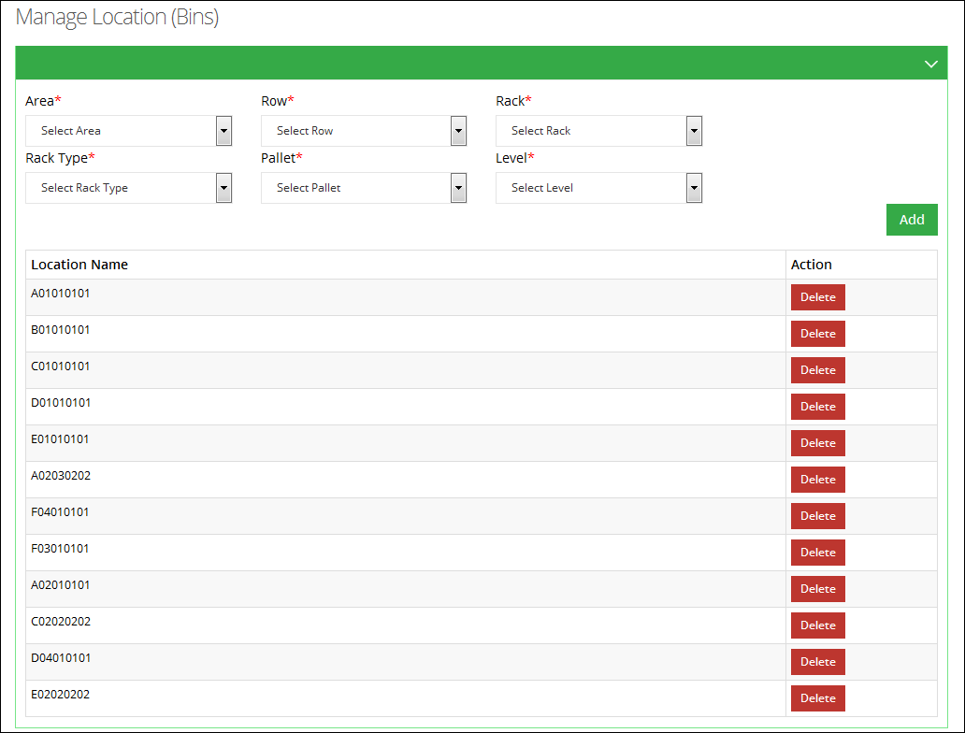

Location list of stock placement locations is available. User can also search for a stock location from the list.

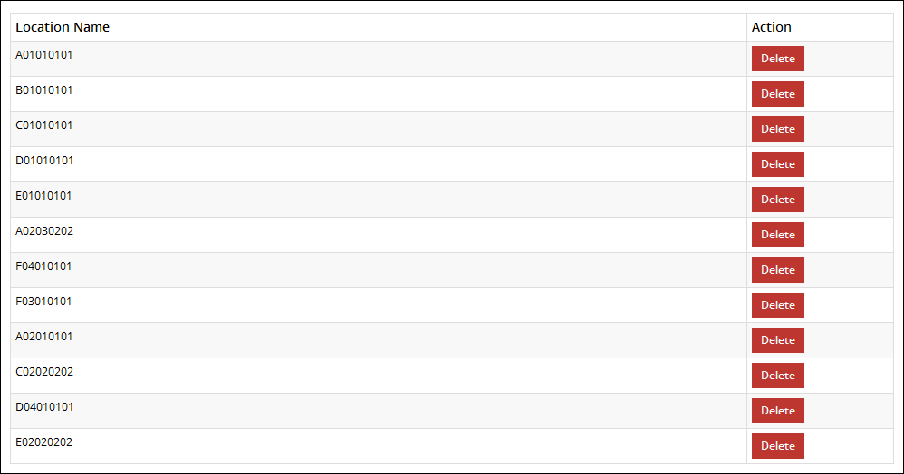

## **Location Status**

EPI Users can select **Vaccine Location** and **Non-Vaccine Location** to show a particular location for allocating the stock.

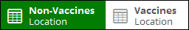

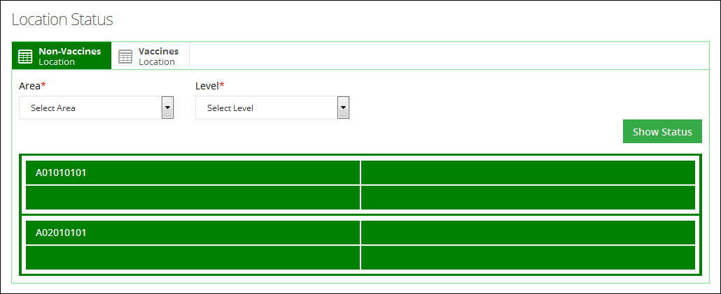

Click a particular location. The status of that location will appear and the details of the product present at that location will appear.

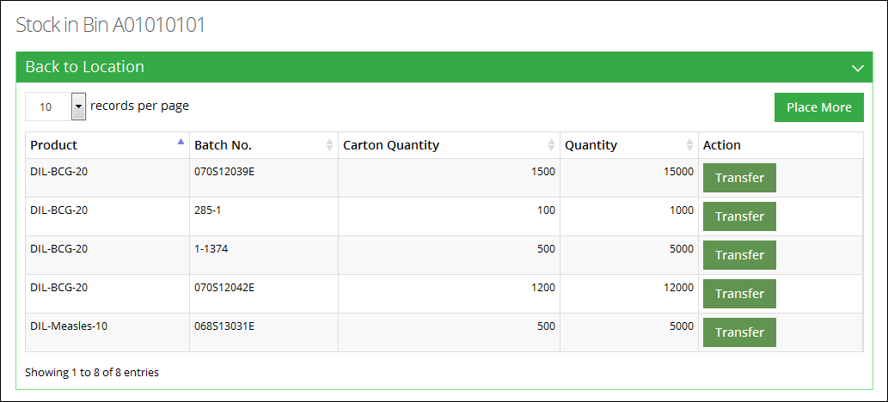

In order to transfer the stock available at this location, click **Transfer.** A new window will pop-up.

* Select the location to transfer stock.
* Add quantity of boxes. (The quantity of boxes to transfer should be less than or equal to the available number of boxes.)
* Click **Transfer.**

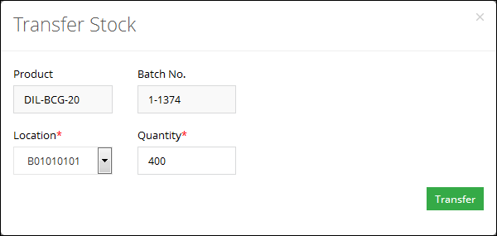

To add more stock to this location, click **Place More.** A complete list of received stock will be displayed.

Add **Place Quantity** and click **Save.**

**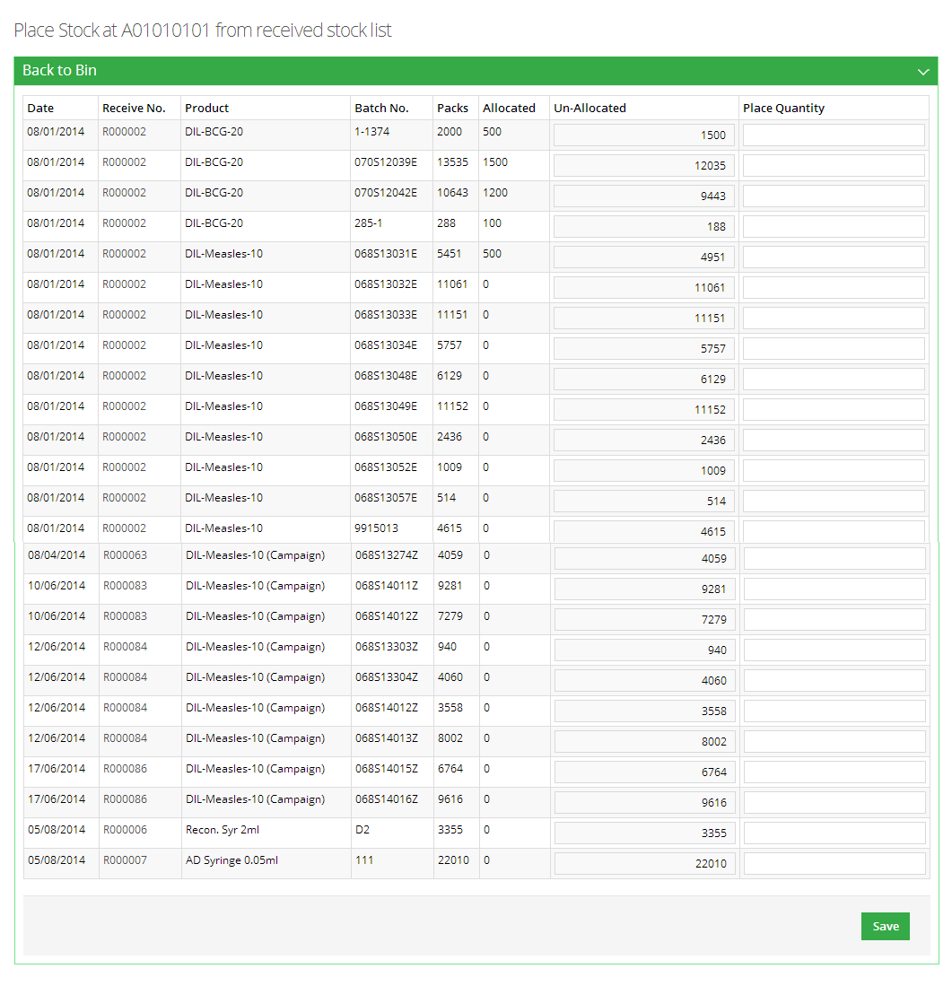**

## **Stock Pick**

EPI Users (National and Provincial) have an option to issue stock to others warehouses, district stores / facilities as well as field offices. Once a user issues stock to another store / facility, it is placed at a location within the warehouse. User can manage placement location of the stock from **Location Status.**

From the **Issue Voucher List**, select **Issue No.** to pick a stock of any particular product.

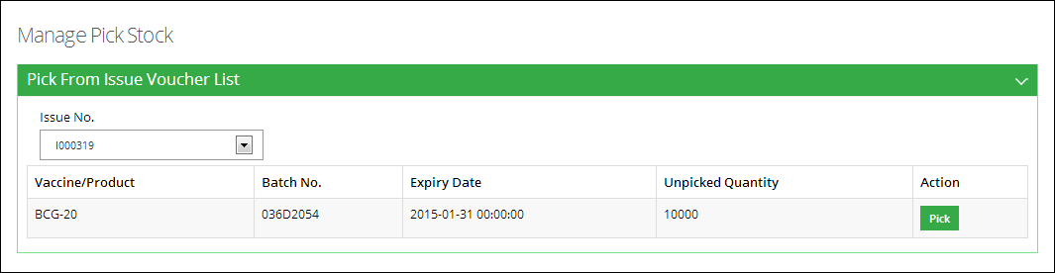

Click **Pick.** A new screen is displayed. Add the stock quantity to pick and click **Pick.**

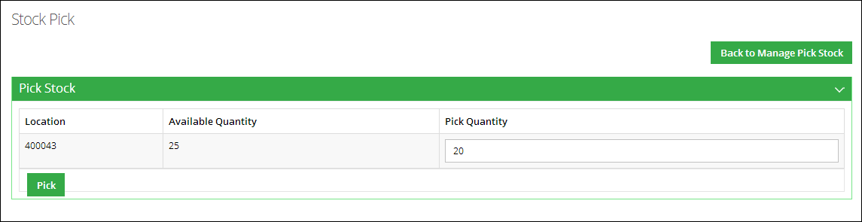

**Gate Pass**

Once a stock has been picked to be transferred to another location, a new gate pass will be created. To create a new gate pass, select the Issue No. of the products to be picked along-with the vehicle and vehicle type. User will also add the quantity to be picked from the issued quantity of the product.

Manage Gate Pass feature enables the Store User to issue a new gate pass as well as view the issued gate passes. The Store User can perform the following:

* **New Gate Pass**: User can issue a new gate pass to transfer stock to another location.
* **Gate Pass List**: User can view a list of gate passes issued within a selected duration

Select **Gate Pass** from the main menu to issue a new gate pass or view a list of gate passes.

**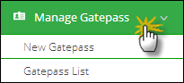**

## **New Gate Pass**

Click **New Gate Pass** under the Gate Pass tab.

To issue a new gate pass, you can specify the following:

* **Date From, Date To:** Click on date to expand the date picker tool and select dates.
* **Vehicle Type:** select a vehicle type.
* **Vehicle:** select a vehicle from the list or check other.
* **Issue No.**: select one or multiple issue numbers from the shown list.
* **Date:** Click on date to expand the date picker tool and select date.

The issued products will be displayed in the list. Add the quantity to create gate pass from the issued quantity and click **Save.**

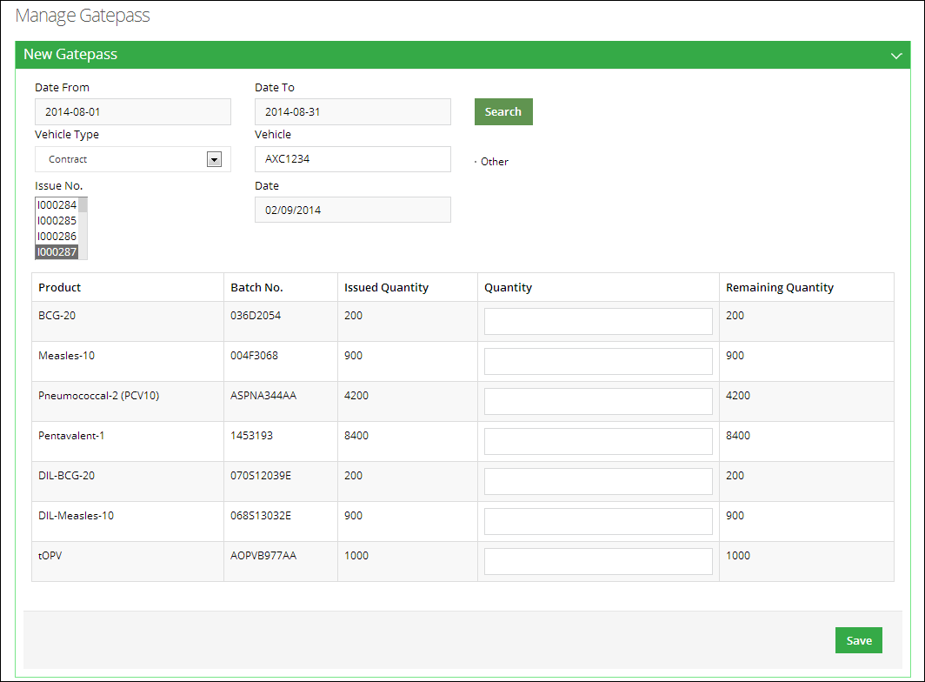

## **Gate Pass List**

Click **Gate Pass List** under the Gate Pass tab.

To view the list of issued gate pass, you can specify the following:

* **Date From, Date To:** Click on date to expand the date picker tool and select dates.
* **Vehicle Type:** select a vehicle type.
* **Item:** select an item for which you want to view gate pass.
* **Batch:** select the batch associated with the selected item.

Click **Search.** The list of gate passes will be displayed.

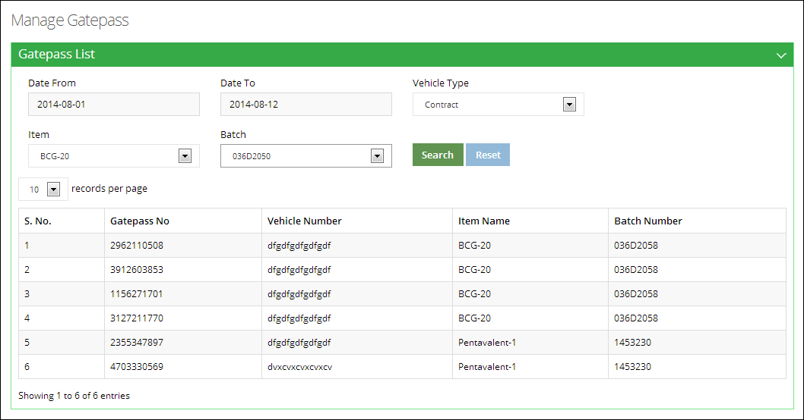

**CCEM**

A vaccine’s cold chain is a [temperature](http://en.wikipedia.org/wiki/Temperature)-controlled [supply chain](http://en.wikipedia.org/wiki/Supply_chain). It is essential for the effectiveness of the vaccines that an unbroken cold chain with uninterrupted series of storage and distribution activities are maintained for the given temperature range. In vLMIS, EPI users at the national and provincial level can provide the Cold-chain assets update information containing its capacity and working status for each month in order to record the cold-chain maintenance data.

Click **Cold Chain** from the main menu and select **Asset Status Update** from the drop down menu.

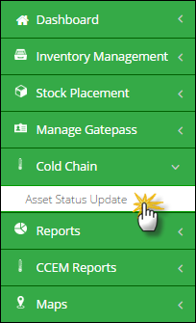

**Introduction to Cold chain Assets**

In vLMIS, cold-chain assets can be divided into two main categories:

1. Registered (Non-quantifiable Assets)
2. Non-Registered (Quantifiable Assets)

Registered assets are those assets which are not added with mentioned quantity. Non-registered assets on the other hand, will consist of a defined quantity.

Currently, there are seven types of cold-chain assets in the vLMIS. All these assets fall into the above mentioned categories.

**Registered Assets**

1. Refrigerators
2. Cold Room
3. Generator
4. Transport

**Non-Registered Assets**

1. Vaccine Carriers
2. Ice Pack
3. Voltage Regulator

Among the registered assets, refrigerators and cold rooms consist of temperature alarms to ensure that the set temperature levels are achieved for vaccines. Generator and transport do not require temperature regulation.

## **Asset Status Update**

EPI account users at the National and Provincial are provided with an option to report the cold chain asset’s status of the assigned warehouse/stores, which helps identify the working condition of the cold-chain machine.

To update Asset’s Status:

1. Sign in to the user account.  
   User Homepage displays.
2. Click **CCEM** and then select **Asset Status Update**.  
   The Asset Status Update page displays. All the available assets for National EPI user will be displayed.

**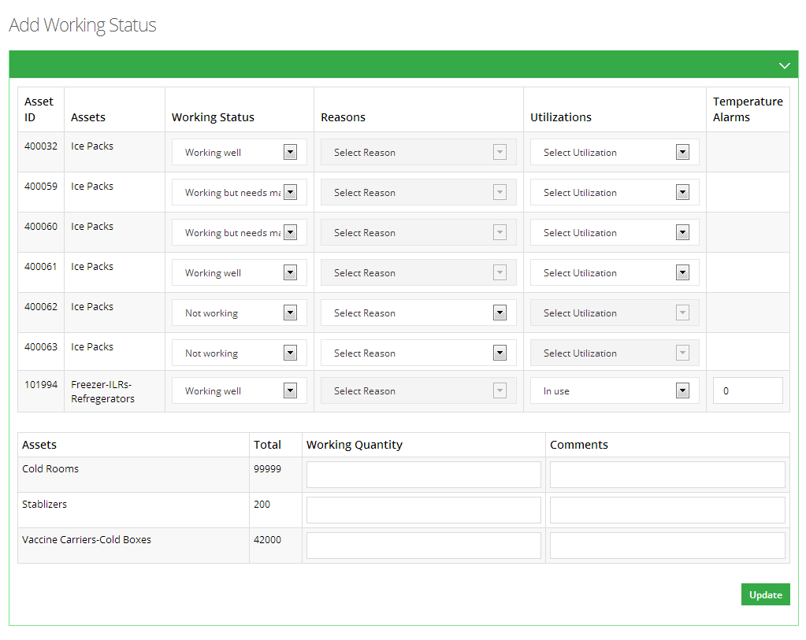**

1. Following fields will be available in the list:

* **Asset ID:** displays the Asset ID for the available assets.
* **Assets:** The type of the asset is also available.
* **Working Status:** select the working status of the asset from the list.
* **Reasons:** If the user selects the status as **Not Working,** select the reason for the not working condition of the asset.
* **Utilizations:** if the user selects the status as **Working,** select utilizations of the asset.
* **Temperature Alarms:** select the temperature alarms for cold-chain assets such as Refrigerators, Freezers and ILRs and cold rooms.

1. Add the **Working Quantity** of the available assets as shown in the image. User can also add comments here.
2. Click **Update**.  
   The Assets Status will be updated.

# vLMIS Explorer

The vLMIS explorer enables you to view the previously submitted Monthly Report data for the selected warehouse and the specified month - year.

Click **vLMIS Explorer** in the side-bar to open the vLMIS Explorer:

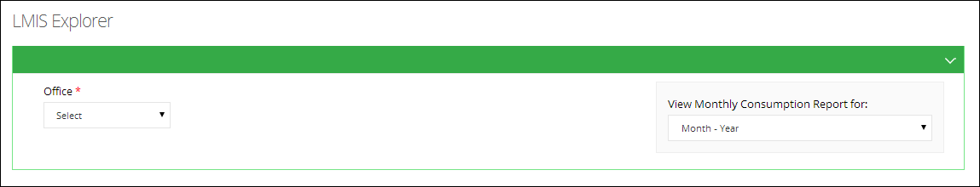

To view the Monthly Report data using vLMIS Explorer:

1. In LMIS Explorer page, click **Office** drop-down list:  
     
   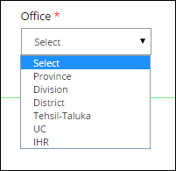

**Province**

If **Province** is selected in the **Office** drop-down list,the **Province** and **Warehouse** dropdown is displayed for the selection, as shown in the image below:

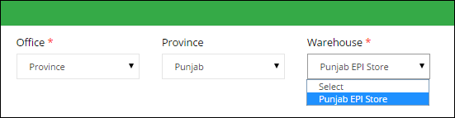

**District**

If **District** is selected in the **Office** drop-down list,the **Province** and **Warehouse** dropdown is displayed for the selection, as shown in the image below:

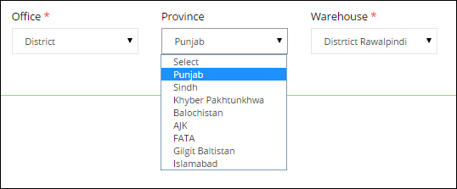

**Tehsil - Taluka**

If **Tehsil - Taluka** is selected in the **Office** drop-down list,the **Province** dropdown is displayed for selecting the Province. On selecting the Province, the **District** drop-down is displayed for selecting the district. On selecting the District, **Warehouse** drop-down displays for selecting the required warehouse store.

**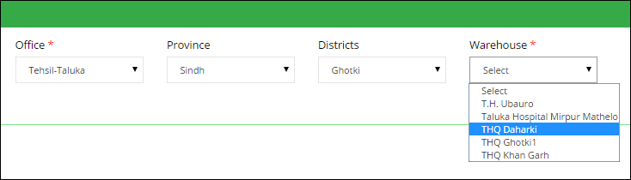**

**UC**

If **UC** is selected in the **Office** drop-down list,the **Province** dropdown is displayed for selecting the Province. On selecting the Province, the **District** drop-down will be displayed for selecting the District. The **Warehouse** drop-down displays for selecting the required warehouse / store within the selected district, as shown in the image below:

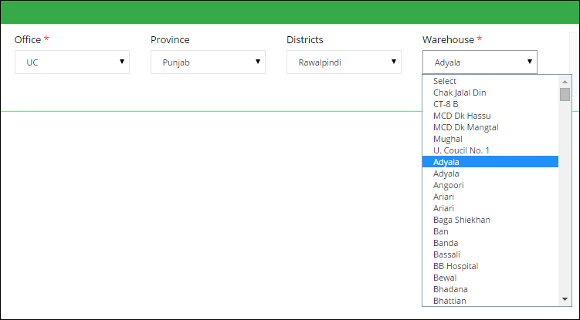

1. In **View Monthly Consumption Report for:** drop-down list, select the Month and Year for which you want to view the report.  
     
   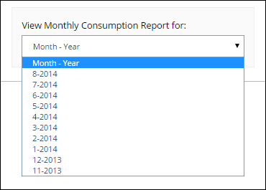

The Monthly Report displays:  
  
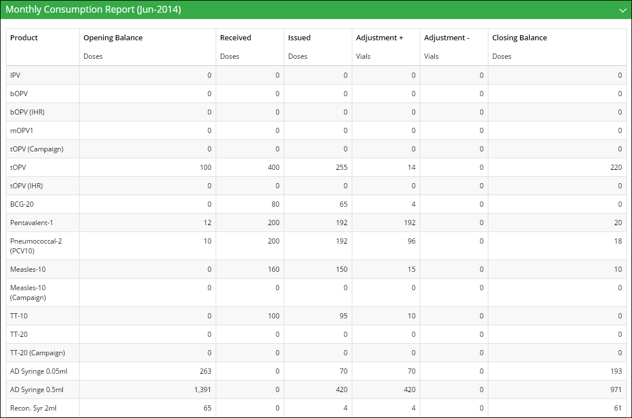

You can change the selections in the filter as required to view Monthly Report for any other location or time period.

**Reports**

Refer to the “Reports” section in the document.

**CCEM Reports**

Refer to the “CCEM Reports” section in the document.

**Maps**

Refer to the “Maps” section in the document.

**IM Graphs**

Refer to the “IM Graphs” section in the document.

**CCEM Graphs**

Refer to the “CCEM Graphs” section in the document.

